ILLITERATE LIGHT NAMED TO NPR’S 2020 SLINGSHOT ARTISTS TO WATCH

NORTH AMERICAN HEADLINE TOUR KICKS OFF JANUARY 23 IN ATLANTA, WITH STOPS IN NY, LA, NASHVILLE + 25 CITIES THROUGHOUT U.S. & CANADA

“BETTER THAN I USED TO” BREAKS TOP 10 AT ADULT ALTERNATIVE RADIO

“an explosive mission statement from a band that’s here to stay”
– NPR

“electrifying, combustible… a refined vein of My Morning Jacket / Band Of Horses-style Americana”
– UPROXX

LISTEN TO ILLITERATE LIGHT HERE:
https://illiteratelight.lnk.to/LP

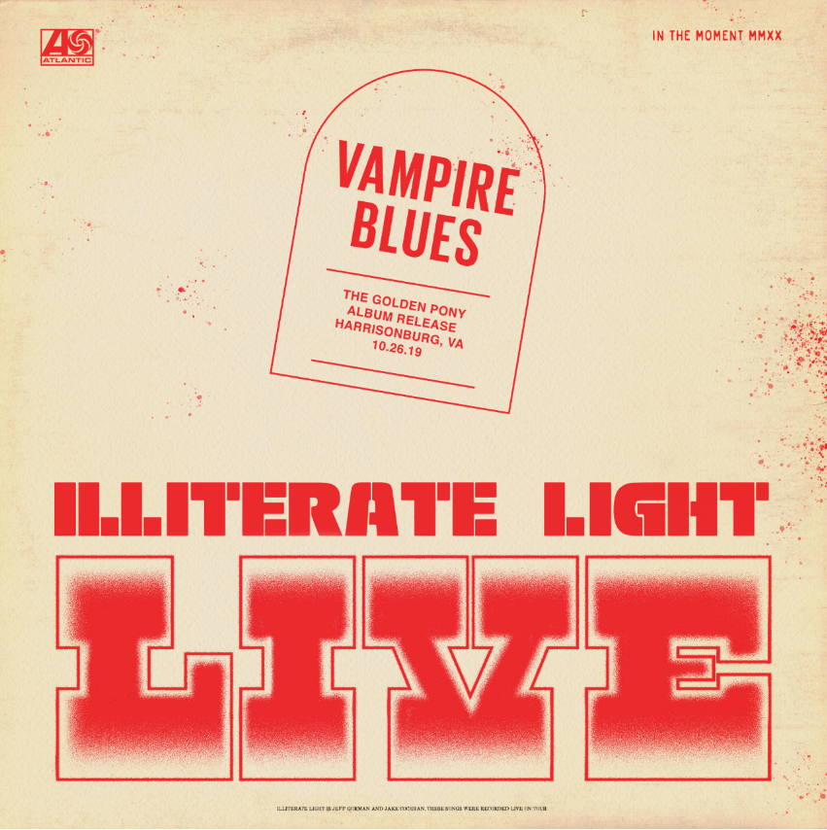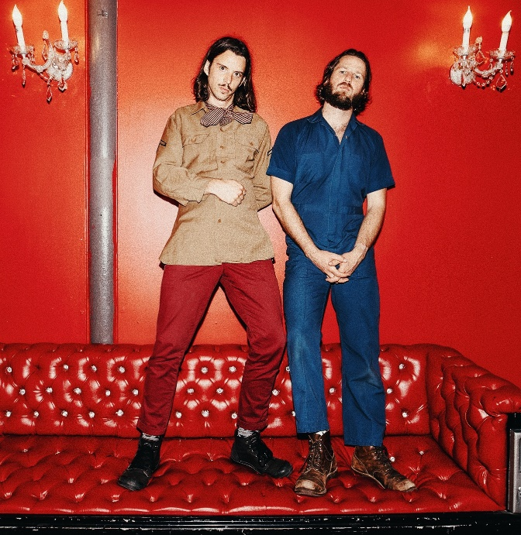
download hi-res artwork download hi-res press photo

Virginia indie rock duo Illiterate Light has been named to NPR’s “Slingshot Artists to Watch,” with the outlet featuring them amongst just 12 other artists “sure to do big things in 2020.” NPR specifically highlighted the duo’s “energetic live shows,” during which the two play a full band’s worth of instruments. “This isn’t a gimmick,” KTBG The Bridge’s Jon Hart continued, “the music on the duo’s self-titled release holds up.” NPR previously highlighted the group in their “Best Songs of 2019 (So Far),” declaring “Carolina Lorelai” to be “an explosive mission statement from a band that’s here to stay.”

Illiterate Light’s current single “Better Than I Used To” also received accolades from NPR, which declared it “a perfect addition to your summertime playlist.” The music video for “Better Than I Used To” was premiered via Billboard, who called it “a visual that translates the euphoric, restorative powers of love into a reverent and downright hypnotic experience.” Currently climbing the Adult Alternative charts, the track cracked the Top 10 at the start of 2020.

Over the coming weeks, the duo will release a series of live performance recordings and videos, to ultimately comprise a full live album called “In The Moment.” The series will kick off with a high-energy cover of Neil Young’s “Vampire Blues” live from VA’s The Golden Pony.

Later this month, the two will kick off their North American headline tour in Atlanta on January 23rd. The tour will include highly-anticipated stops at Brooklyn’s Rough Trade (1/28) and LA’s Moroccan Lounge (2/18), before culminating with a show on February 29th at The Basement in Nashville – tickets available here and full dates below.

This year’s headline tour follows heavy touring last year with Rainbow Kitten Surprise and The Head And The Heart – winning over crowds with their “hypnotic” (Billboard) performances and “electrifying” (Uproxx) stage presence. Despite being one of the festival’s earliest acts, they even received a standing ovation at Newport Folk Fest — “no small feat before noon” according to the Boston Globe.

All of this comes on the heels of Illiterate Light’s self-titled debut album, released in October via Atlantic Records. Upon release, Uproxx heralded the album as a “refined vein of My Morning Jacket / Band of Horses-style Americana.” Focused around the alchemic collaboration and camaraderie between members Jeff Gorman (lead vocals, guitar, synth pedals he plays with his feet) and Jake Cochran (vocal harmonies, stand-up drum kit) and recorded with producers Adrian Olsen (Foxygen, Natalie Prass) and Vance Powell (Jack White, Kings Of Leon, Chris Stapleton), the album is part soaring indie rock, part swirling psychedelia, part atmospheric folk and — alongside critically acclaimed performances this summer at Bonnaroo, Newport Folk Festival, and Lollapalooza — signals their triumphant arrival as an emergent musical force.

Illiterate Light – Tour Itinerary:
(tickets + add’l info: https://www.illiteratelight.com/)

Mon-Jan-20 Lafayette, LA Chip’s Daquiris
Tue-Jan-21 Mobile, AL Soul Kitchen
Thu-Jan-23 Atlanta, GA The Earl
Fri-Jan-24 Carrboro, NC Cat's Cradle Back Room
Sat-Jan-25 Washington, DC DC9 Nightclub ***SOLD OUT***
Mon-Jan-27 Philadelphia, PA Johnny Brenda's
Tue-Jan-28 Brooklyn, NY Rough Trade
Thu-Jan-30 Allston, MA Great Scott ***SOLD OUT***
Fri-Jan-31 Montreal, QC Bar le Ritz PDB
Sat-Feb-01 Toronto, ON Drake Hotel Underground
Mon-Feb-03 Columbus, OH The Basement
Tue-Feb-04 Ann Arbor, MI Blind Pig
Wed-Feb-05 Chicago, IL Schubas Tavern
Fri-Feb-07 Minneapolis, MN 7th Street Entry
Sat-Feb-08 Kansas City, MO Record Bar
Mon-Feb-10 Denver, CO Larimer Lounge
Tue-Feb-11 Salt Lake City, UT Kilby Court
Thu-Feb-13 Portland, OR Mississippi Studios
Fri-Feb-14 Vancouver, BC WISE Hall
Sat-Feb-15 Seattle, WA Barboza
Mon-Feb-17 San Francisco, CA Café du Nord, Swedish-American Hall
Tue-Feb-18 Los Angeles, CA Moroccan Lounge
Thu-Feb-20 San Diego The Casbah
Fri-Feb-21 Phoenix, AZ Valley Bar
Sat-Feb-22 Tucson, AZ 191 Toole
Mon-Feb-24 Austin, TX Barracuda
Tue-Feb-25 Houston, TX White Oak Music Hall
Wed-Feb-26 Dallas, TX Three Links
Fri-Feb-28 Birmingham, AL Saturn
Sat-Feb-29 Nashville, TN The Basement East

CONNECT WITH ILLITERATE LIGHT
Facebook | Instagram | Twitter | Official Site

PRESS CONTACT:
Libby Kober | Libby.Kober@AtlanticRecords.com

