ILLITERATE LIGHT RELEASES LIVE VERSION OF “NUTHIN’S FAIR” – ADDING TO
“IN THE MOMENT” LIVE PERFORMANCE SERIES

TRACK COMES ACCOMPANIED BY HIGH-ENERGY VIDEO FROM
SOLD-OUT HOMETOWN SHOW – PREMIERED TODAY VIA RELIX

SOUTHEAST SPRING TOUR DATES KICK OFF TOMORROW FOLLOWING SOLD-OUT HEADLINE SHOWS IN WASHINGTON DC, PHILADELPHIA, BOSTON + MORE

APPEARANCES CONFIRMED AT MARQUEE FESTIVALS INCLUDING
FIREFLY, OSHEAGA + FORECASTLE

DUO HIGHLIGHTED IN NPR’S “2020 SLINGSHOT ARTISTS TO WATCH”

“an explosive mission statement from a band that’s here to stay”
– NPR

“electrifying, combustible… a refined vein of My Morning Jacket / Band Of Horses-style Americana”
– UPROXX

“Illiterate Light’s live show is its own idiosyncratic phenomenon”
– RELIX

WATCH “NUTHIN’S FAIR [LIVE]”
https://youtu.be/wfeoZ-zrJeA

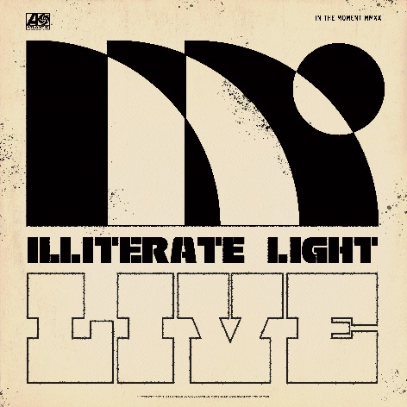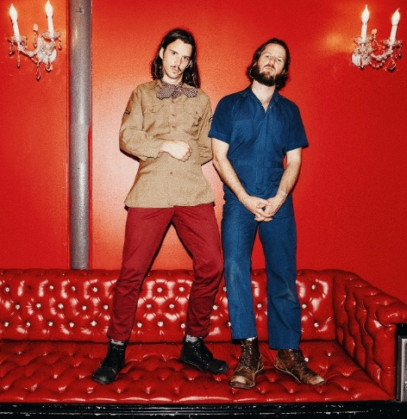
download hi-res "In The Moment" artwork download hi-res press photo

Virginia indie rock duo Illiterate Light has released a live version of “Nuthin’s Fair,” recorded during a hometown show at Harrisonburg, VA’s The Golden Pony in October. The show was one of two sold-out nights celebrating the release of the band’s self-titled debut album, out now on Atlantic Records (listen here).

Accompanied by an electrifying performance visual, today’s release is the second installment in the band’s live series, “In The Moment,” which the band will continue to build out with new recordings and videos from their can’t-miss live shows (download/stream here). To kick off the “In The Moment” series, the band released a spirited cover of Neil Young’s “Vampire Blues,” which has become a fan favorite during their live shows (watch here).

In premiering today’s new release, Relix declared: “Indie-fuzz duo Illiterate Light have been on a whirlwind since the release of their eponymous debut album… a new live video from the band showcases their original ‘Nuthin’s Fair,’ their DIY roots and their hometown venue The Golden Pony.”

As Jeff Gorman – the band’s multi-talented guitarist – expands: “‘Nuthins Fair’ has become a cathartic experience for everyone at our shows to release the heaviness of reality, in a crazy rock'n'roll kind of way … We’re releasing this song as part of our ‘In the Moment’ series, because that’s what our performance ethos is all about, and you can tell the crowd goes there with us.”
After sold-out shows this fall in Richmond and Harrisonburg, VA, the duo kicked off their proper North American headline tour at the end of January – playing to sold out rooms in Washington DC, Philadelphia, Boston, and an enraptured crowd at Brooklyn’s Rough Trade. They also performed live sessions for both Relix and Paste.

After attending their show in Minneapolis, Chris Riemenschneider (music critic at the Star-Tribune) declared: “Bounced from the fancy new Fillmore to the grimy old Entry last night and caught a young band that could soon be too big for both rooms… They jammed through a killer Neil Young cover too.”

Tomorrow (3/6), the duo will kick off another run of live dates in Columbia, SC and make stops throughout the Southeast, culminating on 4/25 with a set at Atlanta’s SweetWater 420 Fest (tickets available here and full dates below). In addition to SweetWater 420, Illiterate Light will play a number of other marquee festivals in 2020 – including Savannah Stopover, Firefly, Forecastle and Osheaga, among others.

In January, the duo was named to NPR’s “Slingshot Artists to Watch,” with the outlet featuring them amongst just 12 other artists “sure to do big things in 2020.” NPR specifically highlighted the duo’s “energetic live shows,” during which the two play a full band’s worth of instruments. “This isn’t a gimmick,” KTBG The Bridge’s Jon Hart continued, “the music on the duo’s self-titled release holds up.” NPR previously highlighted the group in their “Best Songs of 2019 (So Far),” declaring “Carolina Lorelai” to be “an explosive mission statement from a band that’s here to stay.”

In September, Relix named the band to their “5 Artists You Should Know,” asserting: “Illiterate Light’s live show is its own idiosyncratic phenomenon… from the booming psych-rock anthem ‘Growin’ Down’ to the atmospheric sing-along ‘Carolina Lorelai.’”

Illiterate Light’s current single “Better Than I Used To” also received accolades from NPR, which declared it “a perfect addition to your summertime playlist.” The music video for “Better Than I Used To” was premiered via Billboard, which called it “a visual that translates the euphoric, restorative powers of love into a reverent and downright hypnotic experience.” The track cracked the Top 10 of the Adult Alternative chart at the top of 2020.

This year’s live shows follow heavy touring last year with Rainbow Kitten Surprise and The Head And The Heart – winning over crowds with their “hypnotic” (Billboard) performances and “electrifying” (Uproxx) stage presence. Despite being one of the festival’s earliest acts, they even received a standing ovation at Newport Folk Fest — “no small feat before noon,” the Boston Globe declared.

All of this comes on the heels of Illiterate Light’s self-titled debut album, released in October via Atlantic Records. Upon release, Uproxx heralded the album as a “refined vein of My Morning Jacket / Band of Horses-style Americana.” Focused around the alchemic collaboration and camaraderie between members Jeff Gorman (lead vocals, guitar, synth pedals he plays with his feet) and Jake Cochran (vocal harmonies, stand-up drum kit) and recorded with producers Adrian Olsen (Foxygen, Natalie Prass) and Vance Powell (Jack White, Kings Of Leon, Chris Stapleton), the album is part soaring indie rock, part swirling psychedelia, part atmospheric folk and — alongside critically acclaimed performances this summer at Bonnaroo, Newport Folk Festival, and Lollapalooza — signals their triumphant arrival as an emergent musical force.

###

Illiterate Light – Tour Itinerary:
(tickets + add’l info: https://www.illiteratelight.com/)
Fri-Mar-6 Columbia, SC New Brookland Tavern
Sat-Mar-7 Savannah, GA Savannah Stopover Music Festival
Thu-Mar-26 Oxford, MS Proud Larry’s
Fri-Mar-27 New Orleans, LA Hogs for the Cause Music Festival
Mon-Mar-30 Charleston, SC The Royal American
Tue-Mar-31 Wilmington, NC Bourgie Nights
Thu-Apr-02 Asheville, NC The Mothlight
Fri-Apr-03 Charlottesville, VA The Southern
Sat-Apr-04 Charlotte, NC Moo and Brew Fest
Sat-Apr-25 Atlanta, GA Sweetwater 420 – Centennial Olympic Park
Thu-Jun-18 Norfolk, VA NorVa [supporting Rainbow Kitten Surprise]
Jun-18-Jun-21 Dover, DE Firefly Music Festival [daily schedule not yet announced]
Sun-Jul 19 Louisville, KY Forecastle Festival
Thu-Jul-23 Floyd, VA Floydfest
Fri-Jul-24 Floyd, VA Floydfest
Fri-Jul-31 Montreal, QC Osheaga Music Festival

CONNECT WITH ILLITERATE LIGHT
Facebook | Instagram | Twitter | Official Site

PRESS CONTACT:
Libby Kober | Libby.Kober@AtlanticRecords.com

