ILLITERATE LIGHT PAYS TRIBUTE TO BOSTON’S GREAT SCOTT WITH LIVE VERSION OF “SOMETIMES LOVE TAKES SO LONG”

LIVE PERFORMANCE FROM SOLD-OUT SHOW ADDS TO “IN THE MOMENT” SERIES

“SOMETIMES LOVE TAKES SO LONG” ASCENDS UP AAA RADIO CHARTS

WATCH “SOMETIMES LOVE TAKES SO LONG (LIVE FROM GREAT SCOTT)”:
https://illiteratelight.lnk.to/SLTSLGSPR/youtube

NPR 2020 ARTIST TO WATCH
“an explosive mission statement from a band that’s here to stay”
– NPR

“two guys, in the moment, playing their respective rigs; no substitutions”
“The promising Virginia-based duo has an ambition that is promising at a time when rock needs it.”
– SPIN

“Illiterate Light’s live show is its own idiosyncratic phenomenon”
– RELIX

“electrifying, combustible… a refined vein of My Morning Jacket / Band of Horses-style Americana”
– UPROXX

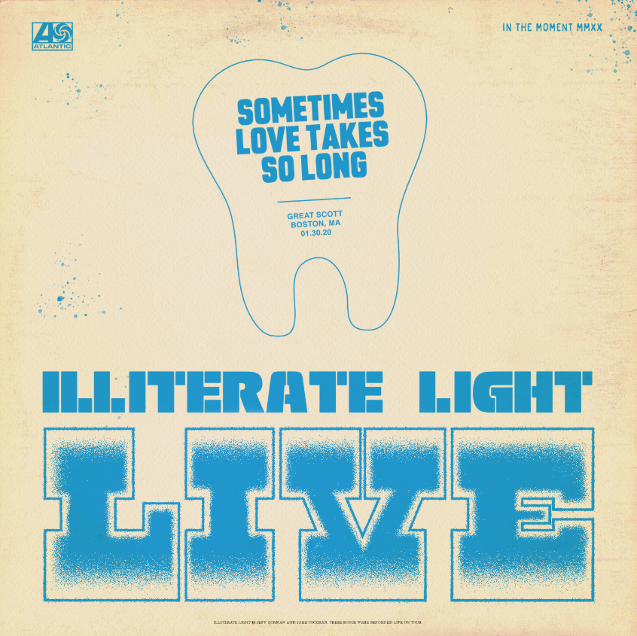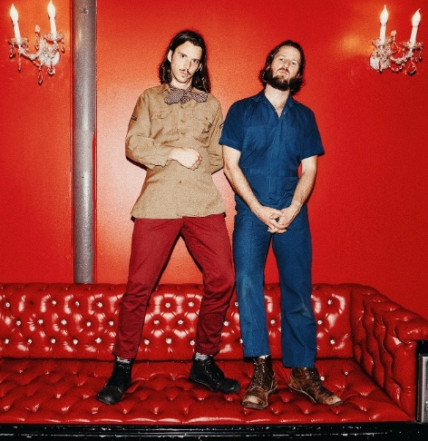
download artwork download hi-res press photo

Indie folk-rock duo Illiterate Light has released a live version of “Sometimes Love Takes So Long,” recorded during a sold-out show at Allston’s Great Scott + accompanied by an electrifying and intimate performance visual – WATCH HERE. The recording was long planned as the fourth installment in the band’s live series “In The Moment,” which the band has been building out with recordings and videos from their incredible live shows.

What was unplanned, however, is that the release now comes just days after Great Scott’s owners announced the venue will sadly not be re-opening its doors. In that way, the video now serves as a fitting homage to the historic club. In fact, the series as a whole has taken on new meaning over the last couple of months – becoming a tribute to the power of live performances and the community formed during the duo’s live shows.

The band shared the following about today’s release and their memories of playing at the venue:

We always end up skating in Boston. I’m not sure why. Before the Great Scott show in January we wandered down to the Orchard, a legendary skate-shop with an indoor bowl. It was cold as hell outside and we’d been stuck in the van from New York for a few hours. We cued up the soundtrack to Tony Hawk 1 and went bananas. After amateur hour in the bowl (let’s be honest) we made our way back to Great Scott, thankful that no one pulled a hammy. We knew it was gonna be a wild night as the show had been sold out for weeks.

We’ve known for months that we’d be releasing “Sometimes Love Takes So Long” live in Boston at Great Scott. What we didn’t know was that, in the midst of the Coronavirus, Great Scott would announce that after 44 years of business, it would not reopen after the pandemic. It was a legendary spot for so many touring artists (including us), and it will be sorely missed. We hope this performance, a blip on the screen, captures the spirit of the Bostonians that called Great Scott their musical home. Thanks for singing along, ya’ll.

To kick off the “In The Moment” series, the band released a spirited cover of Neil Young’s “Vampire Blues,” which has become a fan favorite during their live shows (watch here). Their second release, a live version of “Nuthin’s Fair,” premiered on Relix with the outlet declaring: “Indie-fuzz duo Illiterate Light have been on a whirlwind since the release of their eponymous debut album… a new live video from the band showcases their DIY roots and their hometown venue The Golden Pony.” Last month’s release “In The Ground” was aptly described by SPIN as: “two guys, in the moment, playing their respective rigs; no substitutions.”

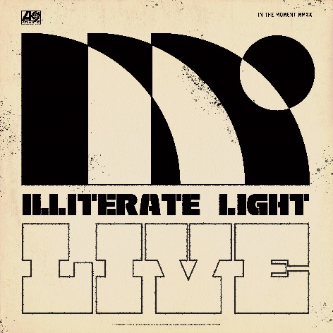
download hi-res "In The Moment" album artwork
After sold-out shows this fall in Richmond and Harrisonburg, VA, the duo kicked off a North American headline tour at the end of January – playing to sold out rooms in Washington DC, Philadelphia, Boston, and an enraptured crowd at Brooklyn’s Rough Trade. They also performed live sessions for both Relix and Paste.

After attending their show in Minneapolis, Chris Riemenschneider (music critic at the Star-Tribune) declared: “Bounced from the fancy new Fillmore to the grimy old Entry last night and caught a young band that could soon be too big for both rooms… They jammed through a killer Neil Young cover too.”

This year’s live shows followed heavy touring last year with Rainbow Kitten Surprise and The Head And The Heart – winning over crowds with their “hypnotic” (Billboard) performances and “electrifying” (Uproxx) stage presence. Despite being one of the festival’s earliest acts, they even received a standing ovation at Newport Folk Fest — “no small feat before noon,” the Boston Globe declared.

At the top of the year, the duo was named to NPR’s “Slingshot Artists to Watch,” with the outlet featuring them amongst just 12 other artists “sure to do big things in 2020.” NPR specifically highlighted the duo’s “energetic live shows,” during which the two play a full band’s worth of instruments. “This isn’t a gimmick,” KTBG The Bridge’s Jon Hart continued, “the music on the duo’s self-titled release holds up.” NPR previously highlighted the group in their “Best Songs of 2019 (So Far),” declaring “Carolina Lorelai” to be “an explosive mission statement from a band that’s here to stay.”

In September, Relix named the band to their “5 Artists You Should Know,” asserting: “Illiterate Light’s live show is its own idiosyncratic phenomenon… from the booming psych-rock anthem ‘Growin’ Down’ to the atmospheric sing-along ‘Carolina Lorelai.’”

Illiterate Light’s single “Better Than I Used To” also received accolades from NPR, which declared it “a perfect addition to your summertime playlist.” The music video for “Better Than I Used To” was premiered via Billboard, which called it “a visual that translates the euphoric, restorative powers of love into a reverent and downright hypnotic experience.” The track cracked the Top 10 of the Adult Alternative chart at the top of 2020.

All of this comes on the heels of Illiterate Light’s self-titled debut album, released in October via Atlantic Records. Upon release, Uproxx heralded the album as a “refined vein of My Morning Jacket / Band of Horses-style Americana.” Focused around the alchemic collaboration and camaraderie between members Jeff Gorman (lead vocals, guitar, synth pedals he plays with his feet) and Jake Cochran (vocal harmonies, stand-up drum kit) and recorded with producers Adrian Olsen (Foxygen, Natalie Prass) and Vance Powell (Jack White, Kings Of Leon, Chris Stapleton), the album is part soaring indie rock, part swirling psychedelia, part atmospheric folk and — alongside critically acclaimed performances this summer at Bonnaroo, Newport Folk Festival, and Lollapalooza — signals their triumphant arrival as an emergent musical force.

###

CONNECT WITH ILLITERATE LIGHT
Facebook | Instagram | Twitter | Official Site

PRESS CONTACT:
Libby Kober | Libby.Kober@AtlanticRecords.com

