ILLITERATE LIGHT ANNOUNCE ADDITIONAL 2020 TOUR DATES THROUGHOUT SOUTHEASTERN U.S.

HIGHLY ANTICIPATED SHOWS ADDED TO NORTH AMERICAN HEADLINE TOUR CURRENTLY UNDERWAY WITH SOLD-OUT SHOWS IN WASHINGTON DC, PHILADELPHIA, BOSTON + MORE

APPEARANCES CONFIRMED AT MARQUEE FESTIVALS INCLUDING
FIREFLY, OSHEAGA + SAVANNAH STOPOVER

“an explosive mission statement from a band that’s here to stay”
– NPR

“electrifying, combustible… a refined vein of My Morning Jacket / Band Of Horses-style Americana”
– UPROXX

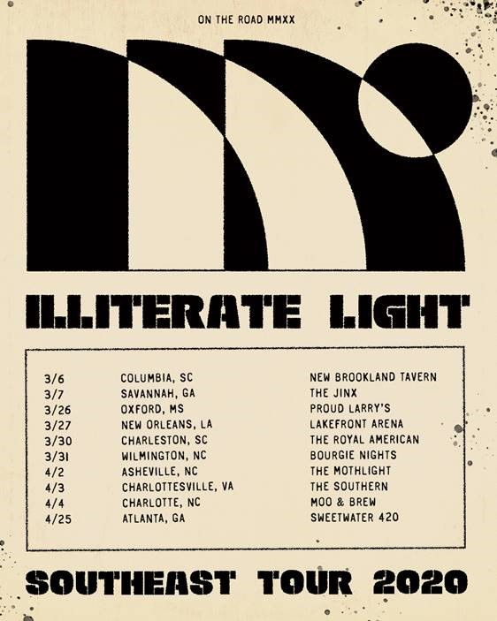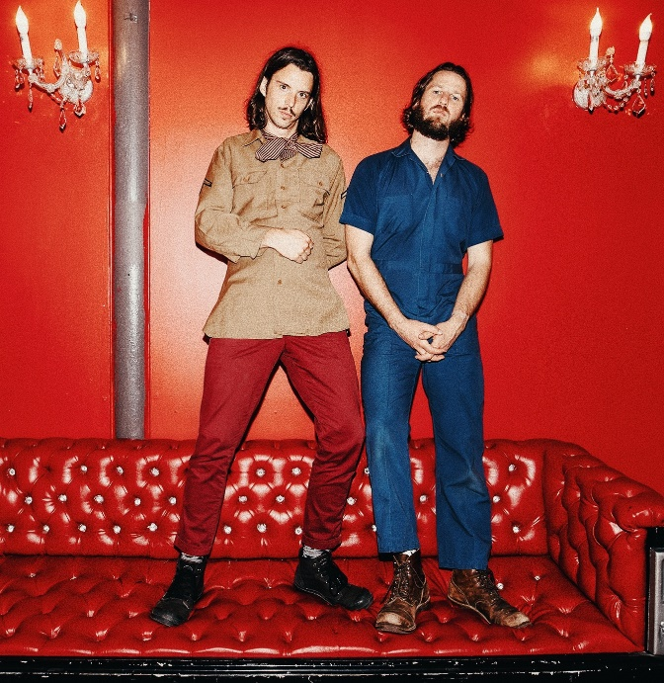
download hi-res admat download hi-res press photo

Virginia indie rock duo Illiterate Light has announced 10 additional dates to their Spring 2020 tour, adding stops to a months-long run that will now include the southeastern U.S.

After sold-out shows this fall in Richmond and Harrisonburg, VA, the duo kicked off their proper North American headline tour at the end of January – already selling out rooms in Washington DC, Philadelphia, and Boston. Last week the band played to an enraptured crowd at Brooklyn’s Rough Trade, and performed live sessions for both Relix and Paste.

Later this month, the band will make highly-anticipated stops at LA’s Moroccan Lounge (2/18) and Nashville’s The Basement East (2/29). In March, the duo will kick off in Columbia, SC (3/6) and make stops throughout the Southeast, culminating on 4/25 with a set at Atlanta’s SweetWater 420 Fest – tickets available here and full dates below. In addition to SweetWater 420, Illiterate Light will play a number of other marquee festivals in 2020 – including Savannah Stopover, Firefly and Osheaga, among others.

Illiterate Light’s current single “Better Than I Used To” received accolades from NPR, which declared it “a perfect addition to your summertime playlist.” The music video for “Better Than I Used To” was premiered via Billboard, who called it “a visual that translates the euphoric, restorative powers of love into a reverent and downright hypnotic experience.” Currently climbing the Adult Alternative charts, the track cracked the Top 10 at the start of 2020.

This year’s headline tour follows heavy touring last year with Rainbow Kitten Surprise and The Head And The Heart – winning over crowds with their “hypnotic” (Billboard) performances and “electrifying” (Uproxx) stage presence. Despite being one of the festival’s earliest acts, they even received a standing ovation at Newport Folk Fest — “no small feat before noon” according to the Boston Globe.

All of this comes on the heels of Illiterate Light’s self-titled debut album, released in October via Atlantic Records. Upon release, Uproxx heralded the album as a “refined vein of My Morning Jacket / Band of Horses-style Americana.” Focused around the alchemic collaboration and camaraderie between members Jeff Gorman (lead vocals, guitar, synth pedals he plays with his feet) and Jake Cochran (vocal harmonies, stand-up drum kit) and recorded with producers Adrian Olsen (Foxygen, Natalie Prass) and Vance Powell (Jack White, Kings Of Leon, Chris Stapleton), the album is part soaring indie rock, part swirling psychedelia, part atmospheric folk and — alongside critically acclaimed performances this summer at Bonnaroo, Newport Folk Festival, and Lollapalooza — signals their triumphant arrival as an emergent musical force.

Illiterate Light – Full Tour Itinerary:
(tickets + add’l info: https://www.illiteratelight.com/)
Fri-Feb-07 Minneapolis, MN 7th Street Entry
Sat-Feb-08 Kansas City, MO Record Bar
Mon-Feb-10 Denver, CO Larimer Lounge
Tue-Feb-11 Salt Lake City, UT Kilby Court
Wed-Feb-12 Boise, ID Record Exchange [free]
Thu-Feb-13 Portland, OR Mississippi Studios
Sat-Feb-15 Seattle, WA Barboza
Mon-Feb-17 San Francisco, CA Café du Nord, Swedish-American Hall
Tue-Feb-18 Los Angeles, CA Moroccan Lounge
Thu-Feb-20 San Diego The Casbah
Fri-Feb-21 Phoenix, AZ Valley Bar
Sat-Feb-22 Tucson, AZ 191 Toole
Mon-Feb-24 Austin, TX Barracuda
Tue-Feb-25 Houston, TX White Oak Music Hall
Wed-Feb-26 Dallas, TX Three Links
Fri-Feb-28 Birmingham, AL Saturn
Sat-Feb-29 Nashville, TN The Basement East
Fri-Mar-6 Columbia, SC New Brookland Tavern
Sat-Mar-7 Savannah, GA Savannah Stopover Music Festival [The Jinx]
Thu-Mar-26 Oxford, MS Proud Larry’s
Fri-Mar-27 New Orleans, LA Hogs for the Cause Music Festival [UNO Lakefront Arena]
Mon-Mar-30 Charleston, SC The Royal American
Tues-Mar-31 Wilmington, NC Bourgie Nights
Thu-Apr-2 Asheville, NC The Mothlight
Fri-Apr-3 Charlottesville, VA The Southern
Sat-Apr-4 Charlotte, NC Moo & Brew
Sat-Apr-25 Atlanta, GA SweetWater 420 Fest [Centennial Olympic Park]
Sat-Jun-20 Dover, DE Firefly Music Festival
Thu-Jul-23 Floyd, VA Floydfest
Fri-Jul-24 Floyd, VA Floydfest
Fri-Jul-31 Montreal, QC Osheaga Music Festival

CONNECT WITH ILLITERATE LIGHT
Facebook | Instagram | Twitter | Official Site

PRESS CONTACT:
Libby Kober | Libby.Kober@AtlanticRecords.com

