ILLITERATE LIGHT RELEASES LIVE VERSION OF NEIL YOUNG’S “VAMPIRE BLUES” ALONGSIDE HIGH-ENERGY PERFORMANCE VIDEO

RECORDING FROM SOLD-OUT HOMETOWN SHOW KICKS OFF
“IN THE MOMENT” LIVE PERFORMANCE SERIES

DUO ANNOUNCES APPEARANCES AT MARQUEE FESTIVALS INCLUDING
FIREFLY, OSHEAGA + SAVANNAH STOPOVER

NORTH AMERICAN HEADLINE TOUR UNDERWAY WITH SOLD-OUT SHOWS IN
WASHINGTON DC, PHILADELPHIA, BOSTON + MORE

ILLITERATE LIGHT NAMED TO NPR’S “2020 SLINGSHOT ARTISTS TO WATCH”

“an explosive mission statement from a band that’s here to stay”
– NPR

“electrifying, combustible… a refined vein of My Morning Jacket / Band Of Horses-style Americana”
– UPROXX

WATCH “VAMPIRE BLUES” HERE:
https://illiteratelight.lnk.to/VampireBluesPR

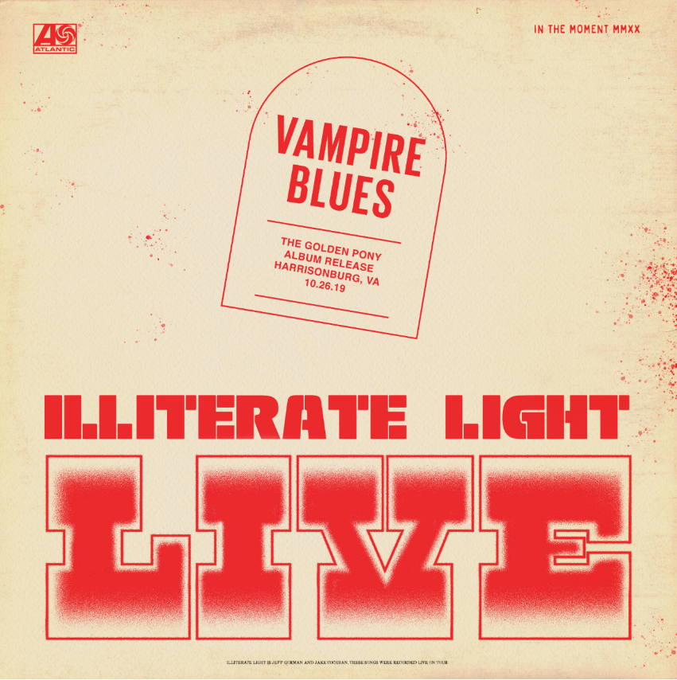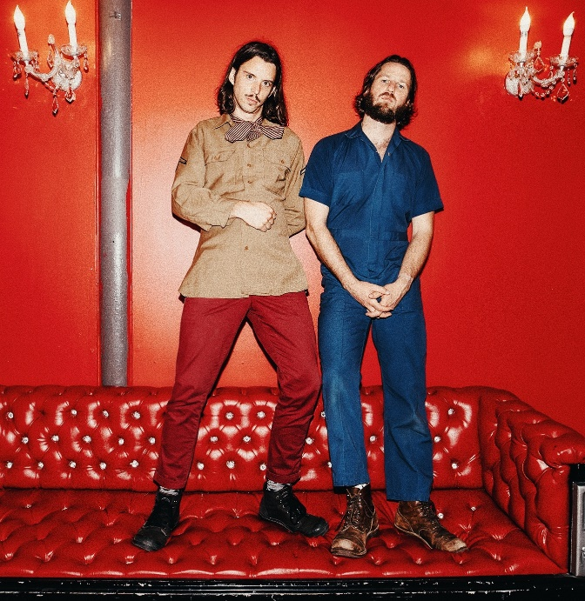
download hi-res artwork download hi-res press photo

Virginia indie rock duo Illiterate Light has released a live version of Neil Young’s “Vampire Blues,” recorded during a sold-out show at Harrisonburg, VA’s The Golden Pony in October. The show was one of two sold-out nights celebrating the release of the band’s self-titled debut album, out now on Atlantic Records (listen here).

Accompanied by a high-energy performance visual, today’s release marks the beginning of a live series called “In The Moment,” which the band will continue to build out with new recordings + videos from their can’t-miss live shows.

After sold-out shows this fall in Richmond and Harrisonburg, VA, the duo kicked off their proper North American headline tour at the end of January – already selling out rooms in Washington DC, Philadelphia, and Boston. Last week the band played to an enraptured crowd at Brooklyn’s Rough Trade, and performed live sessions for both Relix and Paste.

Later this month, the band will make a highly-anticipated stop at LA’s Moroccan Lounge (2/18), before culminating with a show on February 29th at The Basement in Nashville – tickets available here and full dates below. In addition to their headline tour, Illiterate Light will play a number of marquee festivals in 2020 – including Savannah Stopover, Firefly, and Osheaga, among others.

In January, the duo was named to NPR’s “Slingshot Artists to Watch,” with the outlet featuring them amongst just 12 other artists “sure to do big things in 2020.” NPR specifically highlighted the duo’s “energetic live shows,” during which the two play a full band’s worth of instruments. “This isn’t a gimmick,” KTBG The Bridge’s Jon Hart continued, “the music on the duo’s self-titled release holds up.” NPR previously highlighted the group in their “Best Songs of 2019 (So Far),” declaring “Carolina Lorelai” to be “an explosive mission statement from a band that’s here to stay.”

Illiterate Light’s current single “Better Than I Used To” also received accolades from NPR, which declared it “a perfect addition to your summertime playlist.” The music video for “Better Than I Used To” was premiered via Billboard, who called it “a visual that translates the euphoric, restorative powers of love into a reverent and downright hypnotic experience.” Currently climbing the Adult Alternative charts, the track cracked the Top 10 at the start of 2020.

This year’s headline tour follows heavy touring last year with Rainbow Kitten Surprise and The Head And The Heart – winning over crowds with their “hypnotic” (Billboard) performances and “electrifying” (Uproxx) stage presence. Despite being one of the festival’s earliest acts, they even received a standing ovation at Newport Folk Fest — “no small feat before noon” according to the Boston Globe.

All of this comes on the heels of Illiterate Light’s self-titled debut album, released in October via Atlantic Records. Upon release, Uproxx heralded the album as a “refined vein of My Morning Jacket / Band of Horses-style Americana.” Focused around the alchemic collaboration and camaraderie between members Jeff Gorman (lead vocals, guitar, synth pedals he plays with his feet) and Jake Cochran (vocal harmonies, stand-up drum kit) and recorded with producers Adrian Olsen (Foxygen, Natalie Prass) and Vance Powell (Jack White, Kings Of Leon, Chris Stapleton), the album is part soaring indie rock, part swirling psychedelia, part atmospheric folk and — alongside critically acclaimed performances this summer at Bonnaroo, Newport Folk Festival, and Lollapalooza — signals their triumphant arrival as an emergent musical force.

Illiterate Light – Tour Itinerary:
(tickets + add’l info: https://www.illiteratelight.com/)
Wed-Feb-05 Chicago, IL Schubas Tavern
Fri-Feb-07 Minneapolis, MN 7th Street Entry
Sat-Feb-08 Kansas City, MO Record Bar
Mon-Feb-10 Denver, CO Larimer Lounge
Tue-Feb-11 Salt Lake City, UT Kilby Court
Wed-Feb-12 Boise, ID Record Exchange [free]
Thu-Feb-13 Portland, OR Mississippi Studios
Sat-Feb-15 Seattle, WA Barboza
Mon-Feb-17 San Francisco, CA Café du Nord, Swedish-American Hall
Tue-Feb-18 Los Angeles, CA Moroccan Lounge
Thu-Feb-20 San Diego The Casbah
Fri-Feb-21 Phoenix, AZ Valley Bar
Sat-Feb-22 Tucson, AZ 191 Toole
Mon-Feb-24 Austin, TX Barracuda
Tue-Feb-25 Houston, TX White Oak Music Hall
Wed-Feb-26 Dallas, TX Three Links
Fri-Feb-28 Birmingham, AL Saturn
Sat-Feb-29 Nashville, TN The Basement East
Sat-Mar-7 Savannah, GA Savannah Stopover Music Festival
Fri-Mar-27 New Orleans, LA Hogs for the Cause Music Festival
Sat-Apr-25 Atlanta, GA Sweetwater 420 – Centennial Olympic Park
Jun-18-Jun-21 Dover, DE Firefly Music Festival [daily schedule not yet announced]
Thu-Jul-23 Floyd, VA Floydfest
Fri-Jul-24 Floyd, VA Floydfest
Fri-Jul-31 Montreal, QC Osheaga Music Festival

CONNECT WITH ILLITERATE LIGHT
Facebook | Instagram | Twitter | Official Site

PRESS CONTACT:
Libby Kober | Libby.Kober@AtlanticRecords.com

