FOR IMMEDIATE RELEASE

AUGUST 29, 2019

**James Blunt goes back to basics for new album *Once Upon A Mind***

**Multi-GRAMMY nominated & multi-platinum singer/songwriter’s**

**new single “Cold” + album pre-order available now**

**Once Upon A Mind arrives October 25th via Custard/Atlantic Records**

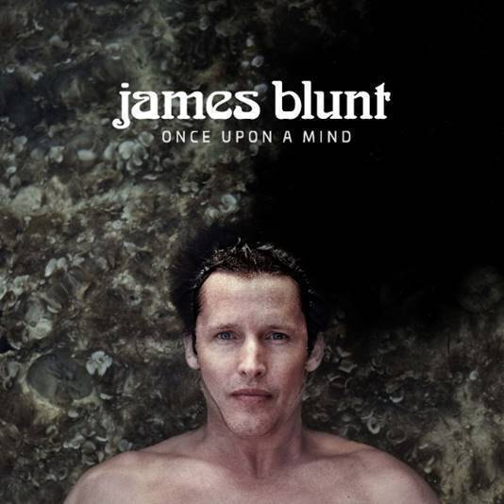

**POST/STREAM “COLD”:** [LINK](https://nam04.safelinks.protection.outlook.com/?url=https%3A%2F%2Fwww.youtube.com%2Fwatch%3Fv%3D6--sRjqlRaw&data=02%7C01%7CBrian.Sommer%40atlanticrecords.com%7Ca94cce2d047c45a46a7c08d72c86bdda%7C8367939002ec4ba1ad3d69da3fdd637e%7C0%7C0%7C637026829524609665&sdata=OknJh%2FQ9Sn0nO%2FTL%2BAvJCBoko5tiFao4YO3Nle5AfLw%3D&reserved=0)

**PRE-ORDER *ONCE UPON A MIND*:** [LINK](https://nam04.safelinks.protection.outlook.com/?url=https%3A%2F%2Flnk.to%2FOnceUponAMind&data=02%7C01%7CBrian.Sommer%40atlanticrecords.com%7Ca94cce2d047c45a46a7c08d72c86bdda%7C8367939002ec4ba1ad3d69da3fdd637e%7C0%7C0%7C637026829524609665&sdata=FG3GNg23dni%2FUON6EViN8b9k%2BAhoXZBVnMPpawQQKPg%3D&reserved=0)

Multi-GRAMMY nominated and multi-platinum British singer/songwriter **James Blunt** has announced his sixth studio album ***Once Upon A Mind***, arriving October 25th and preceded today by new single “**Cold**” – available now via **Custard**/**Atlantic Records**. After flirting with electronica on his last album (2017’s ***The Afterlove****)*, Blunt returns to what he does best on ***Once Upon A Mind***, writing classic songs that touch both the heart and the head.

***Once Upon A Mind*** sees Blunt collaborating with a variety of producers such as **Steve Robson**, **Jimmy Hogarth** and **TMS** – resulting in a freshness that resonates throughout the eleven-song collection, with highlights including the poignant ballad “**Monsters**,” pop-infused “**5 Miles**” and the country tinged “**Halfway**.” The album’s first taste arrives in the shape of the breezy first single “**Cold**,” an effervescent modern spin on love.

*“I think this is the most honest album I have ever made”* said Blunt. *“’****Back To Bedlam****’ was similar in that I had been writing those songs for a while about my life experiences at that time, and they came together on my debut.  And every song on this album represents something that I’m currently going through or have recently experienced. It’s a very personal record, and I’m proud I can share it.”*

Blunt first captured the world’s attention in 2005 with his 3x RIAA platinum-certified debut, ***Back To Bedlam***, and its history-making 4x platinum-certified #1 single “**You’re Beautiful**.” The British tunesmith has since become one of the most popular singer/songwriters of the modern era, with total album sales now in excess of 23 million worldwide. He has also been the recipient of a remarkable range of top honors, including five GRAMMY nominations, two BRIT Awards, two Ivor Novello Awards (honoring British music and songwriters), and a host of MTV awards. Blunt has also earned viral acclaim for his hugely popular and extremely witty Twitter account, boasting over 1.8 million followers and growing ([@jamesblunt](https://nam04.safelinks.protection.outlook.com/?url=https%3A%2F%2Ftwitter.com%2FJamesBlunt&data=02%7C01%7CBrian.Sommer%40atlanticrecords.com%7Ca94cce2d047c45a46a7c08d72c86bdda%7C8367939002ec4ba1ad3d69da3fdd637e%7C0%7C0%7C637026829524619665&sdata=PQHnT4M5sOtjafuC8v0jOsUq8XOJy55yV6rCTFjN%2FYM%3D&reserved=0)). 2020 will also see the announce of a UK headline tour, Blunt’s first since performing on the North American leg of **Ed Sheeran**’s ***÷ Tour*** and international headline run in 2017.

***Once Upon A Mind***

(Custard/Atlantic Records)

1. The Truth

2. Cold

3. Champions

4. Monsters

5. Youngster

6. 5 Miles

7. How It Feels To Be Alive

8. I Told You

9. Halfway

10. Stop The Clock

11. The Greatest

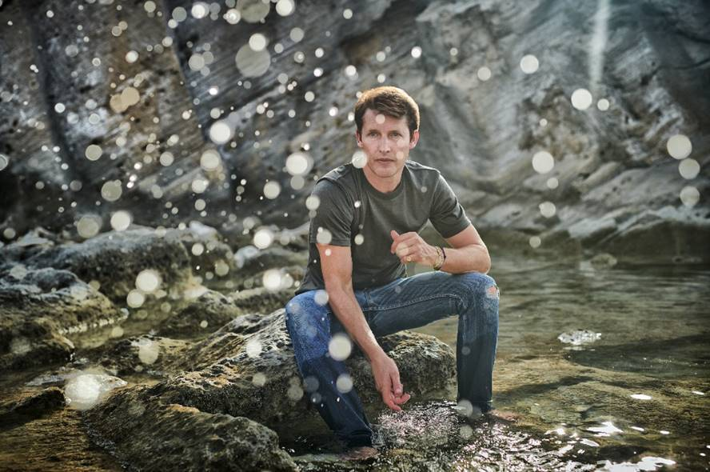

[DOWNLOAD HIGH-RES PRESS IMAGES](https://nam04.safelinks.protection.outlook.com/?url=http%3A%2F%2Fpress.atlanticrecords.com%2Fjames-blunt%2F&data=02%7C01%7CBrian.Sommer%40atlanticrecords.com%7Ca94cce2d047c45a46a7c08d72c86bdda%7C8367939002ec4ba1ad3d69da3fdd637e%7C0%7C0%7C637026829524629663&sdata=61CyYrUiVwFC%2F7SouqmkVHIhXygFY1MC3WO9fKdC%2FFM%3D&reserved=0)

**CONNECT:**

[WEBSITE](https://nam04.safelinks.protection.outlook.com/?url=http%3A%2F%2Fwww.jamesblunt.com%2F&data=02%7C01%7CBrian.Sommer%40atlanticrecords.com%7Ca94cce2d047c45a46a7c08d72c86bdda%7C8367939002ec4ba1ad3d69da3fdd637e%7C0%7C0%7C637026829524629663&sdata=O1QfweCOO52x8uNyUh1CdN4VEjfnIenBDPkCiUqmzac%3D&reserved=0) | [FACEBOOK](https://nam04.safelinks.protection.outlook.com/?url=https%3A%2F%2Fwww.facebook.com%2Fjamesblunt&data=02%7C01%7CBrian.Sommer%40atlanticrecords.com%7Ca94cce2d047c45a46a7c08d72c86bdda%7C8367939002ec4ba1ad3d69da3fdd637e%7C0%7C0%7C637026829524639655&sdata=En8HUk6ykAQy4RMW8E8B4r3TglEDgL%2FVDIn314zjgIM%3D&reserved=0) | [TWITTER](https://nam04.safelinks.protection.outlook.com/?url=https%3A%2F%2Ftwitter.com%2FJamesBlunt&data=02%7C01%7CBrian.Sommer%40atlanticrecords.com%7Ca94cce2d047c45a46a7c08d72c86bdda%7C8367939002ec4ba1ad3d69da3fdd637e%7C0%7C0%7C637026829524649652&sdata=D8S8D8ogQerR7AyGVc9CPa%2BQDlK1sw3jNX7aCc1gVxI%3D&reserved=0) | [INSTAGRAM](https://nam04.safelinks.protection.outlook.com/?url=http%3A%2F%2Finstagram.com%2Fjamesblunt&data=02%7C01%7CBrian.Sommer%40atlanticrecords.com%7Ca94cce2d047c45a46a7c08d72c86bdda%7C8367939002ec4ba1ad3d69da3fdd637e%7C0%7C0%7C637026829524649652&sdata=FIbsZiNcReKrJFcQPle77d8wcqPmY7bsX9FvPOCaGDY%3D&reserved=0) | [YOUTUBE](https://nam04.safelinks.protection.outlook.com/?url=http%3A%2F%2Fwww.youtube.com%2Fuser%2Fjamesbluntmusic&data=02%7C01%7CBrian.Sommer%40atlanticrecords.com%7Ca94cce2d047c45a46a7c08d72c86bdda%7C8367939002ec4ba1ad3d69da3fdd637e%7C0%7C0%7C637026829524659644&sdata=ocpv89UEaszsDFvZMsUfWfOGpKbTP%2FUdTTDQqdhnDLw%3D&reserved=0) | [ASSETS](https://nam04.safelinks.protection.outlook.com/?url=http%3A%2F%2Fpress.atlanticrecords.com%2Fjames-blunt%2F&data=02%7C01%7CBrian.Sommer%40atlanticrecords.com%7Ca94cce2d047c45a46a7c08d72c86bdda%7C8367939002ec4ba1ad3d69da3fdd637e%7C0%7C0%7C637026829524659644&sdata=D3IZDoS1SKm4H8yDPYAh0dbfOd266ynnUKYKLhygq%2F4%3D&reserved=0)

**CONTACT:**

Sheila Richman | [Sheila.Richman@atlanticrecords.com](mailto:Sheila.Richman@atlanticrecords.com)

Ted Sullivan | [Ted.Sullivan@atlanticrecords.com](mailto:Ted.Sullivan@atlanticrecords.com)