JASMINE THOMPSON IS “happy for you”

NEW SONG AND OFFICIAL COMPANION VIDEO PREMIERE TODAY

LISTEN to “happy for you” HERE | WATCH OFFICIAL MUSIC VIDEO HERE

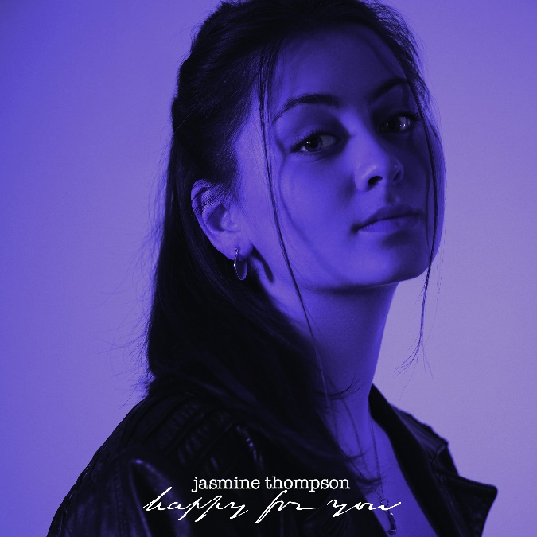
DOWNLOAD PRESS PHOTOS HERE

London-based singer-songwriter Jasmine Thompson has announced today’s premiere of her joyful new single. Written by Ingrid Andress and AJ Pruis “happy for you” is available now via Atlantic Records at all DSPs and streaming services HERE; an official companion video directed by Melody Maker is streaming now via YouTube HERE.

“happy for you” was heralded earlier this summer by “already there,” available now at all digital platforms HERE; an official music video is streaming now via YouTube HERE. Produced by TMS (Lewis Capaldi) and co-written with Kristin Carpenter (Greyson Chance, Nasty Cherry, NOTD), Maddie Eliasson, Sebastian Daniel (Matoma, Afrojack), Michael Pollack (Celine Dion, Kelly Clarkson, Maroon 5) and TMS, the track was met by critical applause from a wide range of media outlets:

“Jasmine Thompson returns with ‘already there,’ a quiet and nostalgic track. More to the nostalgic for the artist, however, who reminisces on a romance struck up with a stranger at a bar, turning into a fond relationship. It subscribes to the recent fervor for songs with more narrative detail and vivid storylines, which when paired with Thompson’s airy, mesmerizing voice, evokes the necessary emotion as well.”
– V Magazine

“Radiant and intimate all at once…A sweet song of fresh starts, rediscovering yourself, and falling in love all over again, Jasmine Thompson’s latest single is a heartfelt outpouring of vulnerability and self-expression…Unassuming yet deeply personal, it’s a brief diary-like dive into the artist’s inner sanctum.”
– Atwood Magazine

“‘already there’ showcases Jasmine’s incredible maturity as an artist as well as her ability to write heartfelt and emotive lyrics. The track embraces the singer-songwriter’s heavenly vocals and reminds us that she continues to evolve as an artist with each release.”
– CelebMix

# # #

Jasmine’s booming YouTube presence and captivating vocals helped lead to a major label deal with Atlantic Records at the age of just 13. Now 20, the London-based singer-songwriter has enjoyed a musical growth that’s taken her from viral covers to her own WONDERLAND and COLOUR EPs. Since then, Thompson has become even more beloved, earning more than 3B global streams and over 5M monthly Spotify listeners worldwide. Her blockbuster YouTube channel has also grown by leaps and bounds, accruing over 674M YouTube views and more than 3.62M subscribers thus far.

Along with her acclaimed solo work, Thompson has made chart-topping appearances on a pair of global blockbuster hit singles. Her collaboration with German DJ/producer Robin Schulz on “Sun Goes Down (Feat. Jasmine Thompson)” earned 1 billion worldwide streams along with a slew of international gold and platinum certifications and Top 5 and Top 10 chart runs in Europe, Australia, and South America. German DJ Felix Jaehn’s billion-streaming “Ain’t Nobody (Loves Me Better)” remix was an even greater smash, ascending to the top 10 on the iTunes Store’s “Top Dance Songs” chart while earned gold and platinum certifications in a range of countries.

More recently, 2020 saw Thompson teaming with GRAMMY® award-winning artist/DJ/producer Zedd for the hit single, “Funny.” Having earned nearly 200M global streams so far, “Funny” is available at all DSPs and streaming services HERE; an official companion video is steaming via YouTube HERE.

# # #

CONNECT WITH JASMINE THOMPSON
JASMINETHOMPSONMUSIC.COM
TWITTER
YOUTUBE
FACEBOOK
INSTAGRAM
ATLANTIC RECORDS

# # #

FOR MORE INFORMATION, PLEASE CONTACT:
Christina Kotsamanidis
Christina.Kotsamanidis@atlanticrecords.com

