JASMINE THOMPSON TEAMS WITH CALUM SCOTT
FOR “love is just a word”

HEARTFELT NEW SINGLE AND OFFICIAL VIDEO PREMIERE TODAY

LISTEN TO “love is just a word” HERE | WATCH OFFICIAL MUSIC VIDEO HERE

(DOWNLOAD HI-RES COVER ART // DOWNLOAD PRESS PHOTOS)

Atlantic recording artist Jasmine Thompson has joined forces with multi-platinum-selling, chart-topping UK singer-songwriter Calum Scott for a heartfelt new single. The soaring, piano driven duet shows off their shining vocals and harmonies while telling a story of love that’s at its most meaningful when they’re together. “love is just a word” premieres today at all DSPs and streaming services, joined by an official music video directed by Jackson Ducasse (Dua Lipa, New Order) and streaming now at YouTube HERE. The accompanying live acoustic video reflects their love of singing live and underscores the song’s raw emotion.

“I went to Wales to work with the producer Jon Maguire, and I remember having the opening lyric in my head,” says Thompson. “We spent two days working together, and managed to make something we were both super proud of. A few months after the session, totally out of the blue, Jon messaged me with an updated version including Calum! It was so magical hearing his voice on it, and I felt so honoured that he wanted to be a part of the song – it immediately felt like the missing link. We had such a laugh, I couldn't keep a straight face while recording, Jon had to stick us in separate rooms but that voice… magical. The song was inspired by slow dancing around my kitchen during lockdown, and it felt like I was hearing these love songs from my childhood with fresh ears and I really wanted to capture how they made me feel.”

“My producer and I were about to sit down and finish a song that we had written for my album when he mentioned a demo he wanted to play me that he had written with Jasmine,” says Scott. “As a big fan of her work already, we sat and listened and as soon as the demo ended, I told him I wanted to help them finish it and be part of it somehow! I love the simplicity of the lyrics but using iconic love songs to imagine how they would be without the key ingredient of love was what really pulled me in. I’m a huge fan of Jasmine’s voice, her songwriting and her energy so to not only to work but to duet with her has been truly amazing.”

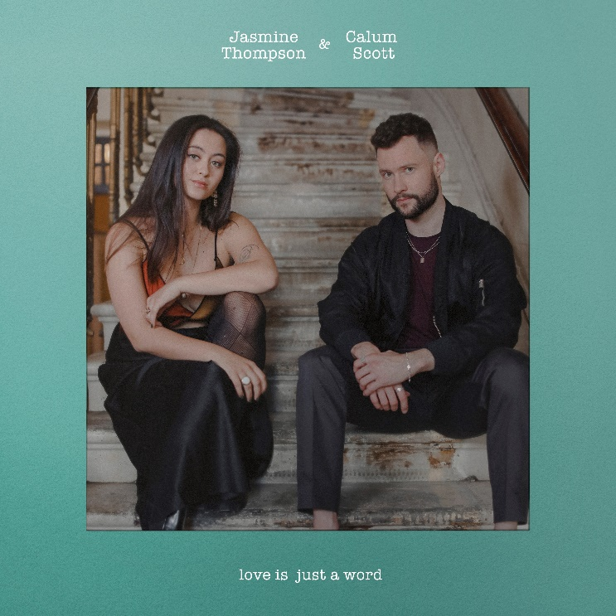

Co-written by Thompson, Scott, and Jon Maguire (James Bay, Liam Payne, Rita Ora), “love is just a word” marks the latest in a series of singles from Thompson, including the recently released “after goodbye,” is available now at all DSPs and streaming services HERE; an official companion video – directed by acclaimed visual artist/director/photographer Melody Maker – is streaming now via YouTube HERE. “‘after goodbye’ is the ultimate breakup song,” enthused The Honey Pop. “Jasmine’s delicate song doesn’t need to have lots of complex orchestration. The guitar hums softly and the voice comes along in magnificent harmony.”

“after goodbye” was in turn preceded by the joyful “happy for you,” available now at all DSPs and streaming services HERE. Hailed by Flaunt as “a breakup song that will have you appreciating the highs and lows of a relationship,” the track is accompanied by an official music video directed by Melody Maker and streaming now via YouTube HERE.

Thompson kicked off the summer with the acclaimed single, “already there,” available now at all digital platforms HERE; an official music video is streaming now via YouTube HERE. Produced by TMS (Lewis Capaldi) and co-written with Kristin Carpenter (Greyson Chance, Nasty Cherry, NOTD), Maddie Eliasson, Sebastian Daniel (Matoma, Afrojack), Michael Pollack (Celine Dion, Kelly Clarkson, Maroon 5) and TMS, the track was met by critical applause from a wide range of media outlets:

“Jasmine Thompson returns with ‘already there,’ a quiet and nostalgic track. More to the nostalgic for the artist, however, who reminisces on a romance struck up with a stranger at a bar, turning into a fond relationship. It subscribes to the recent fervor for songs with more narrative detail and vivid storylines, which when paired with Thompson’s airy, mesmerizing voice, evokes the necessary emotion as well.”
– V Magazine

“Radiant and intimate all at once…A sweet song of fresh starts, rediscovering yourself, and falling in love all over again, Jasmine Thompson’s latest single is a heartfelt outpouring of vulnerability and self-expression…Unassuming yet deeply personal, it’s a brief diary-like dive into the artist’s inner sanctum.”
– Atwood Magazine

“‘already there’ showcases Jasmine’s incredible maturity as an artist as well as her ability to write heartfelt and emotive lyrics. The track embraces the singer-songwriter’s heavenly vocals and reminds us that she continues to evolve as an artist with each release.”
– CelebMix

# # #

ABOUT JASMINE THOMPSON
Jasmine’s booming YouTube presence and captivating vocals helped lead to a major label deal with Atlantic Records at the age of just 13. Now 20, the London-based singer-songwriter has enjoyed a musical growth that’s taken her from viral covers to her own WONDERLAND and COLOUR EPs. Since then, Thompson has become even more beloved, earning more than 3B global streams and over 5M monthly Spotify listeners worldwide. Her blockbuster YouTube channel has also grown by leaps and bounds, accruing over 680M YouTube views and more than 3.6M subscribers thus far. Along with her acclaimed solo work, Thompson has made chart-topping appearances on a pair of global blockbuster hit singles. Her collaboration with German DJ/producer Robin Schulz on “Sun Goes Down (Feat. Jasmine Thompson)” earned 1B worldwide streams along with a slew of international gold and platinum certifications and Top 5 and Top 10 chart runs in Europe, Australia, and South America. German DJ Felix Jaehn’s billion-streaming “Ain’t Nobody (Loves Me Better)” remix was an even greater smash, ascending to the top 10 on the iTunes Store’s “Top Dance Songs” chart while earning gold and platinum certifications in a range of countries. More recently, 2020 saw Thompson teaming with GRAMMY® award-winning artist/DJ/producer Zedd for the hit single, “Funny,” available now at all DSPs and streaming services HERE. Currently boasting over 215M global streams to date, the track is joined by an official companion video streaming now via YouTube HERE.

ABOUT CALUM SCOTT
With the arrival of his 2018 debut album Only Human, U.K.-based singer/songwriter Calum Scott landed at No. 1 on the iTunes album chart in over 20 countries around the world, in addition to selling more than 3.6 million in adjusted album sales and amassing over 7.5 billion total global streams and counting. Now certified platinum or gold in 21 countries, Only Human includes his platinum-selling smash “You Are The Reason,” a track that cracked the top 25 on Spotify’s US Viral 50 and hit the top 10 on iTunes single charts in 38 countries. The album also features Calum’s stripped-back, platinum-certified cover of Robyn’s “Dancing On My Own,” which earned a Brit Award nomination in the category of Best British Single. Calum released his first new music since Only Human, in June with the track “Biblical” which marked an exciting evolution of his artistry, bringing even more raw emotion to his soulful and timeless sound. The piano-laced ballad is the first song released from his highly anticipated sophomore album, due out in early 2022. Calum’s new single “Rise,” offers exactly the kind of reassurance needed in difficult times. As the song unfolds in a joyful and majestic sound , Calum delivers a spirited vocal performance that perfectly captures the uplifting message at the heart of the song. Calum also features on Lost Frequencies new track, “Where Are You Now” which has already amassed over 80 million global streams. Over the last few years, his songs have appeared on countless TV shows (including “American Idol,” “The Voice,” “So You Think You Can Dance,” “Grey’s Anatomy,” and many more), while Calum has performed on such shows as “Late Night with Seth Meyers,” “Ellen,” “Good Morning America,” “Live with Kelly and Ryan,” “Dancing With The Stars,” and “The TODAY Show” among others. In addition, he’s garnered acclaim from outlets including Billboard (who hailed his “stunningly pure voice”), The Huffington Post (who stated that “Scott makes an impressive splash…compelling”), and Ones to Watch (who noted that Calum’s music “elegantly transforms pain into beauty”).

CONNECT WITH JASMINE THOMPSON
WEBSITE | TWITTER | YOUTUBE | FACEBOOK | INSTAGRAM
ATLANTIC RECORDS

# # #
FOR MORE INFORMATION, PLEASE CONTACT:
Christina Kotsamanidis
Christina.Kotsamanidis@atlanticrecords.com

