JOSIE DUNNE UNVEILS LATE TEENS/EARLY TWENTIES EP

INCLUDING MOVING NEW SINGLE & AT-HOME VIDEO FOR “LOST”
WATCH HERE

LATE TEENS/EARLY TWENTIES ARRIVES TODAY AT ALL DSPS AND STREAMING SERVICES
STREAMING HERE NOW

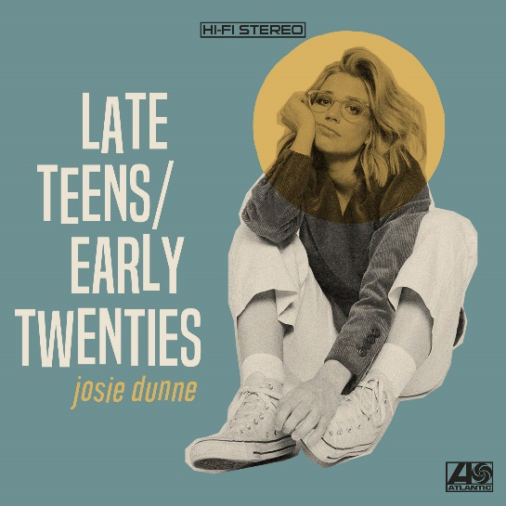

Acclaimed singer-songwriter Josie Dunne has announced today’s release of her eagerly anticipated new EP. LATE TEENS/EARLY TWENTIES is available now via Atlantic Records at all DSPs and streaming services.

LATE TEENS/EARLY TWENTIES is highlighted by the moving new single, “Lost,” joined today by an at-home video streaming HERE now at the Nashville-based artist’s official YouTube channel. The video directed by Joey Brodnax practices social distancing and was filmed from the comfort of Josie’s home.

“You’re hearing me grow up – the real growth spurt,” the singer says of the unique blend of soul-infused pop found on LATE TEENS/EARLY TWENTIES. “You’re seeing me learn these lessons for the first time.”

Along with “Lost,” LATE TEENS/EARLY TWENTIES features a number of previously released tracks – including “Back To It,” “Ooh La La,” “Mute,” “Same,” and “Stay The Way I Left You (Feat. Dahl)“ – all of which are available now for streaming and download. ”Back To It“ premiered earlier this year, accompanied by an inventive official video streaming HERE; an exclusive behind-the-scenes look at the making of the clip can be viewed HERE.

“Stay The Way I Left You (Feat. Dahl)“ also arrived alongside a delightful video, streaming now via YouTube HERE, as did “Ooh La La,” streaming now HERE. “The warm, summery colors and excessive dancing may seem cheery on the surface, but don’t let it fool you,” wrote Billboard in its exclusive “Ooh La La” video premiere, “With Dunne’s quirky humor, it’s a charming display of the singer’s charisma and her ability to move on.”

“Mute“ arrived with its own video, streaming HERE. The track was hailed as “a quirky make-out anthem” in its exclusive Atwood Magazine video premiere, “a passionate and fun embrace of intimacy full of love, lust, and Dunne’s charismatic nerdy charm…A groovy, feel-good pop song with jamming vibes and infectious melodies, ‘Mute’ is a sweet n’ savory PG outpouring of desire – leaving much to the imagination, Dunne captures the urgency of lust while toying with candid wordplay and clever poetry.”

“Same“ is accompanied by an official video streaming HERE following its exclusive premiere via Refinery 29, which wrote, ““Same” plays with love song conventions while also infusing some fun into the “wish I could tell you how I feel” sentiment that so many musicians have tackled before… Dunne’s new music video for the track will bring you back to the days of not quite knowing how to spell out your deepest feelings to your crush.”

Dunne – who has earned applause for a recent string of festival appearances and support runs alongside such artists as Ben Rector, Andy Grammer, and Julia Michaels – hopes to introduce fans to the songs of LATE TEENS/EARLY TWENTIES with a wide-ranging North American tour, to be announced shortly. For complete details, please see www.josiedunne.com.

“Harnessing the raw honesty and emotion of soul music and a catchy pop beat, Josie Dunne seamlessly combines her two favorite genres.”
-FLAUNT Magazine

“The hook-laden track, with its sultry calypso vibe and Dunne’s captivating vocal performance, is of the sort that gets stuck in your head in a matter of moments.”
-BLACKBOOK Magazine

“The delicate nature of the song echoes the tentative feeling of taking that big step to share those three important little words. This alternate version of the song showcases a more wistful sentiment than the original and underscores Dunne’s lovely vocals.”
-PARADE Magazine

For more, please visit JOSIEDUNNE.COM
INSTAGRAM * YOUTUBE * FACEBOOK * TWITTER

JOSIE DUNNE
LATE TEENS/EARLY TWENTIES
(Atlantic Records)

TRACKLISTING
Ooh La La
Same
Stay The Way I Left You (Feat. Dahl)
Mute
Back To It
Lost

# # #

CONTACT:
CHRISTINA KOTSAMANIDIS | CHRISTINA.KOTSAMANIDIS@ATLANTICRECORDS.COM
TRISH MOLLO | TRISH.MOLLO@ATLANTICRECORDS.COM

