FOR IMMEDIATE RELEASE
SEPTEMBER 13, 2019

JAKE TROTH ARRIVES WITH IT IS AS IF

ACCLAIMED SINGER/SONGWRITER/PRODUCER UNVEILS DEBUT ALBUM,
CO-PRODUCED BY GRAMMY® AWARD-WINNER DAVE COBB

SOFAR SOUNDS TOUR BEGINS OCTOBER 16TH IN TORONTO

IT IS AS IF AVAILABLE EVERYWHERE TODAY

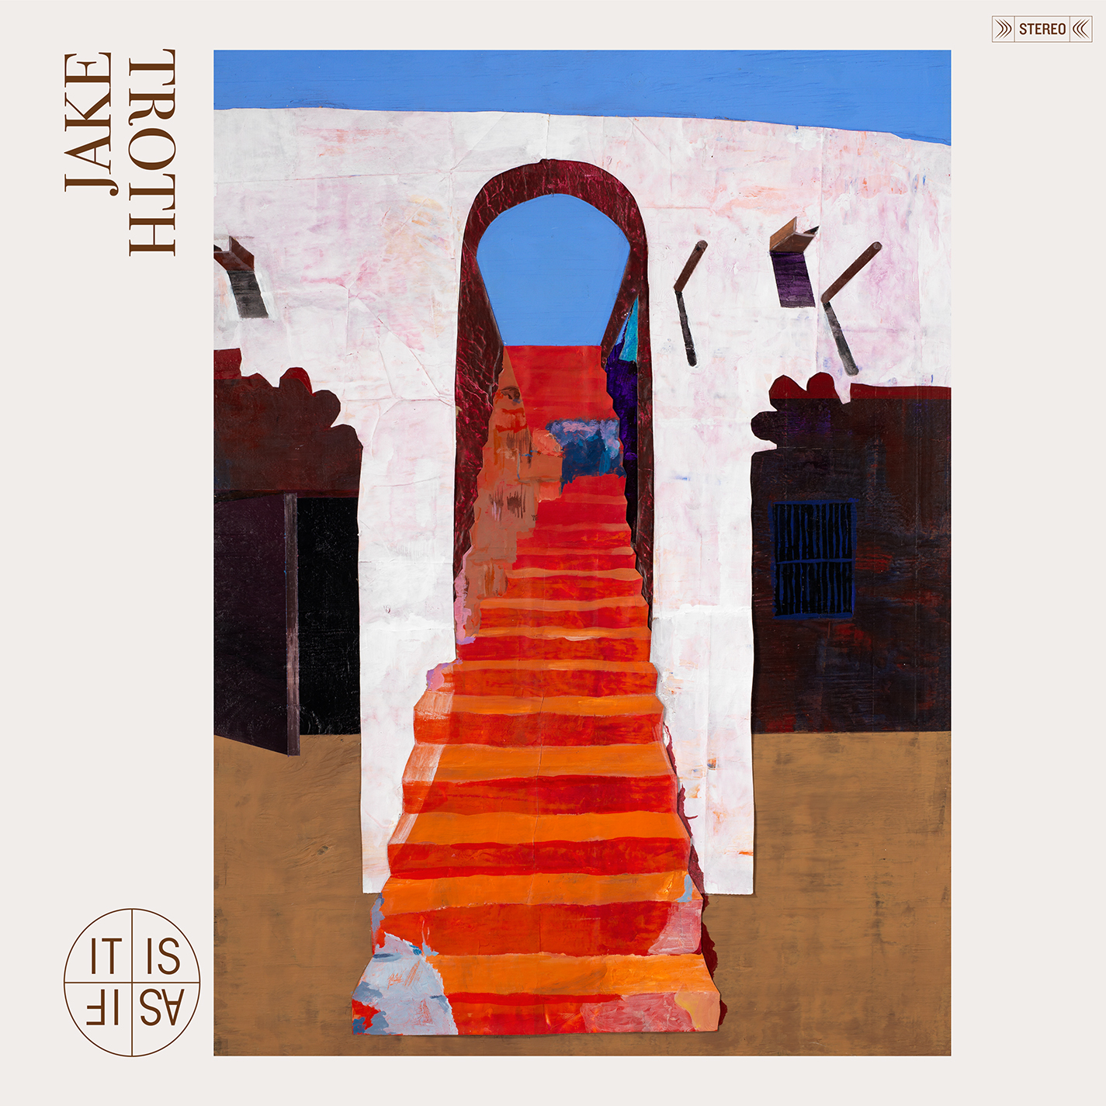

Atlantic Records has announced today’s release of the eagerly awaited debut album from singer-songwriter Jake Troth. IT IS AS IF is available now for streaming and download HERE

IT IS AS IF is heralded by recently released singles, “Open Door,” “Alive and Well” and “The Queen.” Both “Open Door” and “Alive and Well” are joined by companion videos, while “The Queen” is joined by a lyric video, all streaming now via Troth’s official YouTube channel HERE. The latter had its exclusive premiere last month via Ones To Watch, which declared, “As someone who has always appreciated the beauty in simplicity, Troth crafts raw music that can be just as powerful and moving sung acapella as with instruments. His latest and greatest is an honest tune titled ‘Alive and Well,’ which sees Troth struggling with his inner self as he transitions from his lowest points to some of his best moments.”

Troth will celebrate IT IS AS IF with a very special North American concert tour. Jake’s Sofar Sounds tour begins October 16th in Toronto, ON with more dates to be added shortly – for complete details and ticket information, please visit www.jaketroth.com.

Jake Troth has spent years penning massive pop singles for some of music’s biggest names, including Lizzo, Kehlani, Sia, Big Boi, and many more. Still, the Davidson, NC-born and now Nashville-based singer/songwriter/producer/guitarist yearned to connect to his own work on a deeper and more personal level. Produced by GRAMMY® Award-winner Dave Cobb (Sturgill Simpson, Brandi Carlile, Chris Stapleton) and Troth at Nashville’s famed RCA Studio A, IT IS AS IF reveals a sweet and succinct new musical approach, anchored by remarkably refined melodies and deft lyrical observations. Written over the course of two solitary weeks in a Woodstock, NY cabin, songs like “Open Door” are both compelling and instantly familiar, their acoustic intimacy and spare atmosphere only serving to amplify the elemental power of Troth’s contemplative, soft-spoken songcraft. An accomplished visual artist as well as musician, Troth hand painted the striking IT IS AS IF cover art, as well as the single art.

"When I walk around the world, I see all the materials temporarily here like gas station snacks, fashion billboards, luxury condos and people still driving Hummers...but sometimes I get lucky and the evergreens catch my senses,” Troth says. “Making this album was an act of planting a redwood in your back yard. I believe one day it will provide shade and refuge for your experiences with love, loss, and loving again. I'm not nervous or afraid for you to hear it; I'm scared you won't! It's been a pleasure bringing it here to fruition for you. Please enjoy! With warmth, Jake"

JAKE TROTH
SOFAR SOUNDS TOUR 2019

OCTOBER
16 - Toronto, ON
18 - New York, NY
19 - Philadelphia, PA
20 - Washington, DC
22 - Indianapolis, IN
25 - Chicago, IL
26 – Kansas City, MO
29 - Denver, CO

NOVEMBER
2 - Portland, OR
3 - Vancouver, BC
4 - Seattle, WA
6 - San Francisco, CA
7 - Los Angeles, CA
10 - Atlanta, GA
11 - Charlotte, NC
12 - Nashville, TN

# # #

CONNECT WITH JAKE TROTH
OFFICIAL
TWITTER
FACEBOOK
INSTAGRAM
YOUTUBE

Contact Information:
Christina Kotsamanidis
212.707.2241
Christina.Kotsamanidis@atlanticrecords.com

