FOR IMMEDIATE RELEASE
SEPTEMBER 10, 2021

James Blunt Strikes Gold With New Track ‘Love Under Pressure’

Co-Written with Jack Savoretti, Taken from his upcoming Hits album
The Stars Beneath My Feet (2004-2021) Out November 19th
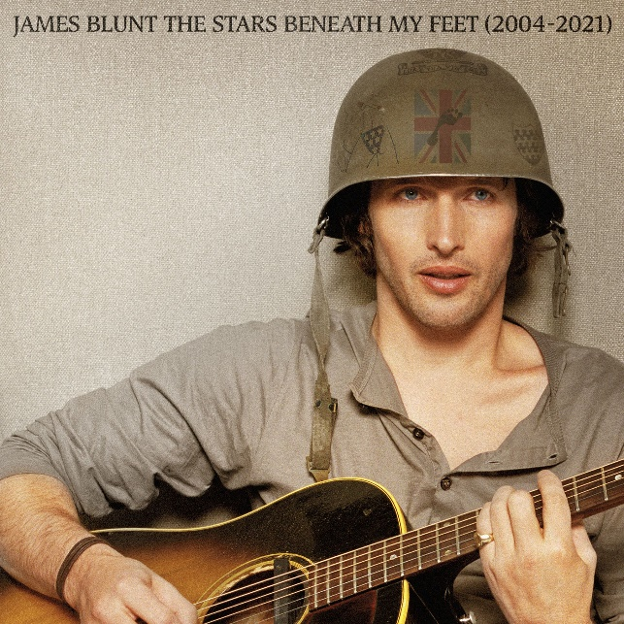

STREAM “LOVE UNDER PRESSURE”: https://jamesblunt.lnk.to/Love-Under-Pressure
ALBUM PRE-ORDER: http://jamesblunt.lnk.to/Stars-Beneath-My-Feet

James Blunt delivers more magic with the release of his stellar new song “Love Under Pressure” - one of four new tracks taken from his forthcoming greatest hits album, The Stars Beneath My Feet (2004-2021) - out November 19th on Atlantic Records.

Written with Jack Savoretti, and produced by LA songwriting duo Afterhrs (One Direction, Maroon 5), “Love Under Pressure” is James at his finest - featuring an infectious piano driven hook from the start, a powerful vocal performance and a hypnotic beat fit for any dancefloor.
James reflects; 'Earlier this year during lockdown, I was lucky enough to have a Zoom writing session with the very talented Jack Savoretti. We had never worked together before, but our managers thought it might be a good idea to get us together to do some writing. I’m very pleased we did. Not only is Jack a great guy, but we wrote a banger of a single!”
James also recently announced a nine date UK arena tour for 2022 which will see him celebrate songs spanning a 17-year career that has spawned over 23 million album sales, a global smash hit with “You’re Beautiful,” two Brit Awards and two Ivor Novello Awards, as well as receiving five Grammy Award nominations.
Amongst the string of hit singles, The Stars Beneath My Feet (2004-2021) will include four new songs (“Love Under Pressure,” “Unstoppable,” “Adrenaline” & “I Came For Love”), as well as four exclusive live performances from around the world, including the Glastonbury Festival. It also features stunning tracks from his latest Gold-selling album Once Upon A Mind, including “Cold,” and the heartbreaking ballad for his father, “Monster.”

James’ classic 2004 debut album Back To Bedlam, was recently named as one of the top ten best selling albums of that decade, and with Once Upon A Mind, James Blunt reinforced his reputation for writing honest, emotional songs that people can easily relate to. The album marked a return to what James Blunt does best – writing classic songs that touch both the heart and the head. Another side of James - his wit and charm - have in recent times been showcased via his always engaging Twitter account.

James Blunt 2022 UK arena dates:
Feb 3rd – BRIGHTON, Brighton Centre
Feb 4th – MANCHESTER, AO Arena
Feb 5th – LONDON, SSE Wembley Arena
Feb 7th – CARDIFF, Motorpoint Arena
Feb 8th – HULL, Bonus Arena
Feb 10th – BIRMINGHAM, Resort World
Feb 11th – LEEDS, First Direct Arena
Feb 12th – NOTTINGHAM, Motorpoint Arena
Feb 13th – GLASGOW, SEC Armadillo

The Stars Beneath My Feet (2004-2021)
1. Love Under Pressure
2. 1973
3. Wisemen
4. Same Mistake
5. You’re Beautiful
6. Monsters
7. Tears And Rain
8. Bonfire Heart
9. I Really Want You (live in New York)
10. The Truth
11. Heart To Heart
12. Champions
13. Postcards
14. No Bravery (live in London)
15. Adrenaline
16. Smoke Signals
17. Unstoppable
18. Goodbye My Lover
19. Coz I Love You (live at Glastonbury)
20. So Long, Jimmy
21. Carry You Home
22. The Greatest
23. High
24. Don’t Give Me Those Eyes
25. OK
26. Stay The Night
27. Bartender
28. Cold
29. Where Is My Mind? (live in Paris)
30. I Came For Love
CONNECT:
WEBSITE | FACEBOOK | TWITTER | INSTAGRAM | YOUTUBE | ASSETS

CONTACT:
Sheila Richman | Sheila.Richman@atlanticrecords.com
Ted Sullivan | Ted.Sullivan@atlanticrecords.com

