FOR IMMEDIATE RELEASE
SEPTEMBER 20, 2021

JAMES BLUNT RELEASES VIDEO FOR NEW SMASH SINGLE “LOVE UNDER PRESSURE”
CO-WRITTEN WITH JACK SAVORETTI & TAKEN FROM HIS UPCOMING BEST OF ALBUM
THE STARS BENEATH MY FEET (2004-2021) OUT NOVEMBER 19TH

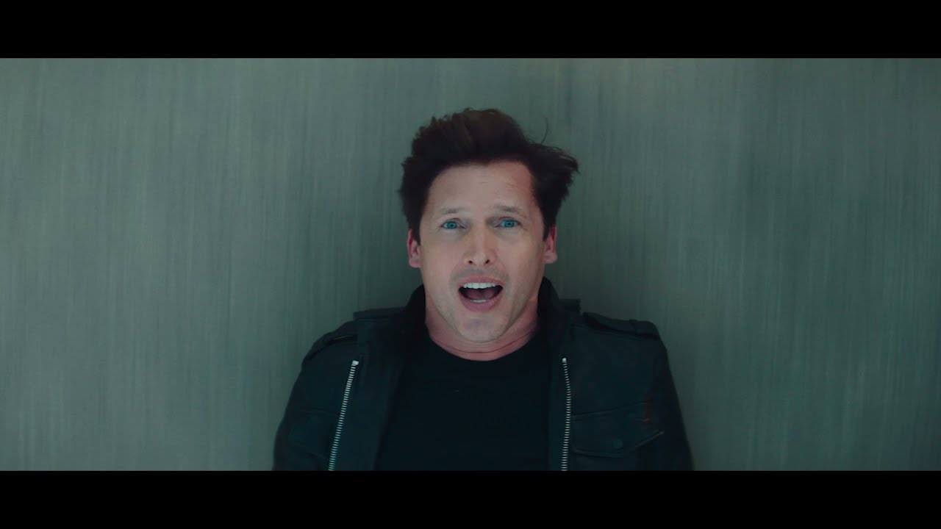

WATCH “LOVE UNDER PRESSURE”: https://jamesblunt.lnk.to/Love-Under-Pressure-Video
ALBUM PRE-ORDER: http://jamesblunt.lnk.to/Stars-Beneath-My-Feet

James Blunt today releases the video for his stellar new song “Love Under Pressure” - taken from his forthcoming greatest hits album, The Stars Beneath My Feet (2004-2021) - out November 19th via Atlantic Records.

Co-written with Jack Savoretti and produced by LA songwriting duo Afterhrs (One Direction, Maroon 5), “Love Under Pressure” is James at his finest - featuring an infectious piano-driven hook from the start, a powerful vocal performance and a hypnotic beat fit for any dancefloor.

Filmed in Suffolk and featuring a break-neck chase of James by a lover, the Michael Baldwin (Gary Barlow, Olly Murs, The Vamps) directed video hilariously echoes the pressure and tension felt in a relationship, presented in James’ ever-humble, self-deprecating way. Of the video James said, “If you’ve run out of ideas with how to terminate James Blunt, then please watch my new video…you won’t be disappointed.” Watch the video HERE.

James recently announced a nine date UK arena tour for 2022 which will see him celebrate songs spanning a 17-year career that has spawned over 23 million album sales, a global smash hit with ‘You’re Beautiful’, two Brit Awards and two Ivor Novello Awards, as well as receiving five Grammy Award nominations.
Amongst the string of hit singles, The Stars Beneath My Feet (2004-2021) will include four new songs (“Love Under Pressure,” “Unstoppable,” “Adrenaline” & “I Came For Love”), as well as four exclusive live performances from around the world, including the Glastonbury Festival. It also features stunning tracks from his latest Gold-selling album Once Upon A Mind, including “Cold,” and the heartbreaking ballad for his father, “Monster.”

James’ classic 2004 debut album Back To Bedlam, was recently named as one of the top ten best-selling albums of that decade, and with Once Upon A Mind, James Blunt reinforced his reputation for writing honest, emotional songs that people can easily relate to. The album marked a return to what James Blunt does best – writing classic songs that touch both the heart and the head. Another side of James - his wit and charm - have in recent times been showcased via his always engaging Twitter account.

James Blunt plays the following 2022 UK arena dates:

Thursday, 2/3 – BRIGHTON, Brighton Centre
Friday, 2/4 – MANCHESTER, AO Arena
Saturday, 2/5 – LONDON, SSE Wembley Arena
Monday, 2/7 – CARDIFF, Motorpoint Arena
Tuesday, 2/8 – HULL, Bonus Arena
Thursday, 2/10 – BIRMINGHAM, Resort World
Friday, 2/11 – LEEDS, First Direct Arena
Saturday, 2/12 – NOTTINGHAM, Motorpoint Arena
Sunday, 2/13 – GLASGOW, SEC Armadillo

CONNECT WITH JAMES BLUNT:
TWITTER | FACEBOOK | INSTAGRAM | YOUTUBE | PRESS SITE

CONTACT:
SHEILA RICHMAN | SHEILA.RICHMAN@ATLANTICRECORDS.COM
TED SULLIVAN | TED.SULLIVAN@ATLANTICRECORDS.COM

