FOR IMMEDIATE RELEASE

DECEMBER 18, 2019

**James Blunt Unveils Video For Latest Track “The Truth”**

**NEW ALBUM *ONCE UPON A MIND* out now**

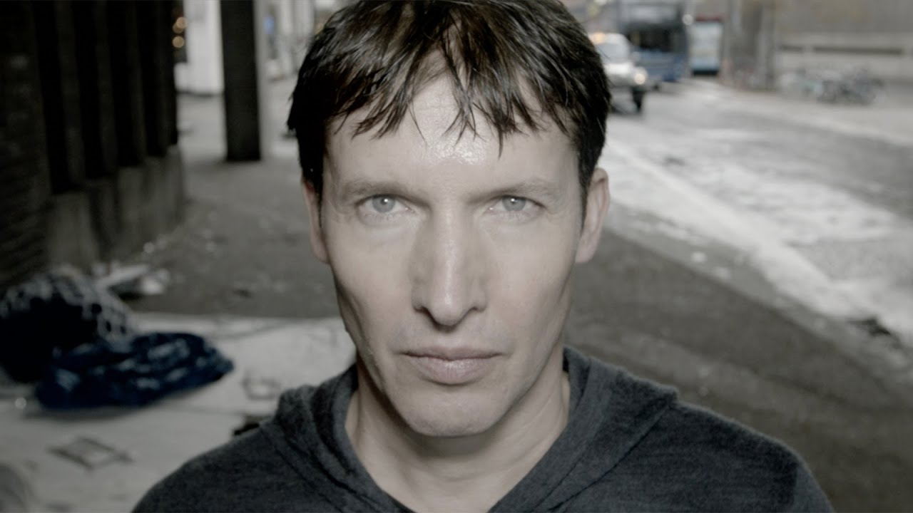

**WATCH “THE TRUTH” MUSIC VIDEO:** [https://atlanti.cr/TheTruth-video](https://nam04.safelinks.protection.outlook.com/?url=https%3A%2F%2Fatlanti.cr%2FTheTruth-video&data=02%7C01%7CBrian.Sommer%40atlanticrecords.com%7C6fcfb9eb1ad7413fd5ee08d783b25c55%7C8367939002ec4ba1ad3d69da3fdd637e%7C0%7C0%7C637122675197614591&sdata=8lwtSMbH3q4DFt6y6pWLT5dpYuPzJMiRjwHLbOQlsDk%3D&reserved=0)

**STREAM *ONCE UPON A MIND*:** <http://atlanti.cr/OnceUponAMind>

Following the release of his sixth studio album ***Once Upon A Mind***, multi-GRAMMY nominated and multi-platinum British singer/songwriter **James Blunt** has released the video for latest track “**The Truth**.”

Directed by **Vaughan Arnell** (**George Michael**, **One Direction**), the video sees Blunt strapped up with cameras running through London. Steeped in the beauty of simplicity, the video highlights the notion that we’re all travelling in certain directions, not always certain of our destination, and sometimes, even if we are, some might never get there. Featuring a catchy acoustic guitar and Blunt’s pitch perfect vocal, “**The Truth**” is an upbeat and heart-warming love song. When asked if the song was a direct love note to his wife, Blunt said, *“Well, I’ve avoided using those words - but, yeah, I’m lucky to be here! It’s been a long, lonely journey searching for someone, and I wouldn’t want to be anywhere else than right here, with her.”*

Blunt’s classic 2004 debut album ***Back To Bedlam***, has just been named as one of the top ten best-selling albums of that decade, and now with ***Once Upon A Mind***, he has reinforced his reputation for writing honest, emotional songs that people can easily relate to.

***

After flirting with electronica on his last album (2017’s ***The Afterlove****)*, **James Blunt** returns to what he does best on ***Once Upon A Mind***, writing classic songs that touch both the heart and the head.  The album sees Blunt collaborating with a variety of producers such as **Steve Robson**, **Jimmy Hogarth** and **TMS** – resulting in a freshness that resonates throughout the eleven-song collection, with highlights including first single “[**Cold**](https://youtu.be/xU4wN8WbTfE)” (with a music video mirroring the iconic “**You’re Beautiful**” video fourteen years later), the poignant ballad “**Monsters**,” pop-infused “**5 Miles**” and the country tinged “**Halfway**.”

*“I think this is the most honest album I have ever made”* said Blunt. *“’****Back To Bedlam****’ was similar in that I had been writing those songs for a while about my life experiences at that time, and they came together on my debut.  And every song on this album represents something that I’m currently going through or have recently experienced. It’s a very personal record, and I’m proud I can share it.”*

Blunt first captured the world’s attention in 2005 with his 3x RIAA platinum-certified debut, ***Back To Bedlam***, and its history-making 2x platinum-certified #1 single “**You’re Beautiful**.” The British tunesmith has since become one of the most popular singer/songwriters of the modern era, with total album sales now in excess of 23 million worldwide. He has also been the recipient of a remarkable range of top honors, including five GRAMMY nominations, two BRIT Awards, two Ivor Novello Awards (honoring British music and songwriters), and a host of MTV awards. Blunt has also earned viral acclaim for his hugely popular and extremely witty Twitter account, boasting over 1.9 million followers and growing ([@jamesblunt](https://nam04.safelinks.protection.outlook.com/?url=https%3A%2F%2Ftwitter.com%2FJamesBlunt&data=02%7C01%7CSophie.Kaplan%40atlanticrecords.com%7C7d170d60a386412a572108d748da4c6f%7C8367939002ec4ba1ad3d69da3fdd637e%7C0%7C0%7C637057974742645477&sdata=ILzO7uejQpTKbyA3TlQ86HsMH7Fv6pwCbSnp3rrdgI8%3D&reserved=0)). 2020 will also see Blunt embarking on a major UK and European headline tour, his first since performing on the North American leg of **Ed Sheeran**’s ***÷ Tour*** and international headline run in 2017.

***Once Upon A Mind***

(Custard/Atlantic Records)

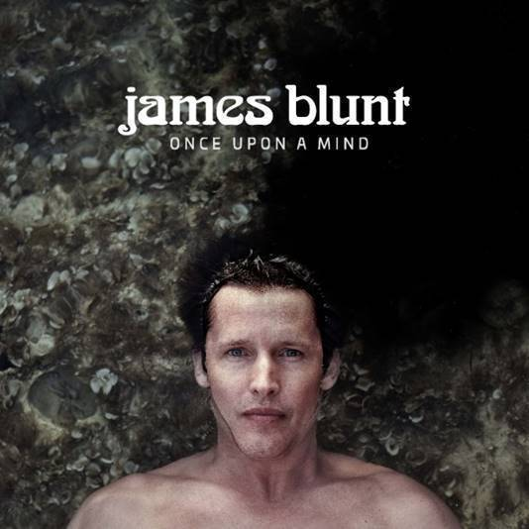

1. The Truth

2. Cold

3. Champions

4. Monsters

5. Youngster

6. 5 Miles

7. How It Feels To Be Alive

8. I Told You

9. Halfway

10. Stop The Clock

11. The Greatest

**CONNECT:**

[WEBSITE](https://nam04.safelinks.protection.outlook.com/?url=http%3A%2F%2Fwww.jamesblunt.com%2F&data=02%7C01%7CSophie.Kaplan%40atlanticrecords.com%7C7d170d60a386412a572108d748da4c6f%7C8367939002ec4ba1ad3d69da3fdd637e%7C0%7C0%7C637057974742655468&sdata=JOSNWbMhvE6ZP5rXhmPTtzvzVjGRXT7nWZlPmIPk%2Bq0%3D&reserved=0) | [FACEBOOK](https://nam04.safelinks.protection.outlook.com/?url=https%3A%2F%2Fwww.facebook.com%2Fjamesblunt&data=02%7C01%7CSophie.Kaplan%40atlanticrecords.com%7C7d170d60a386412a572108d748da4c6f%7C8367939002ec4ba1ad3d69da3fdd637e%7C0%7C0%7C637057974742655468&sdata=V0dM6Cs6rZKnwsxeunGkko75DFBvaRsIW8ankBTe3TE%3D&reserved=0) | [TWITTER](https://nam04.safelinks.protection.outlook.com/?url=https%3A%2F%2Ftwitter.com%2FJamesBlunt&data=02%7C01%7CSophie.Kaplan%40atlanticrecords.com%7C7d170d60a386412a572108d748da4c6f%7C8367939002ec4ba1ad3d69da3fdd637e%7C0%7C0%7C637057974742655468&sdata=turAHCUR3yJNU%2Fu53uZ7rAyhSDd8grdUtd7Xl7pGzCE%3D&reserved=0) | [INSTAGRAM](https://nam04.safelinks.protection.outlook.com/?url=http%3A%2F%2Finstagram.com%2Fjamesblunt&data=02%7C01%7CSophie.Kaplan%40atlanticrecords.com%7C7d170d60a386412a572108d748da4c6f%7C8367939002ec4ba1ad3d69da3fdd637e%7C0%7C0%7C637057974742665467&sdata=G8P9Vz9ECpxpqkX6%2BZUvcRnmkQXRsC%2FOJGCMx5pP%2BeM%3D&reserved=0) | [YOUTUBE](https://nam04.safelinks.protection.outlook.com/?url=http%3A%2F%2Fwww.youtube.com%2Fuser%2Fjamesbluntmusic&data=02%7C01%7CSophie.Kaplan%40atlanticrecords.com%7C7d170d60a386412a572108d748da4c6f%7C8367939002ec4ba1ad3d69da3fdd637e%7C0%7C0%7C637057974742665467&sdata=mr58Qy%2FHmtvHG3vaN1iBsjq2qhbtq4I2nOLSP4WatDQ%3D&reserved=0) | [ASSETS](https://nam04.safelinks.protection.outlook.com/?url=http%3A%2F%2Fpress.atlanticrecords.com%2Fjames-blunt%2F&data=02%7C01%7CSophie.Kaplan%40atlanticrecords.com%7C7d170d60a386412a572108d748da4c6f%7C8367939002ec4ba1ad3d69da3fdd637e%7C0%7C0%7C637057974742675463&sdata=EGmKET7qsS1Fne5lkAXbZ5gqSbjrm0UDuRLY4WQ6GbM%3D&reserved=0)

**CONTACT:**

Sheila Richman | [Sheila.Richman@atlanticrecords.com](mailto:Sheila.Richman@atlanticrecords.com)

Ted Sullivan | [Ted.Sullivan@atlanticrecords.com](mailto:Ted.Sullivan@atlanticrecords.com)