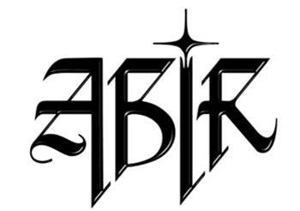

**ABIR BOILERPLATE**

*UPDATED JANUARY 2021*

Hailed as one of the most promising young artists on the music scene today, ABIR is boldly redefining perceptions of what it means to be an Arab woman in the modern world. Born in Morocco and raised in the U.S., the New York City-based singer first showcased her hypnotic vocal work and extraordinary range on her gold-certified record “Finest Hour” and 2018 debut EP *Mint* (her inaugural release for Atlantic Records). On her sophomore EP *Heat*, ABIR embraces her heritage more fully than ever, infusing her magnetic take on pop/R&B with elements of the Arab music she grew up on. A daughter of the east and west, ABIR ultimately shatters countless stereotypes while instilling a thrilling new energy into the pop landscape.