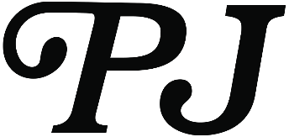
PJ BOILERPLATE
UPDATED JANUARY 2O21

Originally hailing from Greensboro, North Carolina, singer-songwriter PJ launched her career after relocating to Los Angeles. Lending her pen to some of the biggest names in the game, PJ established herself as an in-demand songwriter with dozens of credits, including “Left Right Left” for Charlie Puth, “I Don’t Know” for Meek Mill, “True Colors” for Wiz Khalifa, “Excuse Me” for Kevin Gates, and “Rivals” for Usher. Simultaneously, she built a tastemaker-approved solo discography, spanning the Walking Around Pools and Rare. In 2019, she toured with Pink Sweat$ and served up the fan favorite single “One Missed Call.” In addition to 2 million total streams and praise from Essence, Earmilk proclaimed it, “possibly one of the most upbeat and danceable songs about an ex.”

Along the way, she charismatically stepped into her own as an artist. Similar to a superheroine actualizing her cosmic potential for the first time, she embraced in-your-face energy, vibrant pops of personality, out-sized charisma, and an unpredictable take on R&B with the 2020 Waiting For Paris EP. The EP waterfalled into an exciting year where she performed her explosive single “Element” on NPR Tiny Desk series from the official soundtrack of INSECURE Season 4. Common also recruited her to perform on The Kelly Clarkson Show and The Tonight Show Starring Jimmy Fallon. She rounded out 2020 with “Single on Christmas,” a featured single on Atlantic Records Still Home for the Holidays R&B compilation album.

