JASMINE THOMPSON
“more”
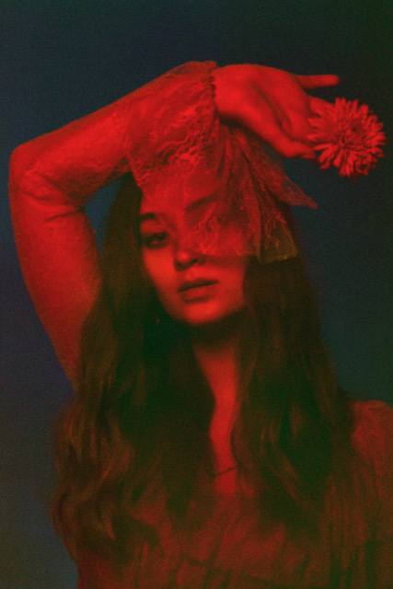

Jasmine Thompson chronicles self-destruction with serene beauty on new song “more,” released today along with companion video. The song will make its place on her upcoming EP titled Colour on April 5th via Atlantic Records.

Watch the video here.

“More was written as an attempt to explain what being self-destructive means to me” explains Thompson, choosing below mellow over angular production, zoning in on the core of the feeling making this beautiful song solely retrospective, that Thomspon describes “I was in a very bad stage of chasing highs to distract myself and I ended up constantly trying to run away and escape from things”.

Today’s new song, like the rest of her forthcoming Colour EP, is a collaborative effort with Thompson’s friend & writer/producer Eg White (Previous work includes; Sam Smith, Adele) and the results are stunning; not only are these songs stunning portrayals of a reflective artist making feelings a priority, they are songs to hold onto.

The Londoner was born to an English father and Chinese born mother. “Having one immigrant parent always provides a unique perspective growing-up, a sense of one foot in two different worlds” says Thompson. At just 18 years old, she might be a new artist to many, but she’s already connected to an audience of millions around the world, who have enjoyed her originals and cover uploads, amassing over a billion streams across the various streaming services. Perhaps more impressive than the numbers on her streams, views and socials is her seemingly ageless soulfulness. Her voice is almost otherworldly, floating over the music like something adrift on a dark ocean. There is a loneliness that simply none of her peers can convey and listeners never knew they needed. It’s hard to see a ceiling for this prodigious talent.

Jasmine’s EP ‘Colour’ will be out April 5th. Mark this as one to watch in 2019.

For more information please contact:
Christina Kotsamanidis
212.707.2241
Christina.Kotsamanidis@atlanticrecords.com

