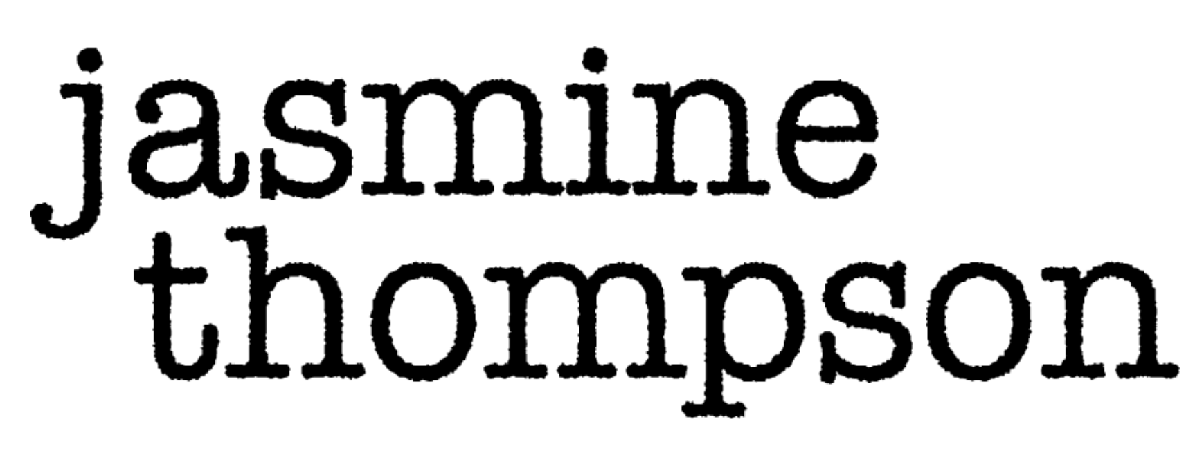

Like for many people around the world, lockdown has been a lonely time for Jasmine Thompson. The 20-year-old London singer wrapped a U.K tour with Freya Ridings, which included a stop at her dream venue the Hammersmith Apollo, right before the pandemic hit, and ever since Jasmine has been mostly on her own in a new apartment. Jasmine, who started recording music at age 10 and was signed to Atlantic at 13, found herself reevaluating things in isolation. Her new EP, all of the above, reflects a musician coming to terms with who she wants to be.

“The past year and a half has been time to sit with myself,” Jasmine says. “I’ve been reassessing my music and what I want to write about. I may not completely have the answer yet, but because of lockdown I’ve been able to work on Zoom with a lot of people I wouldn’t have previously put myself out there to write with. Being able to work with songwriters and producers in America and Sweden from my living room has helped me focus and it’s given me the opportunity to explore songs that feel like a step forward in my career.”

Jasmine did numerous Zoom sessions with a group of songwriters in Sweden Kristin Carpenter (Greyson Chance, Nasty Cherry, NOTD, Rhys), Maddie Eliasson, Sebastian Daniel (Matoma, Afrojack, Sam Feldt), Michael Pollack (Celine Dion, Kelly Clarkson, Maroon 5, Bebe Rexha, Lauv) and TMS, who helped her channel the poignant story of a long-distance relationship into “already there.” Casey Smith and Zach Skelton joined forces for “after goodbye,” and Ingrid Andress, Derek Southerland, and AJ Pruis collaborated on writing “happy for you,” a melancholy ballad that grapples with lingering emotional pain.

“It was this gorgeous flip on saying you’re going to be happy for someone and you’re not spiteful, but you realize the relationship is going down a bad path,” Jasmine says. “It’s about being in denial in a way, but also being okay with it. It starts so quiet and delicate and by the end of the song it all really rises and becomes much stronger. The lyrics become more hurtful. It feels so relatable. I saw it as a love song to an ex, but it could also be feeling hurt by anything that’s ended.”

While Jasmine wanted to create something more upbeat for her fourth EP, the musician felt it was more important to be genuine to the moment she was in. all of the above, which follows 2019’s Colour EP and 2017’s Wonderland EP, looks inward, dealing with everything from grief after the loss of a family member on “Georgie” to self-doubt after a negative relationship on the title track.

“The EP is about the emotions that went through my head during lockdown,” Jasmine explains. “There are several songs about relationships and the struggles of relationships, the highs and lows of them. Through lockdown I felt quite lonely and isolated. It’s that universal feeling I’m sure everyone has experience this past year and a half. I tried to put it into music that was relatable. I had some really low points and sometimes I wasn’t even sure what I wanted to write about, but collaborating with other songwriters helped get me outside my little bubble.”

Since signing with Atlantic, Jasmine has been actively recording music and touring. She dropped out of school at 14, home-schooling from the studio and on the road, and it wasn’t until she turned 17 that she realized she needed a break. In 2017, Jasmine took a year off to wait tables at a restaurant in London’s Soho, an experience she references in “already there.” That time away from the industry brought Jasmine a new perspective, which is also what she’s found recently. She recorded most of her vocals on all of the above at home, bringing her full circle to her early years of self-recording songs for YouTube.

“All of my time as an artist has been amazing,” she recalls. “But looking back I didn’t really know who I wanted to be. That was a huge part of my life where I was developing as a person and developing musically, and a lot has changed since then. Being able to work at home has made me prioritize and better understand what I like to do and what makes me feel more comfortable. Having this year to reset and learn what works for me has been really helpful. I feel like I can be more grounded and less overwhelmed going forward.”

Over the past decade, Jasmine has accumulated over 3 billion global audio streams, with 5 million monthly Spotify listeners, and has made chart-topping appearances on several global blockbuster hit singles, including her 2020 joint track with Zedd, “Funny,” and her 2014 breakout “Sun Goes Down” with Robin Schulz. Her collaboration with Felix Jaehn, “Ain't Nobody (Loves Me Better),” has over 400 million global streams and over 370 million YouTube views, and earned Gold and Platinum certifications in a range of countries worldwide. Currently, the singer boasts 3.5 million subscribers and 2 billion views on YouTube.

all of the above marks the next chapter in Jasmine’s career, showcasing an evolving artist with the ability to give voice to the emotions that connect us all. While the past year and a half has been a challenge, it’s also given her the opportunity find out what else she wants to say. “This EP covers a paragraph in my life,” Jasmine notes. “It’s an offering to my fans and I hope it connects with them the way it’s connected with me.”

CONNECT WITH JASMINE THOMPSON

JASMINETHOMPSONMUSIC.COM
TWITTER
YOUTUBE
FACEBOOK
INSTAGRAM

