GRAMMY AWARD WINNER JESS GLYNNE RELEASES
SECOND ALBUM ALWAYS IN BETWEEN ON ATLANTIC RECORDS!

+ NEW SINGLE “THURSDAY” CO-WRITTEN WITH ED SHEERAN
ALONGSIDE ANNOUNCEMENT OF NORTH AMERICAN HEADLINE TOUR

ALWAYS IN BETWEEN -THE FILM COMING SOON

LISTEN/SHARE
‘THURSDAY’ HERE
ALWAYS IN BETWEEN HERE

BUY/STREAM
‘THURSDAY’ HERE
ALWAYS IN BETWEEN HERE

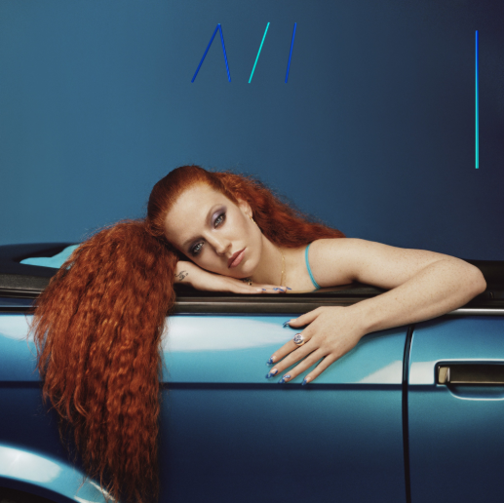

Jess Glynne - singer, star, voice of the street and the only British female to achieve 7 number 1 singles is the ultimate, modern British popstar. Today she releases her hugely anticipated second album “Always In Between,” featuring the UK #1 single ‘I’ll Be There’, follow up smash hit ‘All I Am’ alongside the new Ed Sheeran co-penned single ‘Thursday’ which arrived yesterday. Buy/stream the album HERE!

Alongside the album release, Jess also reveals an exclusive first-look trailer for the forthcoming documentary to accompany the album. Directed by Scott Carthy (Just So Films) the film is a stylized and intimate documentary presenting Jess as she’s never been seen before, baring her soul through her first arena tour and the making of her second album. More info on the film’s release will follow soon – check out the trailer here.

‘Always In Between’ finds Jess on a breath-taking journey of self-acceptance as she comes to terms with her new-found fame, heartbreak and the well-known pressure of writing a second album. Her blockbuster debut album, “I Cry When I Laugh” is one of the defining British pop records of its era. It debuted at number one in the UK, spanning 12 million worldwide singles sales, 39 weeks on the UK top 10, 2.5 billion Spotify streams, a sold-out UK arena tour, Brit, MTV: EMA, Ivor Novello, MOBO, Q and Glamour award nominations.

Underneath all the facts though is Jess’ peerless ability to communicate with an audience through song; to tell the truths young women want to hear about their concerns, the loves that build them up and let them down; the aspirations and dreams that might turn sour but you’ll smile through them anyway. It’s because of all these themes that “Always In Between” is so triumphant, capturing the heart of what being a 28-year old woman in 2018 can feel like – trying to balance real life with everything that you want it to be. Never has Jess sounded more empowering than on brand new single ‘Thursday’ which explores our many insecurities and the idea that sometimes stripping everything back can make you feel most yourself. There’s no doubt that ‘Always In Between’ will capture many under its spell as Jess Glynne once again reaches out her hand and offers love, friendship and unity to all that can hear her.

Jess will of course be celebrating the release of ‘Always In Between’ with a headlining US tour in 2019, as well as North American live dates supporting Leon Bridges ‘Good Thing’ 2019 tour. See full itinerary below. General ticket sale opens today, 10/12 at 10am local.

JESS GLYNNE ‘ALWAYS IN BETWEEN’ HEADLINE TOUR
+ DATES SUPPORTING LEON BRIDGES ‘GOOD THING’ TOUR
For more information: https://jessglynne.co.uk/
** indicates HEADLINE show
Monday, March 25, 2019 - San Francisco, CA - Regency Ballroom **
Wednesday, March 27, 2019 - Los Angeles, CA - The Wiltern **
Friday, March 29, 2019 - Minneapolis, MN - First Avenue **
Saturday, March 30, 2019 - Chicago, IL - Vic Theatre **
Monday, April 1, 2019 - Boston, MA - House of Blues **
Tuesday, April 2, 2019 - New York, NY - Terminal 5 **
Friday, April 5, 2019 - Washington, DC - Lincoln Theatre **
Saturday, April 6, 2019 - Philadelphia, PA - Union Transfer **
Wednesday, April 10, 2019 - Charlottesville, VA - Sprint Pavilion (LEON BRIDGES)
Thursday, April 11, 2019 - Charlotte, NC - Charlotte Metro Credit (LEON BRIDGES)
Friday, April 12, 2019 - Chattanooga, TN - Soilders & Sailors Memorial Aud (LEON BRIDGES)
Monday, April 15, 2019 - Asheville, NC - Thomas Wolfe Auditorium (LEON BRIDGES)
Wednesday, April 17, 2019 - St. Augustine, FL - Saint Augustine Amp. (LEON BRIDGES)
Thursday, April 18, 2019 - Clearwater, FL - Ruth Eckerd Hall (LEON BRIDGES)
Friday, April 19, 2019 - Miami Beach, FL- Fillmore Miami Beach (LEON BRIDGES)
Saturday, April 20, 2019 - Lake Buena Vista, FL - House of Blues (LEON BRIDGES)
Monday, April 22, 2019 - Mobile, AL - Saenger Theatre (LEON BRIDGES)
Tuesday, April 23, 2019 - Birmingham, AL - BJCC Concert Hall (LEON BRIDGES)
Wednesday, April 24, 2019 - Memphis, TN - Orpheum Theatre (LEON BRIDGES)
Friday, April 26, 2019 - The Woodlands, TX - Cynthia Woods (LEON BRIDGES)
Saturday, April 27, 2019 - Dallas, TX - Bomb Factory **
Tuesday, April 30, 2019 - Tulsa, OK - Brady Theatre (LEON BRIDGES)
Saturday, May 4, 2019 - Columbus, OH - Express Live! (LEON BRIDGES)
Sunday, May 5, 2019 - Cleveland, OH - Jacobs Pavillion at Nautica (LEON BRIDGES)

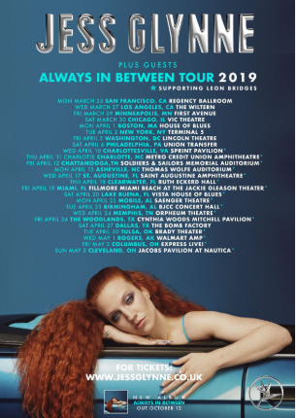
Download hi-res here

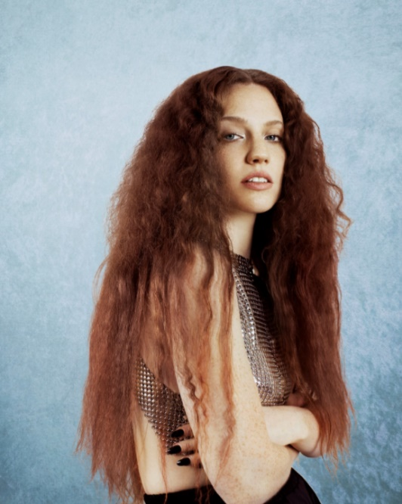
Credit: Nadine Ijewere; download hi-res here

Connect with Jess Glynne:
www.jessglynne.co.uk
Facebook / Instagram / Twitter

For press assets: http://press.atlanticrecords.com/jessglynne/

For press inquiries:
Jordan Danielle Frazes
Head of Publicity, Big Beat Records
Jordan.Frazes@atlanticrecords.com

Ted Sullivan
Tour/Online Press
Ted.Sullivan@atlanticrecords.com

