**JESS GLYNNE**

**delivers new video for ‘Take Me Home’**

**+ announces North American ‘I Cry When I Laugh’ Tour**

**(supported by Conrad Sewell)**

**Watch & Post the official video:** <https://youtu.be/2ebfSItB0oM>



**Debut LP, “I Cry When I Laugh”** – **iTunes** ([LINK](http://smarturl.it/ICryWILaughiTunesX)) & **Spotify** ([LINK](http://smarturl.it/ICryWILaughSpotify))

*“This is a song about the need to have someone who cares when you are at your most vulnerable. It’s a very emotional song for me and I have to admit it brings me to tears when I sing it live or when I made the video with Declan (Whitebloom). I hope it makes people realise that they should reach out to others at a time of need.”* – **Jess Glynne**

**Jess Glynne**’s astonishing year is set to continue with the release of single **‘Take Me Home’**; a soaring ballad that gives insight to Jess at her most raw, heartfelt and exposed. This in mirrored in the accompanying video, echoing the likes of Sinead O’Conner or Alanis Morissette in its unflinching and unmediated directness that embraces both empowerment as much as vulnerability. It similarly corresponds with the title of her debut album, **‘I Cry When I Laugh’** out now ([LINK](https://itunes.apple.com/gb/album/i-cry-when-i-laugh-deluxe/id993230070)) via **Atlantic Records** – alluding to Jess’ real life propensity to tear up in moments of joy as much as sadness - and the implicit emotional duality of her music. ‘I Cry When I Laugh’ is the biggest selling UK debuts, having gone platinum in the UK in only 10 weeks, with over **10 Million worldwide** single sales combined and over **1 Billion YouTube** views. She has also just performed a song medley (including her current US single “**Hold My Hand**” ([LINK](https://youtu.be/cLyUcAUMmMY))) at the prestigious EMA’s and has announced a major **‘I Cry When I Laugh’ North American Tour** today – supported by Conrad Sewell - kicking off January 18th at the 9:30 Club in Washington, DC and crisscrossing the country through February 11th headlining at El Rey Theatre in Los Angeles – *see full itinerary below*!

**Jess Glynne ‘I Cry When I Laugh” North American Tour**

*+ dates supported by Conrad Sewell*

Jan-18 - Washington, DC @ 9:30 Club *+*

Jan-20 - New York, NY @ Webster Hall *+*

Jan-22 - Boston, MA @ Paradise Rock Club *+*

Jan-23 - Philadelphia, PA @ Union Transfer *+*

Jan-25 - Nashville, TN @ Mercy Lounge *+*

Jan-26 - Atlanta, GA @ Terminal West *+*

Jan-28 - Orlando, FL @ The Social *+*

Jan-29 – Fort Lauderdale, FL @ Culture Room *+*

Jan-30 – St. Petersburg, FL @ The State Theatre *+*

Feb-1 - Houston, TX @ The Studio @ Warehouse live *+*

Feb-2 - Austin, TX @ The Parish *+*

Feb-3 - Dallas, TX @ Trees *+*

Feb-5 - Denver, CO @ Bluebird Theater *+*

Feb-8 - San Francisco, CA @ Mezzanine *+*

Feb-10 - San Diego, CA @ House of Blues *+*

Feb-11 - Los Angeles, CA @ The Fonda *+*

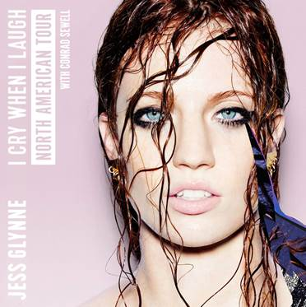

**Connect:**

[www.jessglynne.co.uk](http://www.jessglynne.co.uk)

[www.facebook.com/JessGlynne](http://www.facebook.com/JessGlynne)

**Press tools:**

<http://press.atlanticrecords.com/jessglynne/>

**Contact:**

Jordan Frazes (National) / [jordan.frazes@atlanticrecords.com](mailto:jordan.frazes@atlanticrecords.com)

Ted Sullivan (Tour) / [ted.sullivan@atlanticrecords.com](mailto:ted.sullivan@atlanticrecords.com)