JESS GLYNNE INSPIRES WITH HEARTFELT PERFORMANCE OF SINGLE ‘THURSDAY’ WITH SPECIAL GUEST H.E.R. AT THE 2019 BRITS IN LONDON!

THE GRAMMY AWARD WINNING SONGWRITER CELEBRATES WITH NEW VIDEO FOR TRACK “NO ONE” -STREAMING TODAY!

WATCH/SHARE “Thursday” (feat. H.E.R.) (Live at The BRIT Awards 2019): https://youtu.be/qCRfFDi_8Io
BUY/STREAM “Thursday” (feat H.E.R.): https://atluk.lnk.to/Thursday-HER

WATCH/SHARE “No One”: https://youtu.be/kxlvwKGHmog
BUY/STREAM “No One”: https://atluk.lnk.to/NoOne

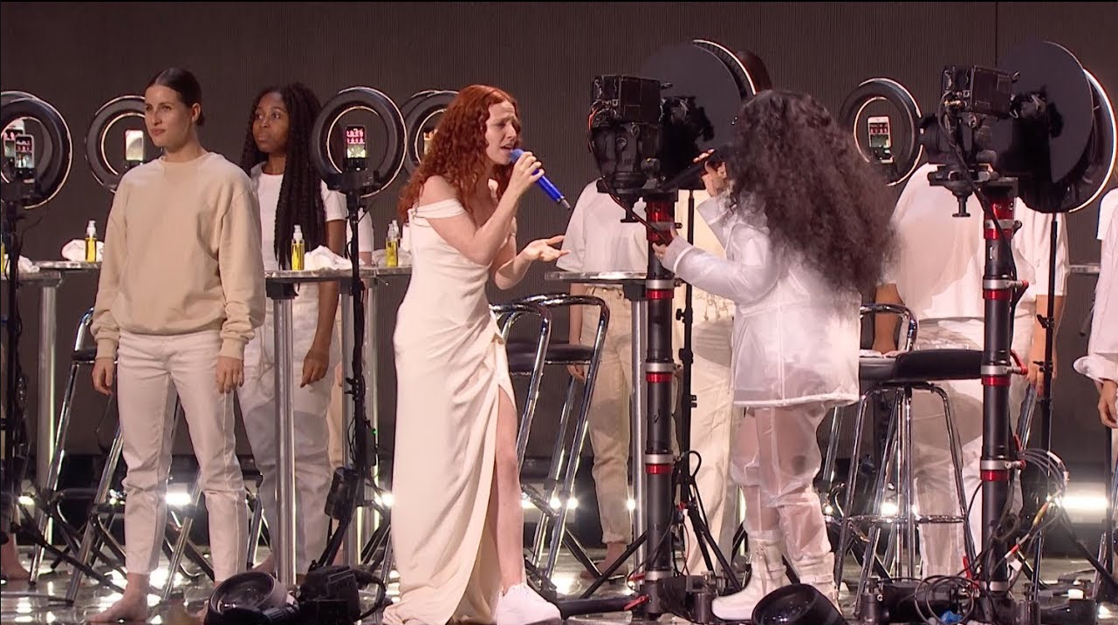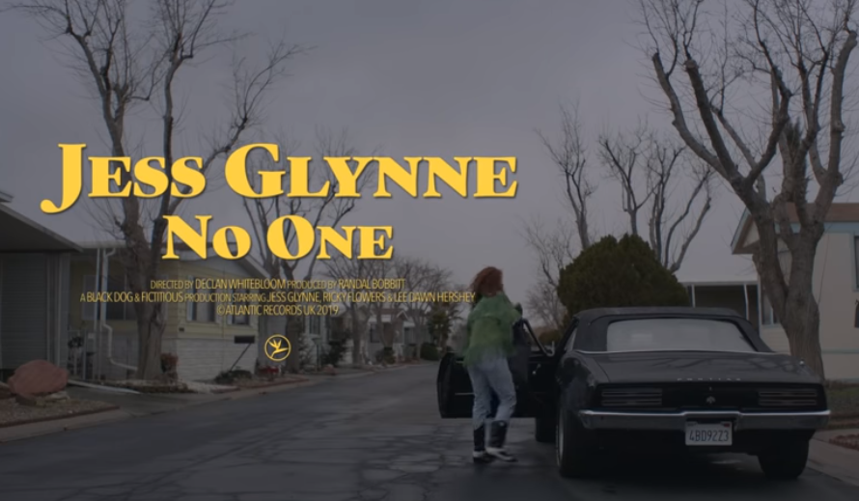

“…an absolute standout.” -PAPER

“A self-empowerment workshop set to cathartic dance-pop” -GQ

“Glynne has a husky, yet supple voice marked by a restless vibrato, and she powers it with the sort of panache that would make even the most in-touch feelings-haver blush.” -ROLLING STONE

GRAMMY-award winning singer, songwriter and artist Jess Glynne took to The BRITs stage in London yesterday with H.E.R. to perform her latest single “Thursday” (ft. H.E.R.) Watch the beautiful, moving live performance HERE! Glynne celebrates her BRITs performance by releasing the music video for “No One”, the latest single to be shared from her sophomore album ‘Always In Between’ released in October last year on Atlantic. Watch HERE!

‘Always In Between’ was a history-making, chart-topping sensation and the biggest selling album released by a British female in 2018. It has remained a dominant force ever since and today, still sits #10 on the British charts. It included a number of hugely loved UK #1 singles including BRIT-nominated ‘These Days’ and ‘I’ll Be There’ along with smash single ‘All I Am’ and the more recent ‘Thursday’ (which also had a re-work featuring friend and collaborator, fast-rising US star H.E.R.).

‘No One’ is the next brilliantly empowering anthem to step forward from ‘Always In Between’. In true Jess style, ‘No One’ tackles the all-too familiar notion of learning how to accept yourself when you find yourself in and out of love. It comes with a beautiful accompanying video which features Jess telling the story of the passion and provocations that come with relationships, both old and new.

Jess Glynne returns to America to headline ‘Always In Between’ North American tour in March 2019, as well as live dates supporting Leon Bridges -- see full itinerary below. Tickets on sale now! Jess Glynne will also open for Spice Girls reunion tour across Europe.

JESS GLYNNE ‘ALWAYS IN BETWEEN’ HEADLINE TOUR
+ DATES SUPPORTING LEON BRIDGES ‘GOOD THING’ TOUR
For more information: https://jessglynne.co.uk/
** indicates HEADLINE show
Monday, March 25, 2019 - San Francisco, CA - Regency Ballroom **
Wednesday, March 27, 2019 - Los Angeles, CA - The Wiltern **
Friday, March 29, 2019 - Minneapolis, MN - First Avenue **
Saturday, March 30, 2019 - Chicago, IL - Vic Theatre **
Monday, April 1, 2019 - Boston, MA - House of Blues **
Tuesday, April 2, 2019 - New York, NY - Terminal 5 **
Friday, April 5, 2019 - Washington, DC - Lincoln Theatre **
Saturday, April 6, 2019 - Philadelphia, PA - Union Transfer **
Wednesday, April 10, 2019 - Charlottesville, VA - Sprint Pavilion (LEON BRIDGES)
Thursday, April 11, 2019 - Charlotte, NC - Charlotte Metro Credit (LEON BRIDGES)
Friday, April 12, 2019 - Chattanooga, TN - Soilders & Sailors Memorial Aud (LEON BRIDGES)
Monday, April 15, 2019 - Asheville, NC - Thomas Wolfe Auditorium (LEON BRIDGES)
Wednesday, April 17, 2019 - St. Augustine, FL - Saint Augustine Amp. (LEON BRIDGES)
Thursday, April 18, 2019 - Clearwater, FL - Ruth Eckerd Hall (LEON BRIDGES)
Friday, April 19, 2019 - Miami Beach, FL- Fillmore Miami Beach (LEON BRIDGES)
Saturday, April 20, 2019 - Lake Buena Vista, FL - House of Blues (LEON BRIDGES)
Monday, April 22, 2019 - Mobile, AL - Saenger Theatre (LEON BRIDGES)
Tuesday, April 23, 2019 - Birmingham, AL - BJCC Concert Hall (LEON BRIDGES)
Wednesday, April 24, 2019 - Memphis, TN - Orpheum Theatre (LEON BRIDGES)
Friday, April 26, 2019 - The Woodlands, TX - Cynthia Woods (LEON BRIDGES)
Saturday, April 27, 2019 - Dallas, TX - Bomb Factory **
Tuesday, April 30, 2019 - Tulsa, OK - Brady Theatre (LEON BRIDGES)
Saturday, May 4, 2019 - Columbus, OH - Express Live! (LEON BRIDGES)
Sunday, May 5, 2019 - Cleveland, OH - Jacobs Pavillion at Nautica (LEON BRIDGES)

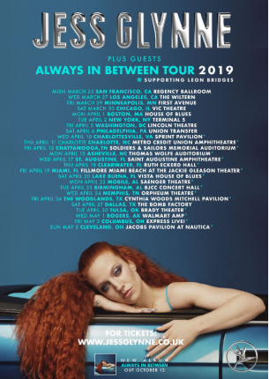
Download hi-res here

Credit: Nadine Ijewere; download hi-res here

Connect with Jess Glynne:
www.jessglynne.co.uk
Facebook / Instagram / Twitter

For press assets: http://press.atlanticrecords.com/jessglynne/

For press inquiries:
Jordan Danielle Frazes
Head of Publicity, Big Beat Records
Jordan.Frazes@atlanticrecords.com

Ted Sullivan
Tour/Online Press
Ted.Sullivan@atlanticrecords.com

