JESS GLYNNE SHARES INTIMATE VIDEO FOR SINGLE ‘THURSDAY’ CO-PENNED WITH ED SHEERAN!

OFF RECORD BREAKING UK #1 ALBUM ‘ALWAYS IN BETWEEN’
OUT NOW VIA ATLANTIC RECORDS

WATCH/SHARE “THURSDAY” MUSIC VIDEO: https://ad.gt/watchthursday
BUY/STREAM ‘ALWAYS IN BETWEEN’: http://ad.gt/alwaysinbetween

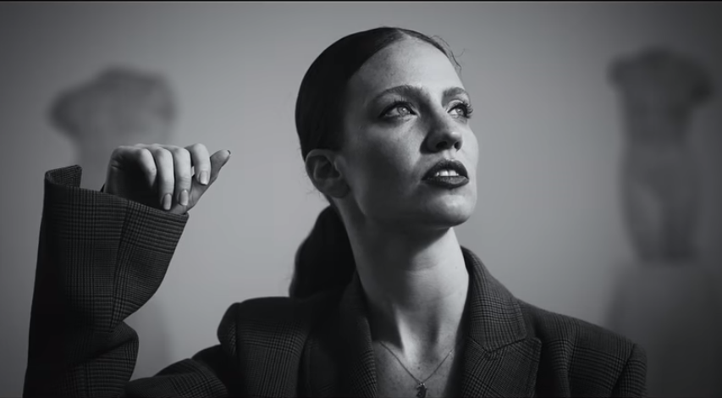

GRAMMY award-winning singer, songwriter, artist Jess Glynne shares a stunning and intimate new official music video for her current single ‘Thursday’ co-written with Ed Sheeran, off her new sophomore album ‘Always Between’ which is currently soaring up the UK charts. The LP entered the UK album chart at #1, making her the first British female artist this year to top it. The single ‘Thursday’ has quickly become a fan favorite anthem for self-acceptance with over 14 million streams to date. The official music video unveiled today – WATCH HERE - is a brilliantly fitting visual accompaniment to the beautiful pop-ballad that finds Jess exploring the power of a make-up free face. Sitting alongside previous UK #1 single ‘I’ll Be There’ and its follow-up smash ‘All I Am’, ‘Thursday’ captures everything that Jess embodies, as well as her 12th consecutive top 10 single in the UK. Jess Glynne returns to America to headline ‘Always In Between’ North American tour in March 2019, as well as live dates supporting Leon Bridges -- see full itinerary below. Tickets on sale now!

JESS GLYNNE ‘ALWAYS IN BETWEEN’ HEADLINE TOUR
+ DATES SUPPORTING LEON BRIDGES ‘GOOD THING’ TOUR
For more information: https://jessglynne.co.uk/
** indicates HEADLINE show
Monday, March 25, 2019 - San Francisco, CA - Regency Ballroom **
Wednesday, March 27, 2019 - Los Angeles, CA - The Wiltern **
Friday, March 29, 2019 - Minneapolis, MN - First Avenue **
Saturday, March 30, 2019 - Chicago, IL - Vic Theatre **
Wednesday, April 1, 2019 - Boston, MA - House of Blues **
Tuesday, April 2, 2019 - New York, NY - Terminal 5 **
Friday, April 5, 2019 - Washington, DC - Lincoln Theatre **
Saturday, April 6, 2019 - Philadelphia, PA - Union Transfer **
Wednesday, April 10, 2019 - Charlottesville, VA - Sprint Pavilion (LEON BRIDGES)
Thursday, April 11, 2019 - Charlotte, NC - Charlotte Metro Credit (LEON BRIDGES)
Friday, April 12, 2019 - Chattanooga, TN - Soilders & Sailors Memorial Aud (LEON BRIDGES)
Monday, April 15, 2019 - Asheville, NC - Thomas Wolfe Auditorium (LEON BRIDGES)
Wednesday, April 17, 2019 - St. Augustine, FL - Saint Augustine Amp. (LEON BRIDGES)
Thursday, April 18, 2019 - Clearwater, FL - Ruth Eckerd Hall (LEON BRIDGES)
Friday, April 19, 2019 - Miami Beach, FL- Fillmore Miami Beach (LEON BRIDGES)
Saturday, April 20, 2019 - Lake Buena Vista, FL - House of Blues (LEON BRIDGES)
Monday, April 22, 2019 - Mobile, AL - Saenger Theatre (LEON BRIDGES)
Tuesday, April 23, 2019 - Birmingham, AL - BJCC Concert Hall (LEON BRIDGES)
Wednesday, April 24, 2019 - Memphis, TN - Orpheum Theatre (LEON BRIDGES)
Friday, April 26, 2019 - The Woodlands, TX - Cynthia Woods (LEON BRIDGES)
Saturday, April 27, 2019 - Dallas, TX - Bomb Factory **
Tuesday, April 30, 2019 - Tulsa, OK - Brady Theatre (LEON BRIDGES)
Saturday, May 4, 2019 - Columbus, OH - Express Live! (LEON BRIDGES)
Sunday, May 5, 2019 - Cleveland, OH - Jacobs Pavillion at Nautica (LEON BRIDGES)

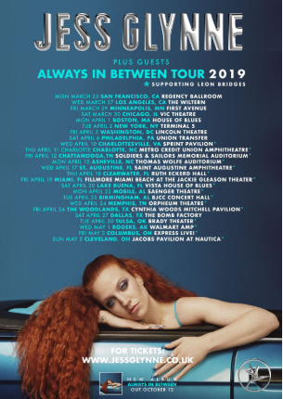
Download hi-res here

Credit: Nadine Ijewere; download hi-res here

Connect with Jess Glynne:
www.jessglynne.co.uk
Facebook / Instagram / Twitter

For press assets: http://press.atlanticrecords.com/jessglynne/

For press inquiries:
Jordan Danielle Frazes
Head of Publicity, Big Beat Records
Jordan.Frazes@atlanticrecords.com

Ted Sullivan
Tour/Online Press
Ted.Sullivan@atlanticrecords.com

