FOR IMMEDIATE RELEASE

APRIL 20, 2018

**JOSIE DUNNE RELEASES NEW SINGLE AND VIDEO FOR “GOOD BOYS”**

**VIDEO AIRING HOURLY VIA MTVU AND MTV LIVE**

**FOLLOWING LAST NIGHT’S PREMIERE**

**DEBUT EP, “TO BE THE LITTLE FISH,” DUE FRIDAY, JUNE 1ST**

[**“GOOD BOYS” AVAILABLE NOW**](https://atlantic.lnk.to/GoodBoysID)

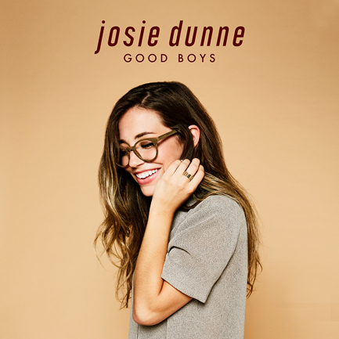

Atlantic recording artist Josie Dunne has announced the release of her new single. “Good Boys” – which follows Dunne’s breakthrough pop debut, “[Old School](https://atlantic.lnk.to/OldSchoolID)” – is available today at all digital music retailers and streaming services.

“Good Boys” is accompanied by an equally delightful companion visual that premiered live last night via MTVU and MTV Live and is currently airing at the top of each hour on both channels. In addition, “Good Boys” is among the programming now featured on the famous 1515 Broadway digital billboard in New York City’s Times Square. [“Good Boys”](https://www.youtube.com/watch?v=icXwX6U3u5w) is also streaming now at Dunne’s official YouTube channel.

“Good Boys” heralds Dunne’s upcoming debut EP, “TO BE THE LITTLE FISH,” due to arrive at all DSPs and streaming services on Friday, June 1st. The EP sees the Nashville-based Dunne marrying her love of Motown and brassy soul with contemporary pop energy and songcraft, including collaborations with such Music City luminaries as Nathan Chapman (Taylor Swift, The Band Perry) and Amy Wadge (Ed Sheeran, Camila Cabello).

“TO BE THE LITTLE FISH” will of course include Dunne’s debut single, “[Old School](https://atlantic.lnk.to/OldSchoolID),” available now at all digital music retailers and streaming services. Currently ascending the top 20 at **Radio** **Disney**, the ebullient pop track is accompanied by an emotional companion [visual](https://www.youtube.com/watch?v=_VVVnnB1G-w), inspired by her parents’ love story and shot outside the 21-year-old singer-songwriter’s family home in Chicago. The video – which has received regular rotation at both MTVU and Nickelodeon – is streaming now at Dunne’s official [YouTube](https://www.youtube.com/watch?v=_VVVnnB1G-w) channel.

What’s more, “Old School” earned high praise upon its release late last year, with the Chicago Tribune noting, “Josie Dunne is only 21 years old, but her music industry experience surpasses that of artists a decade older.” “Josie Dunne makes a great first impression with ‘Old School’ – a retro, Motown-channeling bop about an old-fashioned kind of love,” raved Idolator. “The 21-year old…is off to a flying start.”

Josie Dunne grew up amongst a large family in the suburbs of Chicago, taking inspiration from her artistically minded parents and siblings while always searching for her own creative voice. She decided on a musical path early on, making monthly trips to Nashville while still in high school for collaborative sessions with a number of top songwriters and producers. When the time came to officially start her musical career, she uprooted and fully relocated to Music City where she quickly became known as a powerhouse vocalist, gifted multi-instrumentalist (including guitar, piano, bass, ukulele, and trumpet), and distinctive songwriter. The latter talent earned her a 2014 songwriting deal with Warner/Chappell, resulting in songs performed by artists ranging from internet superstar Jacob Sartorius (including his smash single/video, “[Chapstick](https://www.youtube.com/watch?v=w7pymdjrV6U),” now boasting over 21 million views at YouTube alone) to Dunne’s GRAMMY® Award- winning Atlantic Records labelmate, Kelly Clarkson. The latter superstar recently expressed her admiration for Dunne via Twitter, tweeting “Loving [@JosieDunneMusic](https://twitter.com/JosieDunneMusic) right now! [#oldschool](https://twitter.com/hashtag/oldschool?src=hash)” to her 12.6 million followers around the world.

For more, please visit [JOSIEDUNNE.COM](http://josiedunne.com/)

[FACEBOOK](https://en-gb.facebook.com/JosieDunne/) * [TWITTER](https://twitter.com/josiedunnemusic) * [INSTAGRAM](http://www.instagram.com/josiedunne) * [YOUTUBE](https://www.youtube.com/user/JosieDunneMusic/featured)