JOSIE DUNNE UNVEILS NEW SINGLE & VIDEO FOR “SAME”

“SAME” IS FEATURED IN CAMPAIGN CELEBRATING SPERRY BIONIC® COLLECTION

LIVE SCHEDULE INCLUDES U.S. FESTIVAL APPEARANCES
AND DATES SUPPORTING JUILA MICHAELS

STREAM / DOWNLOAD “SAME” HERE
WATCH “SAME” VIDEO HERE

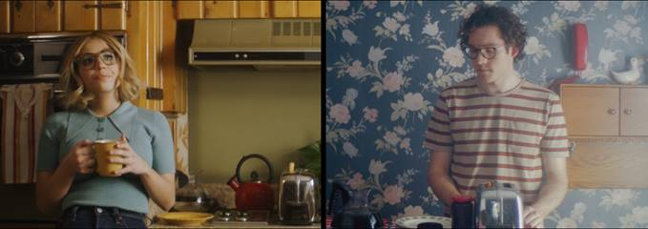

Atlantic recording artist Josie Dunne has released her new video for “Same” today. The video directed by Bree Marie Fish is streaming now on the Nashville-based singer-songwriter’s official YouTube channel HERE following its exclusive premiere earlier today via REFINERY29, who declared, “Nashville-based artist Josie Dunne is making moves. After releasing her first EP with Atlantic Records, To Be The Little Fish, in 2018, Dunne has toured with singer-songwriters Ben Rector and Julia Michaels, making a name for herself as a songwriter and up-and-coming pop act to watch.”

“Same” is also being featured in a new campaign promoting the Sperry BIONIC® Collection, which launched on World Water Day, earlier this week. Dunne has also teamed with Sperry and Zappo’s For Good as collaborator and face of the collection, made with material spun from plastic recovered from marine and coastal environments. Additional information can be found HERE.

“Same” is a song I wrote about saying “I love you” and how low key scary that can be sometimes,” Josie says about the inspiration for the track. “I think a lot of times in movies the moment a couple says “I love you” to each other is portrayed as a really cinematic and beautiful moment, but with the lyrics of “Same”, I wanted to paint it as a very normal, everyday scene: two friends in a grocery store, goofing around and the words just kinda clumsily slip out. That’s how the relationships I’ve been in have played out so with “Same”, I wanted to be true to reality.”
Hailed by Flaunt for “harnessing the raw honesty and emotion of soul music and a catchy pop beat,” “Same” follows Dunne’s recent single, “Mute” and collaboration with Big Beat recording artist Matoma for their single, “Sunday Morning (Feat. Josie Dunne).” Dunne has already spent much of this year on the road, including festival appearances and support runs alongside such artists as Ben Rector and upcoming dates with Julia Michaels.

Released last year, Dunne’s debut EP, “TO BE THE LITTLE FISH,” saw the Nashville-based Dunne marrying her love of Motown and brassy soul with contemporary pop energy and classic songcraft, including collaborations with Nathan Chapman (Taylor Swift, The Band Perry) and Amy Wadge (Ed Sheeran, Birdy) and highlighted by tracks, “Old School“ “Cool With It” and “Good Boys.”

“Josie Dunne is only 21 years old, but her music industry experience surpasses that of artists a decade older.” – CHICAGO TRIBUNE
“Josie Dunne makes a great first impression with ‘Old School’ – a retro, Motown-channeling bop about an old-fashioned kind of love,” – IDOLATOR
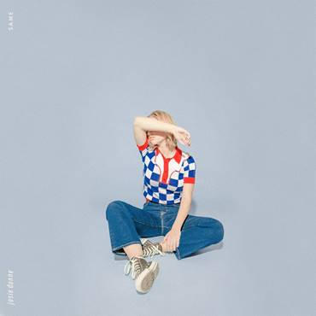

For more, please visit JOSIEDUNNE.COM
FACEBOOK * TWITTER * INSTAGRAM * YOUTUBE

