KAMAUU RETURNS WITH FIRST MUSICAL OFFERING OF 2020,
“FAR ROCKAWAY”

ACCOMPANIED BY NEW COMPANION VISUAL AVAILABLE NOW

TRACK TO BE FEATURED ON INSECURE’S NEWEST EPISODE THIS SUNDAY, APRIL 19TH ON HBO®

DOWNLOAD/STREAM “FAR ROCKAWAY” HERE
WATCH/SHARE “FAR ROCKAWAY” HERE
DOWNLOAD/STREAM THE KAMAUU-CASSETTE: MÍXD GRēēNS HERE

"A song of distant romance in a time of social distancing"

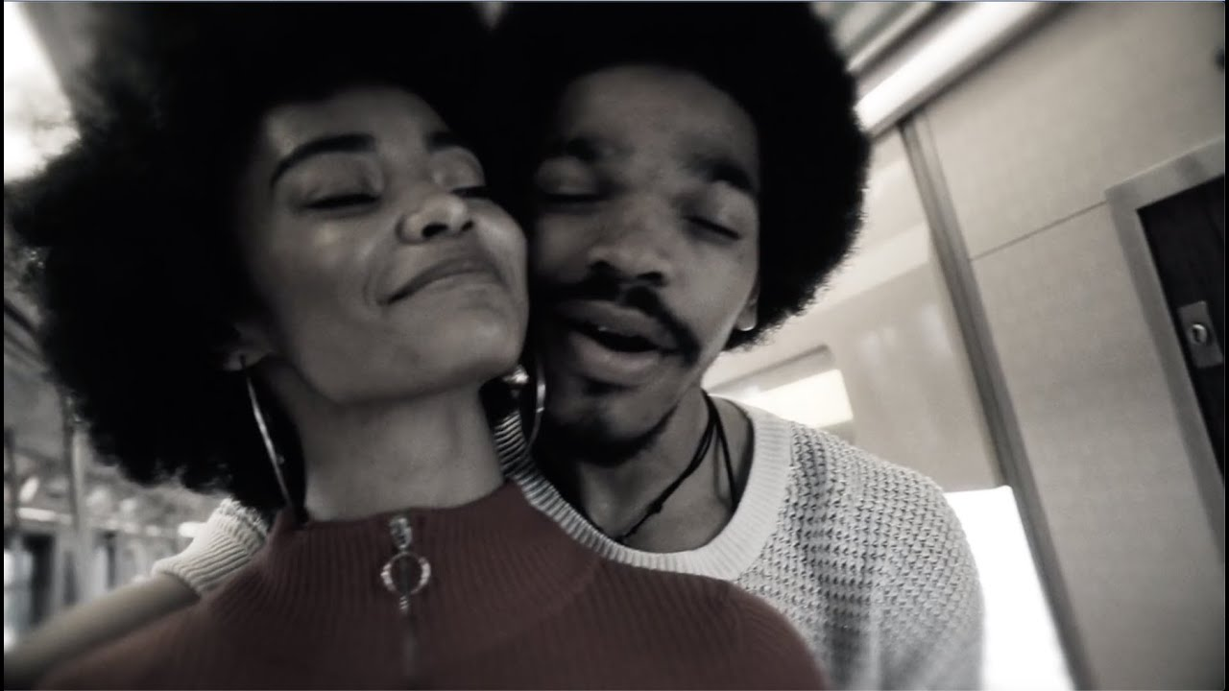

Brooklyn-based artist KAMAUU has arrived with his first musical offering of 2020 with “Far Rockaway.” His newest track is also accompanied by a companion visual and will be featured on this Sunday’s (April 19th) episode of the award-winning HBO® series Insecure airing at 10PM EST.

“Far Rockaway” is "a song of distant romance in a time of social distancing," KAMAUU explains.

Download/stream “Far Rockaway”: https://kamauu.lnk.to/FarRockaway
Watch/share “Far Rockaway”: https://kamauu.lnk.to/FarRockawayVideo
Download/stream The KAMAUU-CASSETTE: MÍXD GRēēNS: https://kamauu.lnk.to/MixdGreensID

During these unexpected times of quarantine KAMAUU has recently taken to his Instagram to share his music and positive message with fans live from his living room and he also participated in Colors’ live YouTube stream last month. He most recently wrapped the North American “Feels Like Cashmere” tour alongside the UK based Kojey Radical after touring with BJ The Chicago Kid for his nationwide “1123 Tour.” KAMAUU’s most recent project The KAMAUU-CASSETTE: MÍXD GRēēNS is available here.

For more information please visit https://www.kamauu.world/.

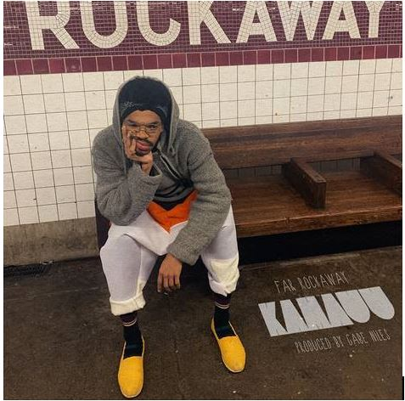

KAMAUU
Washington D.C.-born and New York-based artist, rapper, poet, and thinker KAMAUU officially signed with Atlantic Records in 2015 and made his first proper debut with his appearance on “QUEEN” from No Wyld’s critically acclaimed Ascension EP. In 2016 he released A Gorgeous Fortune EP which introduced his first solo single “Jusfayu.” The single went on to generate over 10 million cumulative streams and was handpicked by NPR as one of their “Songs We Love.” KAMAUU was also featured on The Birth of a Nation: The Inspired By Album with “The Icarus.” A year later, he unleashed his full-length debut, TheKAMAUU-CASSETTE: ŭRTH GōLD, and continued to stoke buzz. He later carefully assembled his third offering for the label, TheKAMAUU-CASSETTE: MíXD GRēēNS which was released last summer. His newest music manages to successfully weave together threads of rap, afro-beat, soul, and even doo wop.

KEEP UP WITH KAMAUU
INSTAGRAM | TWITTER | FACEBOOK | YOUTUBE | WEBSITE

PRESS CONTACT
SELAM BELAY // SELAM.BELAY@ATLANTICRECORDS.COM

# # #

