FOR IMMEDIATE RELEASE
MAY 28TH, 2021

KAMAUU RETURNS WITH “TRANSPARENCY”
ARRIVES WITH OFFICIAL VISUAL ALSO AVAILABLE NOW
SET TO PERFORM AT BRIC CELEBRATE BROOKLYN! FESTIVAL THIS JULY ALONGSIDE ARI LENNOX
“A song about transparency with all the parts of oneself – even the painful parts that we hide and bury.”
– KAMAUU
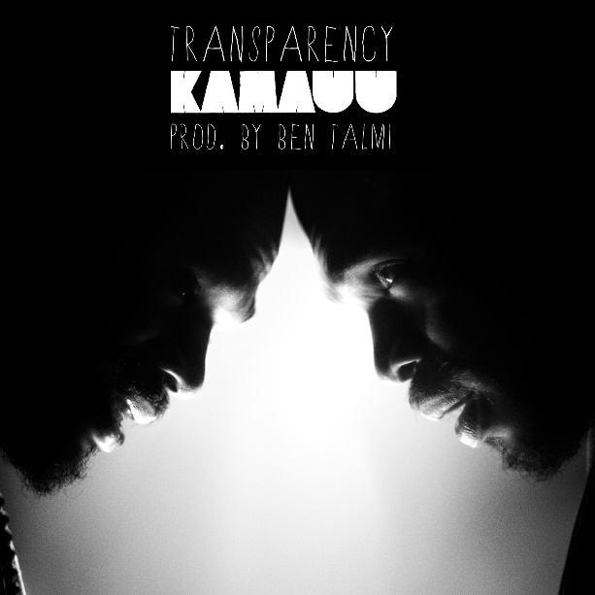
DOWNLOAD HI-RES GRAPHIC HERE

Artist, rapper, poet, and thinker KAMAUU returns to share his latest musical offering, “Transparency.” The song also arrives with an official companion visual directed by close friend and mentor, Michael Marantz. KAMAUU describes the song to be “about transparency with all the parts of oneself – even the painful parts that we hide and bury.” “TRANSPARENCY” was produced by Ben Talmi who is also responsible for producing KAMAUU’s viral interpretation of Outkast’s “Hey Ya” which now sits at over 4 million views to date.
Download/stream “Transparency”
Watch/share “Transparency”

“TRANSPARENCY” arrives after the release of “MANGO” feat Adeline (7.7M views) which The Washington Post deemed to be “the most clearheaded breakup song you’ve ever heard” while Essence went on to describe the song as “rooted in truth and candidness” and “easily the healthiest love song.” After the overwhelming success of “MANGO” KAMAUU & Adeline later recruited Masego for the remix which was followed by a Louis Futon & Robotaki remix. KAMAUU, Adeline & Masego performed their version for Genius’ Open Mic series. KAMAUU also recently stopped by Rolling Stone for a live performance of “MANGO” plus more on their Twitch and was tapped to be apart of Ad Council’s Sound It Out campaign where KAMAUU is seen participating in an intimate conversation with a middle schooler and their caregiver, facilitated by a mental health expert. He then translated the emotions and experiences into a song with “Howie and the Howl.”

As live shows slowly become apart of our norm again, it was recently announced that KAMAUU would be performing at this year’s BRIC Celebrate Brooklyn! Festival on July 31st in Prospect Park alongside Ari Lennox and Nesta. He completed the North American “Feels Like Cashmere” tour alongside the UK based Kojey Radical just last year after touring with BJ The Chicago Kid for his nationwide “1123 Tour.”

Last July, KAMAUU introduced “BOA” which served as “a song about the preservation and cultivation of the black family and community.” Shortly before that he unveiled “Far Rockaway” - a song about pain, acceptance, letting things go, and distant romance in a time of social distancing - which was originally seen on an episode of the award-winning HBO↓ series Insecure. KAMAUU’s most recent project The KAMAUU-CASSETTE: MÍXD GRēēNS has celebrated over 9M global streams and included notable release “clover”, “bamboo”, “ivy” and “absinthe” totaling nearly 3M combined views while TheKAMAUU-CASSETTE: ŭRTH GōLD celebrates over 56M global streams.

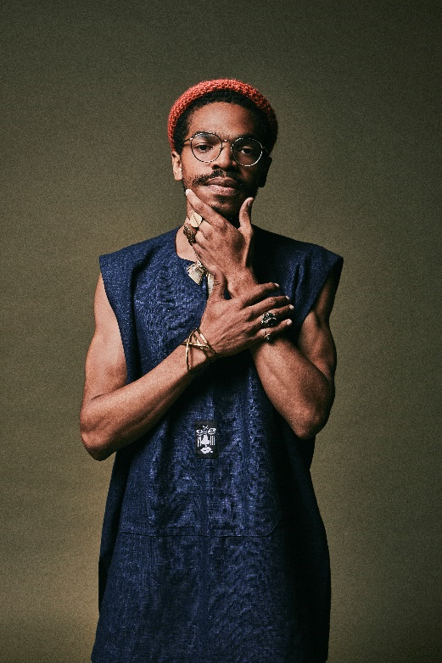

KAMAUU
Washington D.C.-born and New York-based artist, rapper, poet, and thinker KAMAUU officially signed with Atlantic Records in 2015 and made his first proper debut with his appearance on “QUEEN” from No Wyld’s critically acclaimed Ascension EP. In 2016 he released A Gorgeous Fortune EP which introduced his first solo single “Jusfayu.” The single went on to generate over 10 million cumulative streams and was handpicked by NPR as one of their “Songs We Love.” KAMAUU was also featured on The Birth of a Nation: The Inspired By Album with “The Icarus.” A year later, he unleashed his full-length debut, TheKAMAUU-CASSETTE: ŭRTH GōLD, and continued to stoke buzz. He later carefully assembled his third offering for the label, TheKAMAUU-CASSETTE: MíXD GRēēNS. His newest music manages to successfully weave together threads of rap, afro-beat, soul, and even doo wop.

KEEP UP WITH KAMAUU
INSTAGRAM | TWITTER | FACEBOOK | YOUTUBE | WEBSITE

PRESS CONTACT
SELAM BELAY // SELAM.BELAY@ATLANTICRECORDS.COM

