FOR IMMEDIATE RELEASE
FEBRUARY 26, 2021

KAMAUU TAPS MASEGO FOR “MANGO REMIX”
VISUAL FOR ORIGINAL VERSION FEATURING ADELINE CELEBRATES NEARLY 6M VIEWS
“A song about love beyond one’s own involvement.” – KAMAUU
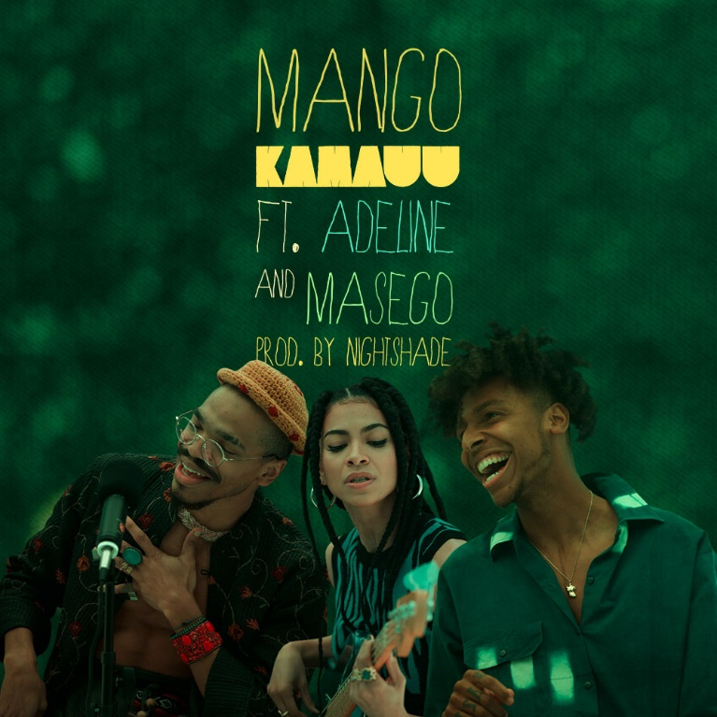
DOWNLOAD HI-RES ARTWORK HERE (DESIGNED BY KAMAUU)

“…may be the most clearheaded breakup song you’ve ever heard…”
- THE WASHINGTON POST

“Rooted in truth and candidness, this song is easily the healthiest love song.”
- ESSENCE

“KAMAUU teaches us what the ultimate form of self-love is and serves as a guide to what we should all aspire to be. Simply put, ‘MANGO’ is beautiful.”
- LADYGUNN

Today, Washington D.C.-born artist KAMAUU officially shares “MANGO Remix” featuring Adeline and Masego. The original version which featured Adeline was initially introduced in September of 2020. The visual has now earned nearly 6M views on YouTube and the track was highlighted by The Washington Post as “an incredibly smooth duet.” Masego joins KAMAUU and Adeline for the official remix which also arrives with a lyric video available now.

“’MANGO’ was inspired by the realization that in relationships, many of us think we want what’s best for our partners, though we often, more accurately, want to be with our partners in the way that feels the best or most right to us. This led me to build more relationships with people who thoroughly studied themselves. If I can trust that someone has really studied and worked on and with themselves, I can trust they have a good grasp on what’s best for them. If what’s best is someone else, who am I to block a blessing,” says KAMAUU about the origin of “MANGO”

In July, KAMAUU introduced “BOA” which served as “a song about the preservation and cultivation of the black family and community.” Shortly before that he unveiled “Far Rockaway” - a song about pain, acceptance, letting things go, and distant romance in a time of social distancing - which was originally seen on an episode of the award-winning HBO® series Insecure. KAMAUU’s most recent project The KAMAUU-CASSETTE: MÍXD GRēēNS has celebrated 3M streams and included notable release “clover”, “bamboo”, “ivy” and “absinthe” totaling over 2M combined views.
At the beginning of quarantine KAMAUU took to his Instagram to share his music and positive messages with fans live from his living room and also participated in Colors’ live YouTube stream. He most recently wrapped the North American “Feels Like Cashmere” tour alongside the UK based Kojey Radical after touring with BJ The Chicago Kid for his nationwide “1123 Tour.”

For more information please visit https://www.kamauu.world/.

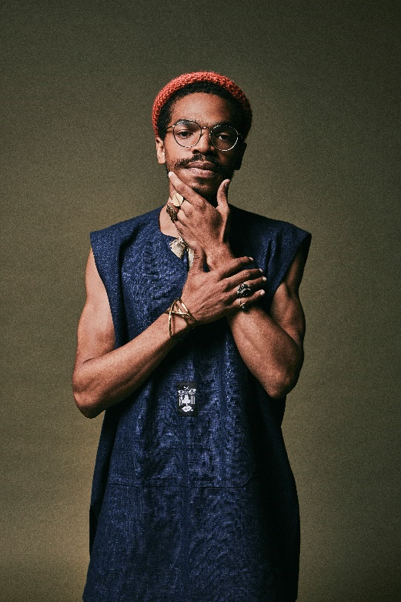

KAMAUU
Washington D.C.-born and New York-based artist, rapper, poet, and thinker KAMAUU officially signed with Atlantic Records in 2015 and made his first proper debut with his appearance on “QUEEN” from No Wyld’s critically acclaimed Ascension EP. In 2016 he released A Gorgeous Fortune EP which introduced his first solo single “Jusfayu.” The single went on to generate over 10 million cumulative streams and was handpicked by NPR as one of their “Songs We Love.” KAMAUU was also featured on The Birth of a Nation: The Inspired By Album with “The Icarus.” A year later, he unleashed his full-length debut, TheKAMAUU-CASSETTE: ŭRTH GōLD, and continued to stoke buzz. He later carefully assembled his third offering for the label, TheKAMAUU-CASSETTE: MíXD GRēēNS which was released last summer. His newest music manages to successfully weave together threads of rap, afro-beat, soul, and even doo wop.

KEEP UP WITH KAMAUU
INSTAGRAM | TWITTER | FACEBOOK | YOUTUBE | WEBSITE

PRESS CONTACT
SELAM BELAY // SELAM.BELAY@ATLANTICRECORDS.COM

# # #

