FOR IMMEDIATE RELEASE

AUGUST 9, 2017

KAP G STRIKES GOLD

“SUPAJEFE” AVAILABLE EVERYWHERE NOW

DOWNLOAD HERE

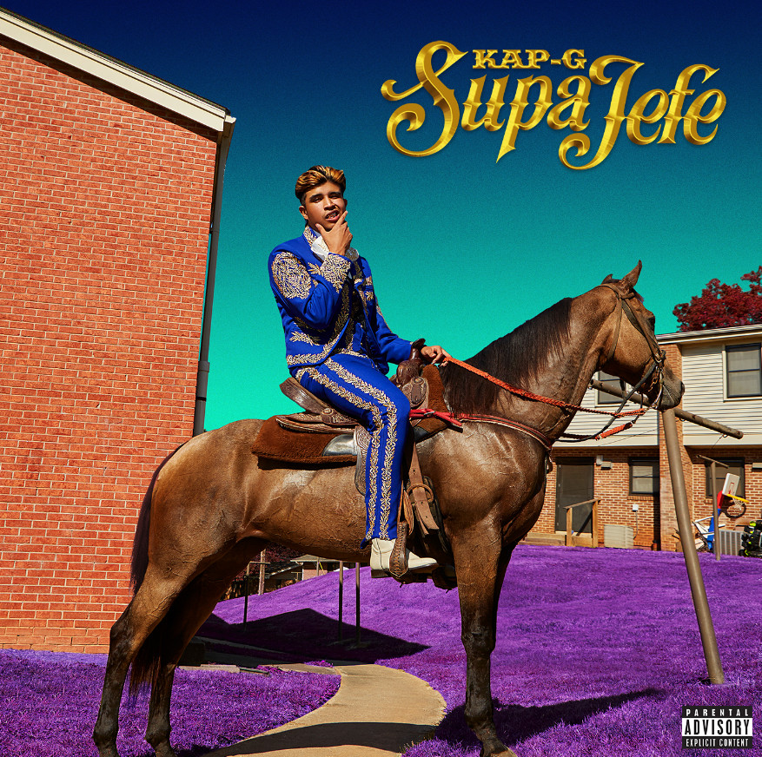
Fourtune Ent/ I am OTHER/ Atlantic recording artist Kap G has been honored by the RIAA with his very first gold single certification. The RIAA gold certification – celebrating sales and streams in excess of 500,000 units was awarded to his smash hit, “Girlfriend,” from his 2016 ‘El Southside’ Mixtape. The tracks companion visual has proven equally successful boasting more than 21 million views on his official YouTube channel.

The great news follows the release of KAP G’s 2017 mixtape “SUPAJEFE” – while Kap G is on the final month of “The SUPAJEFE Tour” with J.R. Donato. The tour wraps on September 2nd in Atlanta, GA at The Masquerade (see attached itinerary). For complete details and ticket information, please visit www.therealkapg.com/tour.

Kap G – who was named among XXL Magazine’s “XXL 2017 Freshmen Class” as well as Latina’s “Artists To Watch in 2017” – was selected to be a part of Sprite’s Summer campaign. Throughout the campaign his lyrics will be featured on 16-ounce Sprite cans and 20-ounce bottles that will be available for a limited time only in nationwide convenience stores and other retail locations. He stars in the campaign alongside Vince Staples, Lil Yachty, DRAM, Vic Mensa, and Kamaiyah.

Hailed by XXL as “loaded with hot new tunes and great features,” “SUPAJEFE” showcases such smoking tracks as “Icha Gicha (Feat. Pharrell Williams)” and the recently released “Rings,” named by XXL upon its release last month as one of the “Best Songs of the Week.” Produced by Young Exclusive and Cardo, “Rings” is streaming now at Kap G’s official YouTube channel.

As if all that weren’t enough, “SUPAJEFE” is further highlighted by Kap G’s breakout 2017 single, “Freakin ‘N’ Geekin.” Produced by Go Grizzly (Kevin Gates, Akon), the track earned attention from national media outlets including XXL, Rap-Up, and HotNewHipHop, which declared “the bouncy party banger could turn out to be Kap G's first 2017 hit.” In addition, the official “Freakin ‘N’ Geekin” companion video – directed by Jon J (Rick Ross, Wale, Meek Mill) – premiered last month and can be viewed now at Kap G’s own YouTube channel.

Kap G – who only just returned from a featured role on Chris Brown’s epic “The Party Tour” – has been hailed as one of the freshest and most important new voices in hip hop for his extraordinary musical chronicles of the Mexican-American experience. Raised in College Park, GA, the gifted rapper made his musical bones in high school, releasing a series of increasingly popular tracks including “Tatted Like Amigos (Feat. Chief Keef).” The next two years saw Kap unleash mixtapes (including 2014’s “LIKE A MEXICAN”) and tracks like the provocative “La Policia,” each earning him further praise and a wider mainstream audience.

For more, please visit www.therealkapg.com, www.facebook.com/TheRealKapG, twitter.com/TheRealKapG, instagram.com/therealkapg, youtube.com/therealkapg, and www.atlanticrecords.com.

(TOUR ITINERARY ATTACHED)
KAP G
REMAINING “THE SUPAJEFE TOUR” 2017
All Dates Feat. Special Guest J.R. Donato Except †

AUGUST
10 Tucson, AZ 191 Toole
11 Roswell, NM Epiq Night Club
12 Lubbock, TX Depot Patio
14 Dallas, TX RBC
15 Austin, TX Grizzly Hall
16 San Antonio, TX Alamo City Music Club
17 Houston, TX Studio @ Warehouse Live
18 New Orleans, LA Gasa Gasa
20 Pensacola, FL Vinyl Music Hall
23 Jacksonville, FL 1904 Music Hall
24 Tampa, FL The Orpheum
25 Orlando, FL Backbooth
26 Miami, FL The Hangar

SEPTEMBER
2 Atlanta, GA The Masquerade

# # #

For press inquiries:
Sydney Margetson / 212.707.2262 / Sydney.Margetson@atlanticrecords.com
Ariana White (Tour) / 212.707.2236 / Ariana.White@atlanticrecords.com

