FOR IMMEDIATE RELEASE

NOVEMBER 2, 2018

KAP G IMAGINES “A DAY WITHOUT A MEXICAN” WITH NEW SINGLE AND VIDEO

GOLD CERTIFIED RAPPER RELEASES NEW TRACK AND VIDEO
CELEBRATING LATINO-AMERICAN CULTURE

COMPANION VISUAL AVAILABLE NOW FOLLOWING LAST NIGHT’S EXCLUSIVE SCREENING & PANEL DISCUSSION IN ATLANTA FOR LEADING MEMBERS OF THE LATINO COMMUNITY

NEW SINGLE FOLLOWS RELECTLY RELEASED MIXTAPE, “no kap”

DOWNLOAD/STREAM “A DAY WITHOUT A MEXICAN” HERE

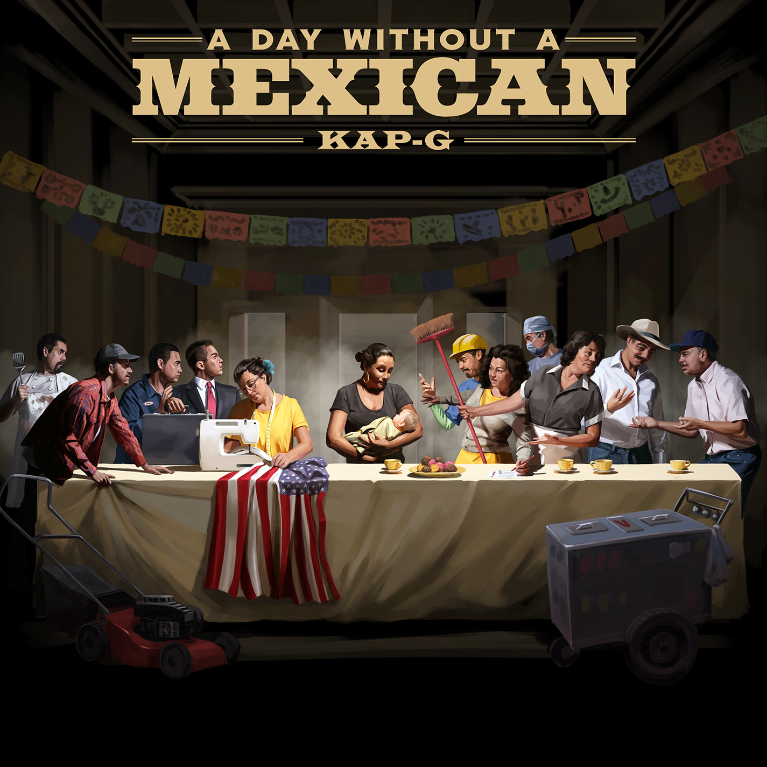
Fourtune Ent/i am OTHER/Atlantic recording artist Kap G has announced today’s release of a remarkable new single. “A Day Without a Mexican” is available today at all DSPs and streaming services here.

A well-timed celebration of Latino-American culture and the gold-certified rapper’s own Mexican heritage, “A Day Without A Mexican” is joined by a new companion visual, available now via Kap G’s official YouTube. Its release follows today’s exclusive premiere via Billboard.

In addition, last night saw Kap G host a special screening of “A Day Without a Mexican” in Atlanta, followed by a stimulating panel discussion with some of the city’s most prominent Latino community members. Head here for a glimpse into the night.

“A Day Without A Mexican” follows the recent arrival of Kap G’s new mixtape, “no kap,” available now at all DSPs and streaming services now here. “no kap” featured guest appearances from Playboy Carti and Chief Cook It Up alongside the recently released tracks, “Raise The Roof (Feat. Ty Dolla $ign)” and “Want My M’s.” The latter track was joined by a One K Motion Pictures directed companion visual streaming HERE following its exclusive premiere on XXL earlier this summer.

“no kap” marked the long-awaited follow-up to last year’s smash mixtape, “SUPAJEFE.” Hailed by XXL as “loaded with hot new tunes and great features,” “SUPAJEFE” showcased such smoking tracks as “I See You (Feat. Chris Brown),” “Icha Gicha (Feat. Pharrell Williams),” and “Rings,” the latter named by XXL upon its release as one of the “Best Songs of the Week.”

Kap G has been praised as one of the freshest and most important new voices in hip hop for his one-of-a-kind musical chronicles of the Mexican-American experience. The ATL-based MC made his i am OTHER/Atlantic debut with 2016’s acclaimed “EL SOUTHSIDE” mixtape, highlighted by the RIAA gold certified hit single, “Girlfriend.” Hailed by Complex as “a low-key record without being subtle, a cold performance so icy it's as if it'd been chilled before release,” “Girlfriend” was joined by a blockbuster companion video, now approaching 27 million views.

Named among XXL Magazine’s “XXL 2017 Freshmen Class” as well as Billboard’s “10 Hottest MCs of Latin Descent in Hip-Hop Today,” Kap G headlined his own headline “Supajefe Tour” in 2017 while also joining Chris Brown, 50 Cent, Fabolous, and O.T. Genasis on the epic “Party Tour.” Kap also performed during 2017’s BET Experience and was among the stars playing in the annual BET Celebrity Basketball Game during 2018’s BET Awards earlier this year, joining other ballers such as Tank, The Game, YFN Lucci, Rich Homie Quan and more.

CONNECT WITH KAP G
OFFICIAL
FACEBOOK
TWITTER
INSTAGRAM
YOUTUBE

PRESS CONTACTS
SYDNEY MARGETSON // SYDNEY.MARGETSON@ATLANTICRECORDS.COM
VERONICA BUENROSTRO // v@supersonixmedia.com

