FOR IMMEDIATE RELEASE

APRIL 14, 2017

KAP G IS THE “SUPAJEFE”

GROUNDBREAKING RAPPER UNVEILS INCREDIBLE NEW PROJECT

COLLECTION INCLUDES THE NEW SINGLE, “I SEE YOU (FEAT. CHRIS BROWN),”
ALONGSIDE ACCLAIMED HIP-HOP HITS “RINGS” AND “FREAKIN ‘N’ GEEKIN”

“THE PARTY TOUR” WITH CHRIS BROWN, FABOLOUS, AND O.T. GENASIS
TRAVELING NORTH AMERICA THROUGH LATE MAY

“SUPAJEFE” AVAILABLE EVERYWHERE TODAY

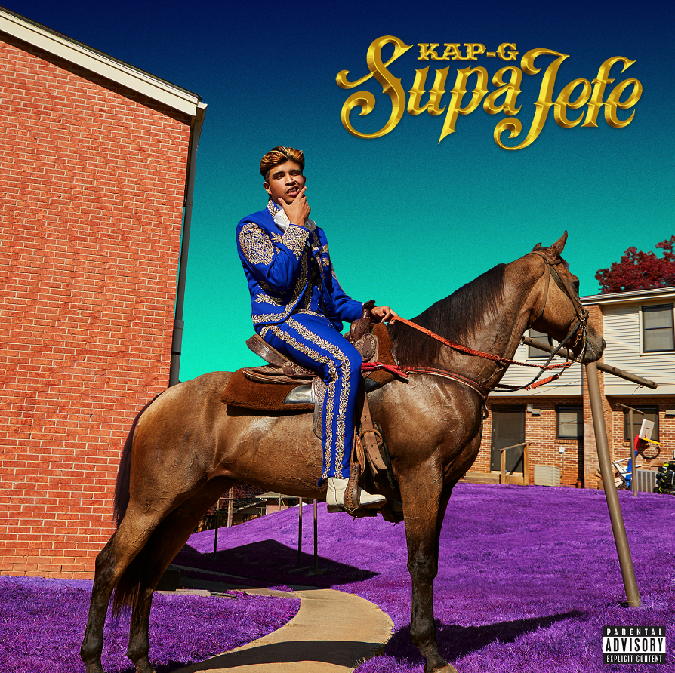

DOWNLOAD | STREAM

i am OTHER/Fourtune Ent/Atlantic recording artist Kap G has announced the release of latest project, “SUPAJEFE” – available at all digital retailers today http://atlantic.lnk.to/SupaJefe.

The project – which sees features from Kapfe, Dae Dae, and i am OTHER founder Pharrell Williams – also showcases the recently released “Rings,” named by XXL upon its release last month as one of the “Best Songs of the Week” and the sizzling new single, “I See You (Feat. Chris Brown).” Produced by Young Exclusive and Cardo, “Rings” is streaming now at Kap G’s official YouTube channel.

Kap G is currently celebrating “SUPAJEFE” with an epic U.S. tour alongside Chris Brown. “The Party Tour” – presented by Live Nation and also featuring Fabolous, and O.T. Genasis – kicked off last month and will continue through a Tuesday, May 23rd finale at The Forum in Los Angeles, CA (see attached itinerary). For complete details and ticket information, please visit www.therealkapg.com/tour.

“SUPAJEFE” also includes Kap G’s breakout 2017 single, “Freakin ‘N’ Geekin,” available now at all DSPs and streaming services. Produced by Go Grizzly (Kevin Gates, Akon), the track earned attention from national media outlets including XXL, Rap-Up, and HotNewHipHop, which declared “the bouncy party banger could turn out to be Kap G's first 2017 hit.” In addition, the official “Freakin ‘N’ Geekin” companion video – directed by Jon J (Rick Ross, Wale, Meek Mill) – premiered last month and can be viewed now at Kap G’s own YouTube channel.

Kap G made his i am OTHER/Fourtune Ent/Atlantic debut with last year’s acclaimed “EL SOUTHSIDE” mixtape, hosted by DJ Drama and available now on the iTunes Store, Google Play, Amazon, and Spotify. The project – which includes production from Pharrell Williams and guest spots from Young Thug, YFN Lucci, Nechie, and Ca$h Out – is highlighted by such tracks as “Don’t Need Em (Feat. Young Thug)” and the hit single, “Girlfriend.” Hailed by Complex as “a low-key record without being subtle, a cold performance so icy it's as if it'd been chilled before release,” “Girlfriend” has drawn more than 41 million streams and is joined by a blockbuster companion video, now exceeding 16 million views at Kap’s official YouTube channel alone. As if that weren’t enough, a very special “Girlfriend (Remix) (Feat. Ty Dolla $ign and Quavo)” is available now on the iTunes Store and Spotify.

Kap G has been hailed as one of the freshest and most important new voices in hip hop for his extraordinary musical chronicles of the Mexican-American experience. Raised in College Park, GA, the gifted rapper made his musical bones in high school, releasing a series of increasingly popular tracks including “Tatted Like Amigos (Feat. Chief Keef).” The next two years saw Kap unleash mixtapes (including 2014’s “LIKE A MEXICAN”) and tracks like the provocative “La Policia,” each earning him further praise and a wider mainstream audience.

For more, please visit www.therealkapg.com, www.facebook.com/TheRealKapG, twitter.com/TheRealKapG, instagram.com/therealkapg, youtube.com/therealkapg, and www.atlanticrecords.com.

(TRACK LISTING & TOUR ITINERARY ATTACHED)

KAP G
“SUPAJEFE”
(i am OTHER/Fourtune Ent/Atlantic)

1. CEO (Feat. Kapfe)
2. Rings
3. MCM
4. I See You (Feat. Chris Brown)
5. Freakin ‘N’ Geekin
6. Basic
7. Ay Yi Yi
8. Motivation
9. I Heard (Feat. Dae Dae)
10. Icha Gicha (Feat. Pharrell Williams)
11. Hope
12. Motions
KAP G
ON TOUR 2017
ALL DATES W/CHRIS BROWN’S THE PARTY TOUR

APRIL
15 Miami, FL American Airlines Arena
16 Tampa, FL Amalie Arena
18 Jacksonville, FL Veterans Memorial Arena
20 Hampton, VA Hampton Coliseum
21 Washington, DC Verizon Center
22 Philadelphia, PA Wells Fargo Center
24 Brooklyn, NY Barclays Center
28 Rosemont, IL Allstate Arena
29 Columbus, OH Schottenstein Center
30 Nashville, TN Bridgestone Arena

MAY
2 Atlanta, GA Philips Arena
4 Houston, TX Toyota Center
6 Dallas, TX American Airlines Center
8 Denver, CO Pepsi Center
10 Portland, OR Moda Center
11 Seattle, WA KeyArena
13 Sacramento, CA Golden 1 Center
15 Phoenix, AZ Talking Stick Resort Arena
16 Anaheim, CA Honda Center
18 San Jose, CA SAP Center
19 San Diego, CA Viejas Arena @ Aztec Bowl
20 Las Vegas, NV MGM Grand Garden Arena
23 Los Angeles, CA The Forum

# # #

Sydney Margetson (National)
212.707.2262
Sydney.Margetson@atlanticrecords.com

Ariana White (Tour)
212.707.2236
Ariana.White@atlanticrecords.com

