FOR IMMEDIATE RELEASE
JULY 29, 2019

KEVIN GATES ANNOUNCES MASSIVE HEADLINE TOUR
CELEBRATING FORTHCOMING ALBUM I’M HIM

THE NATIONWIDE “I’M HIM TOUR” GETS UNDERWAY OCTOBER 12 IN CHICAGO AND CONTINUES ACROSS THE U.S. WITH A FINAL SHOW IN SEATTLE NOVEMBER 30

GATES’ MASSIVE SUMMER ANTHEMS “PUSH IT” & “FACTS” OUT NOW

MULTI-PLATINUM ARTIST WITH OVER 5 BILLION STREAMS
CURRENTLY ON TOUR WITH CARDI B

I’M HIM SET TO ARRIVE SOON
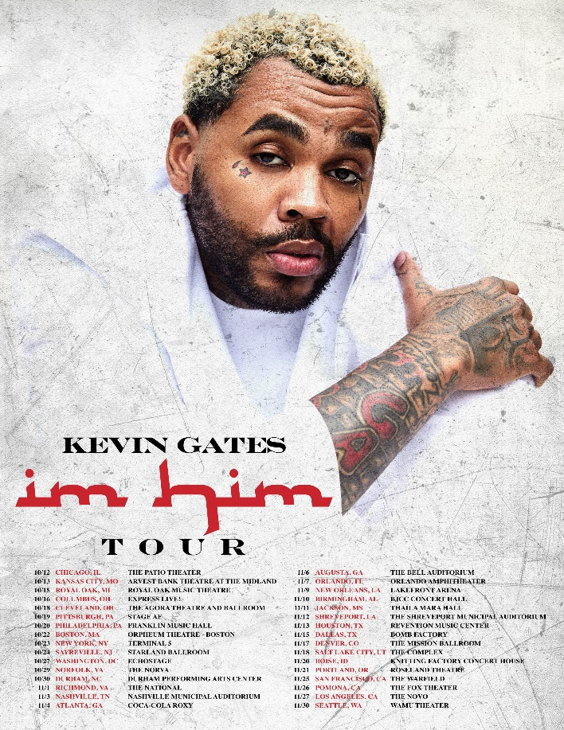

Bread Winners Association recording artist Kevin Gates has announced a massive nationwide headline tour in support of his highly-anticipated new album I’M HIM, set to arrive later this year. The I’M HIM TOUR sees the multi-platinum artist with over 5 billion streams under his belt artist taking on his largest venues to date. Shows will get underway in Chicago, IL at The Patio Theatre on October 12, and continue across the U.S. with a finale show in Seattle, WA at the WaMu Theatre. Watch a trailer for the tour HERE.

“I’m Him,” says Gates of the tour. “I’m going to take everyone that comes out to see me on a journey of everything that I’m Him is. It’s going to be a movie.”

Every ticket purchased online for Gates’ 2019 tour comes with a digital copy I’M HIM. Details on how to redeem the digital album will be emailed on album release day. Tickets will first be available through an artist presale on Wednesday, July 31st at 10am local time, and will be available to the general public on Friday, August 2nd at 10am local. Full tour itinerary below. For ticket information, please visit www.kvngates.com.

Gates recently brought his charm and charisma to New York City, stopping by Complex’s “Everyday Struggle,” and Genius’ “Verified” series. Watch his incredibly entertaining, viral interview with Akademiks, Nadeska and Wayno HERE, plus watch him breakdown the lyrics for “Push It” on Genius HERE.

Gates has released two powerful new summer anthems leading up to his hugely-anticipated album I’M HIM. The relentless banger “Push It” and the undeniably catchy “Facts” are both available now at all DSPs and streaming services HERE. Each track was delivered alongside compelling companion visuals, which have racked up over 10 million views combined on the multi-platinum rap superstar’s official YouTube channel. Watch “Facts” HERE and “Push It” HERE.

“Push It” and “Facts” herald Gates’ hugely anticipated new album, I’M HIM – the enigmatic figure’s first official album release in more than three years, following 2016’s now-classic debut, ISLAH. Gates has been releasing a constant stream of music since his debut album. Despite his legal challenges and incarceration circumstances over the past three years, the Baton Rouge-raised emcee hasn’t stopped delivering heavy-hitting music to his fans, including BY ANY MEANS 2, CHAINED TO THE CITY, LUCA BRASI 3, and his latest ONLY THE GENERALS GON UNDERSTAND, available now at all DSPs and streaming services HERE. The six-track project – which includes such acclaimed singles as “Big Gangsta” and “#Yukatán” – has fast proven another smash for Gates, now with over 80 million streams.

ISLAH affirmed Kevin Gates as one of hip-hop’s greatest new stars, second only to Drake as the best-selling hip-hop artist of 2016. One of the rare major hip hop releases to contain no featured artists, the album made an incredible chart debut upon its January 2016 arrival, entering Billboard’s “Top Rap Albums” chart at #1 while also coming in at #2 on the SoundScan/Billboard 200 with sales in excess of 110,000 – Gates’ biggest sales week to date. ISLAH of course includes a pair of smashes in the 3x platinum certified “Really Really” and the 4x platinum, top 20 blockbuster, “2 Phones,” the latter of which ascended to #17 on Billboard’s overall “Hot 100” – Gates’ highest charting mainstream single to date. What’s more, Gates’ distinctive accompanying visuals saw him ranked by the New York Times as the #5 most-watched artist on YouTube in the US between January 2016 and April 2017. Indeed, “Really Really” has drawn more than 222 million views thus far HERE, while “2 Phones” has earned a remarkable 271 million views and counting via YouTube alone.

KEVIN GATES ON TOUR 2019
*on tour with Cardi B

JULY
30 – Indianapolis, IN - Bankers Life Fieldhouse *
31 – Charlottesville, VA – John Paul Jones Arena *

OCTOBER
12 – Chicago, IL – The Patio Theater
13 – Kansas City, MO – Arvest Bank Theatre at the Midland
15 – Royal Oak, MI – Royal Oak Music Theatre
16 – Columbus, OH – Express Live!
18 – Cleveland, OH – The Agora Theatre and Ballroom
19 – Pittsburgh, PA – Stage AE
20 – Philadelphia, PA – Franklin Music Hall
22 – Boston, MA – Orpheum Theatre
23 – New York, NY – Terminal 5
24 – Sayreville, NJ – Starland Ballroom
25 – Philadelphia, PA – Franklin Music Hall
27 – Washington, DC – Echostage
29 – Norfolk, VA – The Norva
30 – Durham, NC – Durham Performing Arts Center

NOVEMBER
1 – Richmond, VA – The National
3 – Nashville, TN – Nashville Municipal Auditorium
4 – Atlanta, GA – Coca-Cola Roxy
6 – Augusta, GA – The Bell Auditorium
7 – Orlando, FL – Orlando Amphitheater
9 – New Orleans, LA – Lakefront Arena
10 – Birmingham, AL – BJCC Concert Hall
11 – Jackson, MS – Thalia Maria Hall
12 – Shreveport, LA – The Shreveport Municipal Auditorium
13 – Houston, TX – Revention Music Center
15 – Dallas, TX – Bomb Factory
17 – Denver, CO – The Mission Ballroom
18 – Salt Lake City, UT – The Complex
20 – Boise, ID – Knitting Factory Concert House
21 – Portland, OR – Roseland Theatre
25 – San Francisco, CA – The Warfield
26 – Pomona, CA – The Fox Theater
27 – Los Angeles, CA – The Novo
30 – Seattle, WA – WaMu Theater

# # #

CONNECT WITH KEVIN GATES
PRESS PHOTOS // ARTWORK // INSTAGRAM
WEBSITE // TWITTER // YOUTUBE // OFFICIAL BWA // ATLANTIC RECORDS

