FOR IMMEDIATE RELEASE
DECEMBER 3, 2019

KEVIN GATES MAKES AMERICA TRAP AGAIN
WATCH NEW VIDEO FOR “M.A.T.A” HERE

GATES TO PERFORM “I’M NOT GOIN’” WITH GUCCI MANE ON JIMMY KIMMEL LIVE! TOMORROW NIGHT

LISTEN TO LUCA BRASI 3 HERE
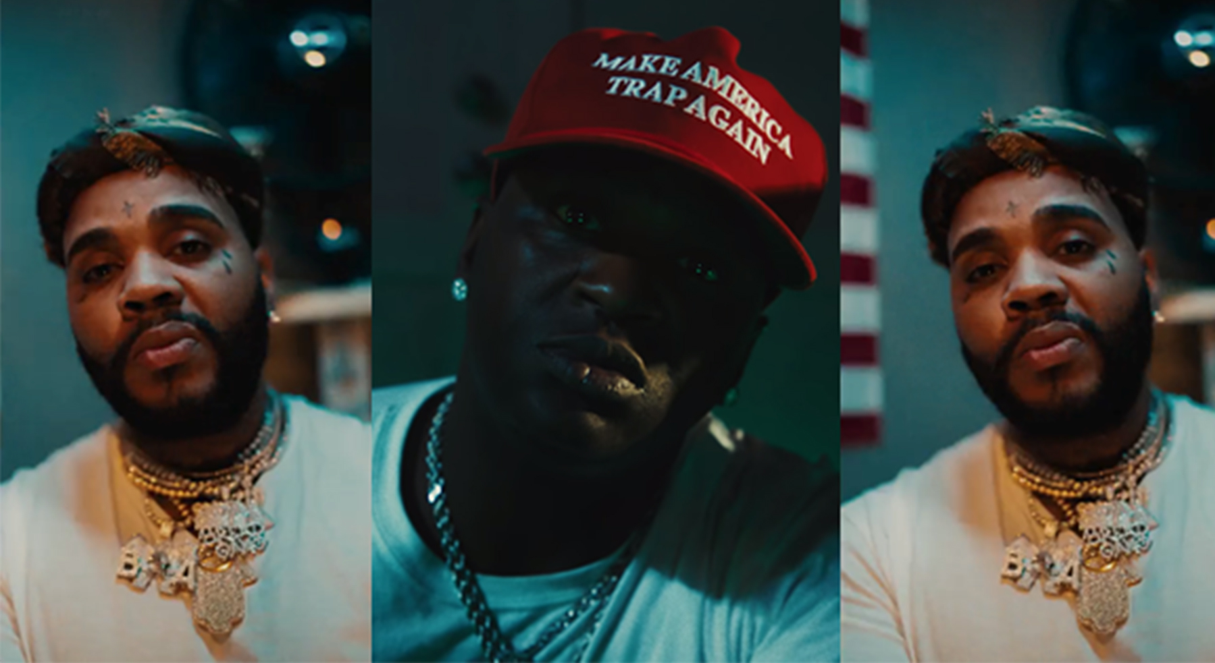

Bread Winners Association recording artist Kevin Gates has unveiled an incredible new companion visual for “M.A.T.A.,” a fan-favorite featured on the multi-platinum rap superstar’s new mixtape LUCA BRASI 3. Gates – who teased the video over the weekend with a controversial presidential clip – filmed the visual at his new business venture, an escape room in Los Angeles called the “House On Carolina,” which is a replica of one of Kevin’s Baton Rouge trap houses and open to the public indefinitely. “M.A.T.A.” is streaming now, watch HERE.

The release of “M.A.T.A.” comes just one day before Gates makes his return to national late-night television, with a performance on ABC’s Jimmy Kimmel Live! alongside Gucci Mane for their song “I’m Not Goin’.” Gates made his national TV debut on The Wendy Williams Show in 2016 followed by his late-night debut CONAN in May 2016.

“M.A.T.A.” follows the recently released video for Gates’ “Great Man,” which now boasts over 5 million views and features cameos by Gates’ immediate family as well as his close friend, New York Giants wide receiver Odell Beckham Jr.

“M.A.T.A.” and “Great Man” are some of the many highlights from LUCA BRASI 3, which is available now at all DSPs and streaming services HERE. Gates’ first mixtape since his release from prison earlier this year made an explosive chart debut last month, entering the SoundScan/Billboard 200 at #4 with sales equivalents exceeding 78,000. LUCA BRASI 3 also includes the recent hits, “Me Too,” “Money Long,” and “Adding Up,” the latter two of which are joined by new companion visuals streaming via Gates’ official YouTube channel. In addition, “Kevin Gates x Sway: The Definitive Interview” premiered last month exclusively via YouTube. The controversial four-part series can be viewed HERE.

LUCA BRASI 3 has drawn critical acclaim equal to its popular success, with HotNewHipHop declaring that “Kevin Gates remains one of the most fascinating personalities and talents.” “Gates doesn’t let his time away knock him off his stride,” wrote Pitchfork. “On ‘LUCA BRASI 3,’ Gates serves as a corrective to a rap landscape that favors absolutes. In his world, everything is always a little less clear-cut.” SPIN hailed the mixtape’s “Money Long” and “Great Man” as “quintessential Gates: melancholic trap songs punctuated by his partially crooned, highly emotive raps.” “(Gates’) everyman hustler persona, charm, and vulnerability are his most valuable assets,” declared Consequence of Sound. “He is clear by the close of ‘LUCA BRASI 3’ that nothing can stop him.”

Widely regarded among hip-hop’s greatest new stars, second only to Drake as the best-selling hip-hop artist of 2016, Gates recently wrapped up his epic sold-out “Luca Brasi 3 Tour.” He’ll be announcing additional live dates soon – for updates, please visit www.kvngates.com.

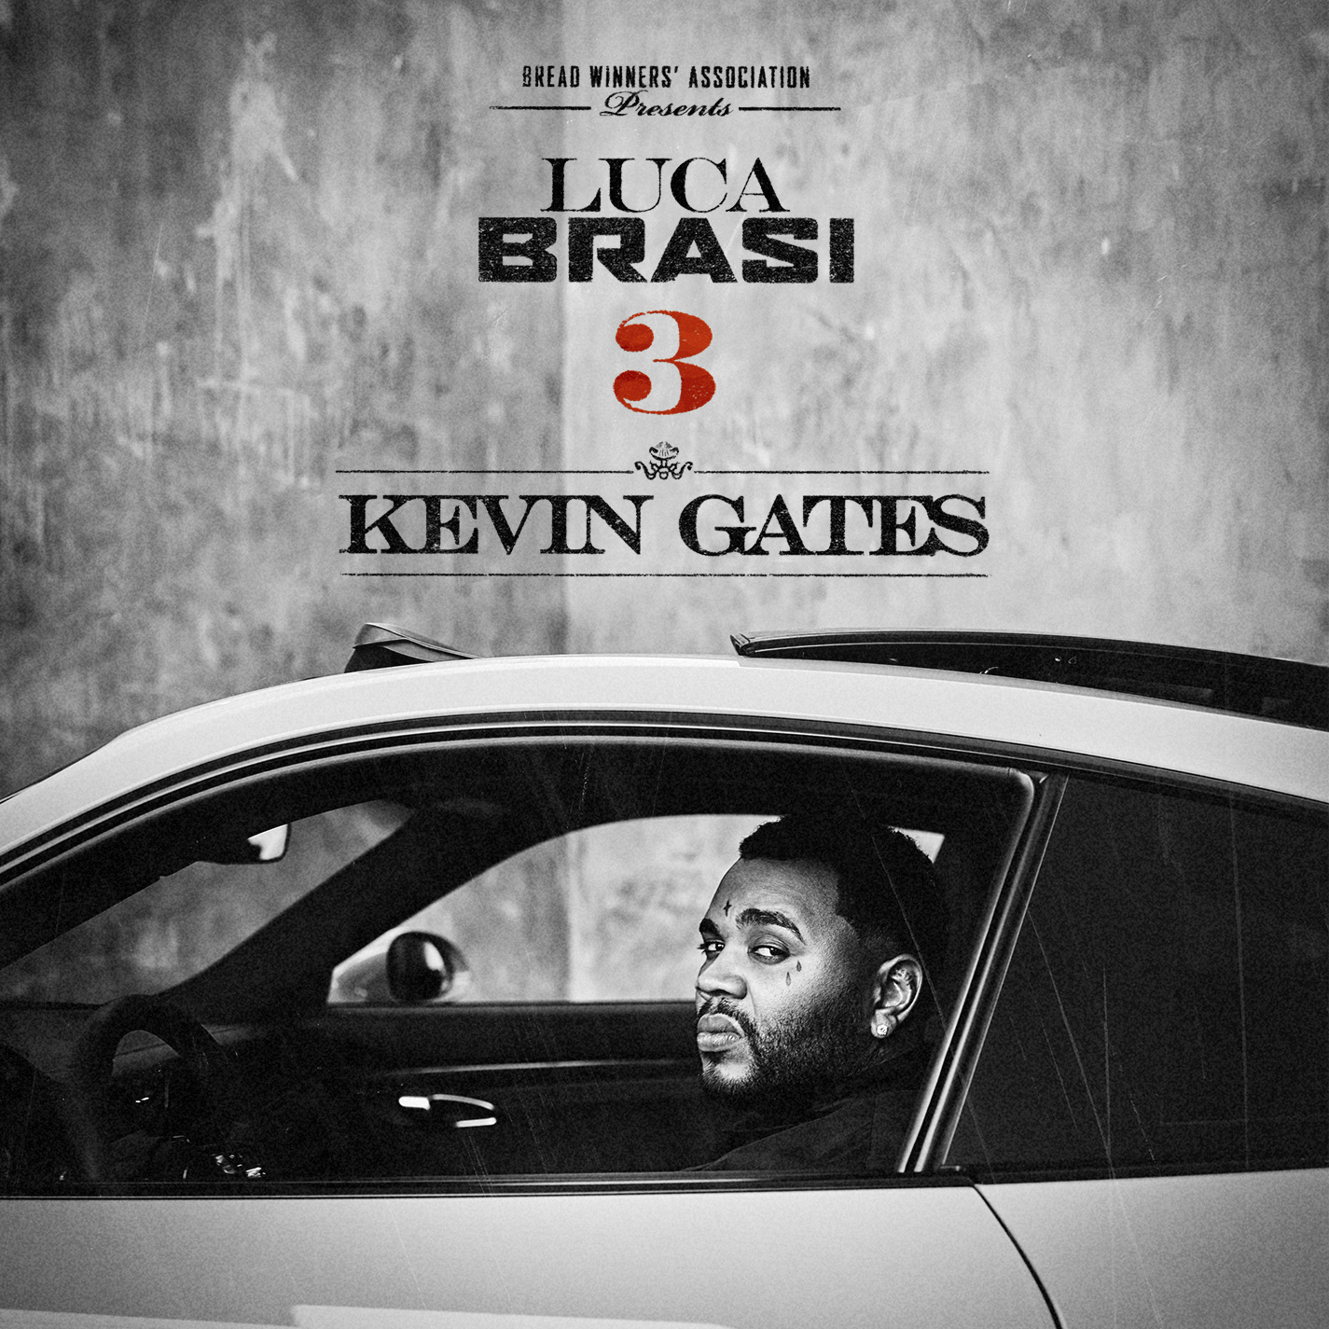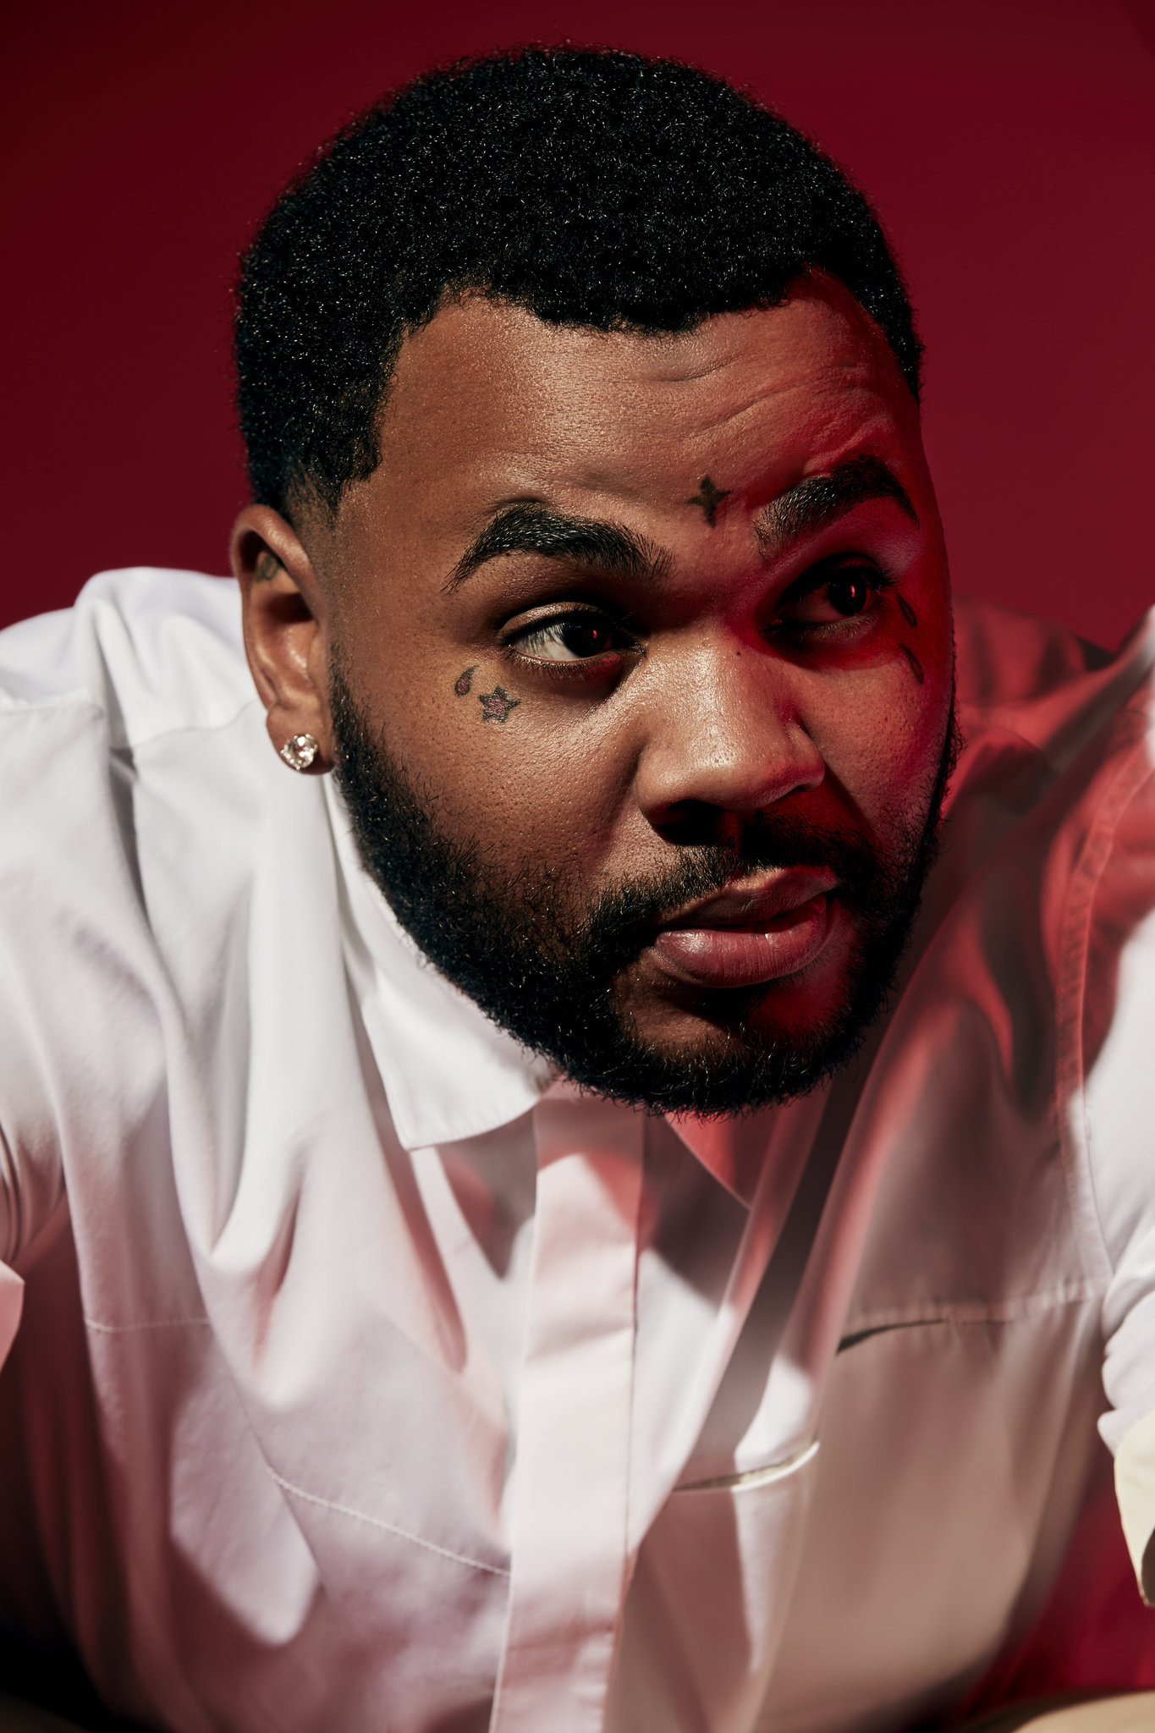

KEVIN GATES ON TOUR 2019
*with Cardi B

JULY
30 – Indianapolis, IN - Bankers Life Fieldhouse *
31 – Charlottesville, VA – John Paul Jones Arena *

OCTOBER
12 – Chicago, IL – The Patio Theater
13 – Kansas City, MO – Arvest Bank Theatre at the Midland
15 – Royal Oak, MI – Royal Oak Music Theatre
16 – Columbus, OH – Express Live!
18 – Cleveland, OH – The Agora Theatre and Ballroom
19 – Pittsburgh, PA – Stage AE
20 – Philadelphia, PA – Franklin Music Hall
22 – Boston, MA – Orpheum Theatre
23 – New York, NY – Terminal 5
24 – Sayreville, NJ – Starland Ballroom
25 – Philadelphia, PA – Franklin Music Hall
27 – Washington, DC – Echostage
29 – Norfolk, VA – The Norva
30 – Durham, NC – Durham Performing Arts Center

NOVEMBER
1 – Richmond, VA – The National
3 – Nashville, TN – Nashville Municipal Auditorium
4 – Atlanta, GA – Coca-Cola Roxy
6 – Augusta, GA – The Bell Auditorium
7 – Orlando, FL – Orlando Amphitheater
9 – New Orleans, LA – Lakefront Arena
10 – Birmingham, AL – BJCC Concert Hall
11 – Jackson, MS – Thalia Maria Hall
12 – Shreveport, LA – The Shreveport Municipal Auditorium
13 – Houston, TX – Revention Music Center
15 – Dallas, TX – Bomb Factory
17 – Denver, CO – The Mission Ballroom
18 – Salt Lake City, UT – The Complex
20 – Boise, ID – Knitting Factory Concert House
21 – Portland, OR – Roseland Theatre
25 – San Francisco, CA – The Warfield
26 – Pomona, CA – The Fox Theater
27 – Los Angeles, CA – The Novo
30 – Seattle, WA – WaMu Theater

MORE ON KEVIN GATES
PRESS PHOTOS // ARTWORK // INSTAGRAM
WEBSITE // TWITTER // YOUTUBE // OFFICIAL BWA // ATLANTIC RECORDS

