FOR IMMEDIATE RELEASE

AUGUST 18, 2017

KODAK BLACK IS BACK WITH “PROJECT BABY TWO”

ACCLAIMED RAPPER ANNOUNCES EAGERLY AWAITED NEW MIXTAPE

INCLUDES NEW TRACK, “ROLL IN PEACE” (FT. XXXTENTACION)

NEW PROJECT FOLLOWS RIAA CERTIFIED GOLD ALBUM “PAINTING PICTURES”

SOLD OUT “FIRST SHOW OUT” CONCERT STREAMING NOW AT YOUTUBE

“PROJECT BABY TWO” ARRIVES AT ALL DSPs TODAY

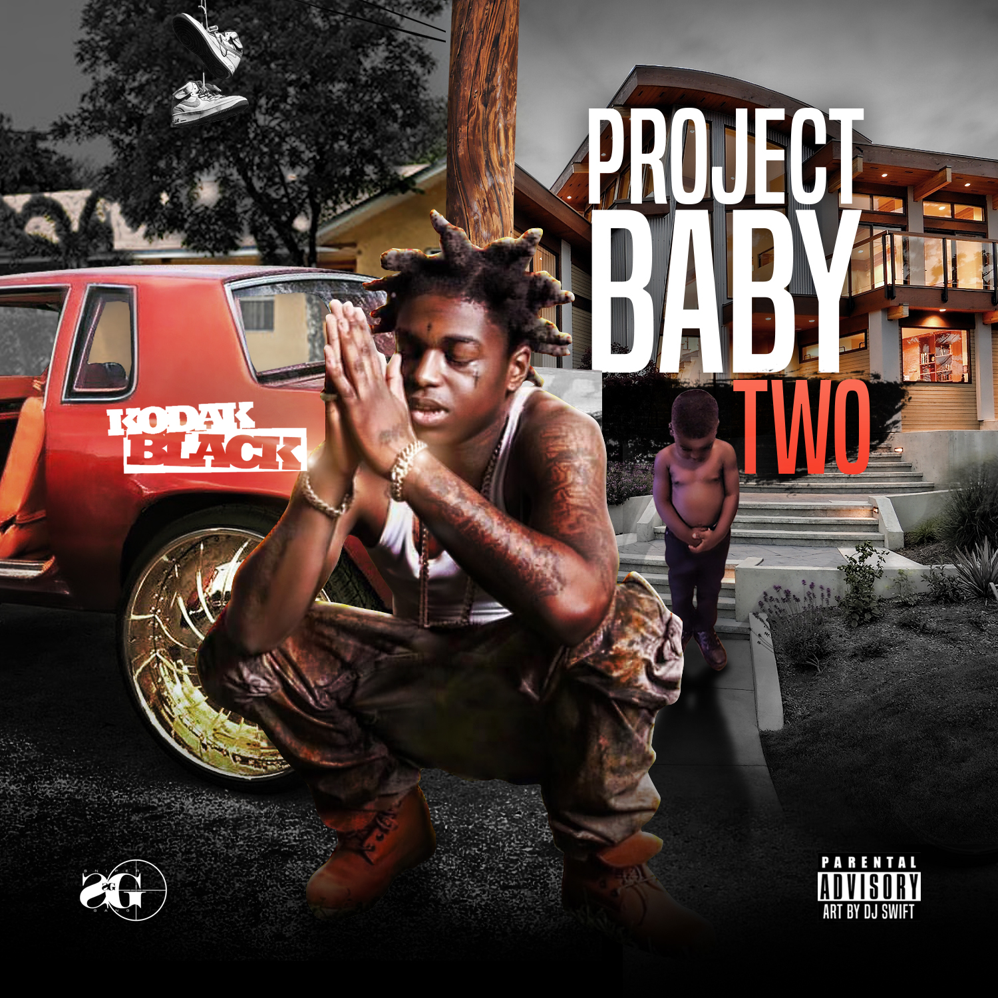

Atlantic recording artist Kodak Black has announced the release of his hugely anticipated new mixtape. “PROJECT BABY TWO” arrives at all DSPs and streaming services today.

“PROJECT BABY 2” includes the new track; “Roll in Peace” (ft. XXXTentacion) produced by London On Da Track. The mixtape also features Offset of the Migos and production by longtime collaborators Dyryk and Ben Billions.
Recently named as an MTV Video Music Award nominee for “Best New Artist,” Kodak Black took to the stage of the Watsco Center at the University of Miami last week for a sold out “First Show Out” celebrating his June release from Broward County Jail. The electrifying performance aired lived via YouTube and can be viewed now in its entirety on Kodak Black’s official channel.

“PROJECT BABY 2” follows Kodak Black’s breakthrough debut album, “PAINTING PICTURES,” which is now RIAA certified GOLD and arrived at #3 on the SoundScan/Billboard 200 upon its release earlier this year. The album includes the 2x RIAA platinum certified single, “Tunnel Vision” – Kodak’s first “Hot 100” hit and highest charting single to date. The track – which proved an instant streaming sensation upon its official release, earning more than 11 million streams in its first week alone – is joined by an equally popular companion video. “Tunnel Vision” has quickly racked up more than 148 million streams and counting on Kodak’s official YouTube channel.

“PAINTING PICTURES” also includes the recent single/video, “Patty Cake.” Released earlier this month, the track’s official visual has already racked up 13 million views via YouTube alone.

Hailed by The Fader as “America’s Hardest Working Teenage Rapper,” Kodak Black is unquestionably among the hottest new artists in the hip-hop game. The Pompano Beach, FL-native began rapping at the age of twelve, eventually releasing 2013’s breakthrough mixtape, “PROJECT BABY,” highlighted by “Shoulda Woulda.”

“HEART OF THE PROJECTS” followed in 2014, with tracks like “Skrilla” and the potent “SKRT” earning Kodak the official thumbs-up from Chris Brown, Drake, and more. In addition, his one take freestyle, “No Flockin,” has proven to be an RIAA platinum certified knockout with its official video now boasting more than 106 million views via Kodak Black’s official YouTube alone.

Released on Christmas Day 2015, “INSTITUTION” was hailed by Genius as “a street classic,” while tracks like the powerful “Institution” received extraordinary applause from SPIN for Kodak’s “clear-eyed, engaged storytelling and throaty Southern drawl. He spends a large portion of his latest tape meditating on his stints in jail and showcasing the range of emotions that incarceration can bring out of you: anger, melancholy, disappointment…Black’s music isn’t Scarface; it’s a horror film where the monster in the closet is internal.”

“LIL BIG PAC” was released later that year and proved an even bigger success, reaching #18 on Billboard’s “Heatseekers” chart while receiving even greater critical acclaim than its predecessor. “Kodak offers a highly pleasurable mix of introspective, gripping street rap, free-flowing punchlines, youthful swagger, and even hints of an old soul,” raved Pitchfork. “Though Gucci Mane and Boosie appear as guests, their presence does not lead to shallow comparisons; rather than being a copycat, Kodak is now living up to their legacies.”

Kodak has reaped extensive attention from a wide range of national media outlets, including Complex, which named him among its “20 Artists To Watch Out For In 2016,” noting “his best songs give off that late-'90s Cash Money vibe, and just like the New Orleans imprint, he has the propensity to construct hits.” VIBE praised Kodak’s “uncanny charisma and heartfelt rhymes” in its “Rappers To Watch in 2016,” declaring him to be “arguably the most promising up-and-coming rapper in the game right now.” What’s more, Kodak’s work was praised in The New Yorker as “a primal declaration of forward momentum. (Kodak Black) joins other young rappers who have rejected an old-school emphasis on lyrical variety, individualism, and personal catharsis.”

As if all that weren’t enough, Kodak Black has partnered up with a number of like-minded hip-hop artists on a host of songs, including 2016’s platinum certified favorite, “Too Many Years (Feat. PnB Rock),” joined by a companion video boasting over 43 million YouTube views alone. The two rising rap superstars reunited this year for PnB Rock, Kodak Black & A Boogie Wit da Hoodie’s “Horses,” featured on Artist Partner Group, Atlantic Records and Universal Pictures’ blockbuster 2017 soundtrack, “THE FATE OF THE FURIOUS: THE ALBUM.”

For additional news and information, please see twitter.com/KodakBlack1k, instagram.com/kodakblack, and www.atlanticrecords.com.
KODAK BLACK
“PROJECT BABY TWO”
(Atlantic Records)
Release Date: Friday, August 18th

1. Versatile
2. Change My Ways
3. Roll In Peace (Feat. XXXTENTACION)
4. 6th Sense
5. Don't Wanna Breathe
6. Need A Break
7. First Love
8. Unexplainable
9. My Klik (Feat. John Wicks & JackBoy)
10. Transportin'
11. You Do That Shit
12. Built My Legacy (Feat. Offset)
13. Misunderstood
14. Pride
15. Up Late
16. No CoDefendant
17. The Recipe
18. Still In The Streets
19. Me For Me

# # #

