**KRANIUM ANNOUNCES NEW EP, *TOXIC* ALONG WITH THE OFFICIAL MUSIC VIDEO FOR “BLOCK TRAFFIC (FEAT. RYTIKAL)”**

***TOXIC* DUE FEBRUARY 12TH**

**WATCH THE OFFICIAL “BLOCK TRAFFIC” MUSIC VIDEO** [**HERE**](https://nam04.safelinks.protection.outlook.com/?url=https%3A%2F%2Fwww.youtube.com%2Fwatch%3Fv%3D8D0sUhsWBXo&data=04%7C01%7CAlyssa.Reddish%40atlanticrecords.com%7C2cfbeeffb9634d9464e208d8b8a2eafc%7C8367939002ec4ba1ad3d69da3fdd637e%7C0%7C0%7C637462357180850312%7CUnknown%7CTWFpbGZsb3d8eyJWIjoiMC4wLjAwMDAiLCJQIjoiV2luMzIiLCJBTiI6Ik1haWwiLCJXVCI6Mn0%3D%7C1000&sdata=tlfOiZNE8pPg3wU7ms97EUdwI1jW1hfXNS3Nd1BQwhc%3D&reserved=0)



To kick off the year, dancehall’s superstar & the Melody Gad himself, Kranium is solidifying his presence as a one to watch, with the announcement of his brand new EP, *Toxic.* Theprojectis slated to release next month (February 12th), just in time for Valentine’s Day.  In addition, the Jamaica-born, NYC based artist has unveiled the official music video for his recent collaboration, “Block Traffic (Feat. [Rytikal](https://nam04.safelinks.protection.outlook.com/?url=https%3A%2F%2Fwww.instagram.com%2Frytikalmuzic%2F%3Fhl%3Den&data=04%7C01%7CAlyssa.Reddish%40atlanticrecords.com%7C2cfbeeffb9634d9464e208d8b8a2eafc%7C8367939002ec4ba1ad3d69da3fdd637e%7C0%7C0%7C637462357180850312%7CUnknown%7CTWFpbGZsb3d8eyJWIjoiMC4wLjAwMDAiLCJQIjoiV2luMzIiLCJBTiI6Ik1haWwiLCJXVCI6Mn0%3D%7C1000&sdata=zMU8L3lAituJcbvlkm5yWugNpkbmuhcsDS%2BevBeyJpo%3D&reserved=0)).”  The video, filmed in Jamaica and directed by 300K, is a breezy, film-style visual that complements the song and shows a slightly different side to both artists; watch [HERE](https://nam04.safelinks.protection.outlook.com/?url=https%3A%2F%2Fwww.youtube.com%2Fwatch%3Fv%3D8D0sUhsWBXo&data=04%7C01%7CAlyssa.Reddish%40atlanticrecords.com%7C2cfbeeffb9634d9464e208d8b8a2eafc%7C8367939002ec4ba1ad3d69da3fdd637e%7C0%7C0%7C637462357180860308%7CUnknown%7CTWFpbGZsb3d8eyJWIjoiMC4wLjAwMDAiLCJQIjoiV2luMzIiLCJBTiI6Ik1haWwiLCJXVCI6Mn0%3D%7C1000&sdata=d3Z%2FF9hao3d%2FTb%2Bx98uNIJivvVMrg0w1eycBIWEEduU%3D&reserved=0). “Block Traffic” is a catchy melody that highlights the raw talent and clever wordplay of both buzzing artists; the record is available via all DSPs and digital retailers [HERE](https://nam04.safelinks.protection.outlook.com/?url=https%3A%2F%2Fkranium.lnk.to%2FBlockTraffic&data=04%7C01%7CAlyssa.Reddish%40atlanticrecords.com%7C2cfbeeffb9634d9464e208d8b8a2eafc%7C8367939002ec4ba1ad3d69da3fdd637e%7C0%7C0%7C637462357180860308%7CUnknown%7CTWFpbGZsb3d8eyJWIjoiMC4wLjAwMDAiLCJQIjoiV2luMzIiLCJBTiI6Ik1haWwiLCJXVCI6Mn0%3D%7C1000&sdata=UlCdgmmAWOGK0PXSjyB8MyIUFoN1cBU%2BccFAUthO86Y%3D&reserved=0).

*Toxic* is a long-awaited follow up to Kranium’s impressive debut album, *Midnight Sparks*, released in December 2019. “[Block Traffic](https://nam04.safelinks.protection.outlook.com/?url=https%3A%2F%2Fkranium.lnk.to%2FBlockTraffic&data=04%7C01%7CAlyssa.Reddish%40atlanticrecords.com%7C2cfbeeffb9634d9464e208d8b8a2eafc%7C8367939002ec4ba1ad3d69da3fdd637e%7C0%7C0%7C637462357180870307%7CUnknown%7CTWFpbGZsb3d8eyJWIjoiMC4wLjAwMDAiLCJQIjoiV2luMzIiLCJBTiI6Ik1haWwiLCJXVCI6Mn0%3D%7C1000&sdata=4hcZRRtI1rHmhB%2Far2bGWTkpWHi3xhZKCxvC4rjMne4%3D&reserved=0),” “[Through The Window](https://nam04.safelinks.protection.outlook.com/?url=https%3A%2F%2Fkranium.lnk.to%2FThroughTheWindow&data=04%7C01%7CAlyssa.Reddish%40atlanticrecords.com%7C2cfbeeffb9634d9464e208d8b8a2eafc%7C8367939002ec4ba1ad3d69da3fdd637e%7C0%7C0%7C637462357180870307%7CUnknown%7CTWFpbGZsb3d8eyJWIjoiMC4wLjAwMDAiLCJQIjoiV2luMzIiLCJBTiI6Ik1haWwiLCJXVCI6Mn0%3D%7C1000&sdata=UZihzFfDuIeCshJVTumir6zQZpcx0QZdgARj0W99AmQ%3D&reserved=0)” and [“Gal Policy,”](https://nam04.safelinks.protection.outlook.com/?url=https%3A%2F%2Fkranium.lnk.to%2FGalPolicyVideo&data=04%7C01%7CAlyssa.Reddish%40atlanticrecords.com%7C2cfbeeffb9634d9464e208d8b8a2eafc%7C8367939002ec4ba1ad3d69da3fdd637e%7C0%7C0%7C637462357180880297%7CUnknown%7CTWFpbGZsb3d8eyJWIjoiMC4wLjAwMDAiLCJQIjoiV2luMzIiLCJBTiI6Ik1haWwiLCJXVCI6Mn0%3D%7C1000&sdata=41Us8FVTn5cVieSAX6iBNJG9YIVYkxe1n4bowdATXAQ%3D&reserved=0) Kranium’s summer hit that took the world and dancehall scene by storm, will all be featured on the new upcoming EP, along with a few surprise collaborations. Stay tuned for more details.

Over the years, Kranium has continuously provided fans with hits that are here to stay, taking over parties and bashments everywhere. All of the hard work seems to paying off as Kranium snagged yet another GOLD certification (“We Can” – Canada) this year and was recently nominated for the [*Best Dancehall Act* category for the2021Caribbean Afro Music Awards (CAMA)](https://nam04.safelinks.protection.outlook.com/?url=https%3A%2F%2Fcamawards.co.uk%2Fbest-dancehall-act&data=04%7C01%7CAlyssa.Reddish%40atlanticrecords.com%7C2cfbeeffb9634d9464e208d8b8a2eafc%7C8367939002ec4ba1ad3d69da3fdd637e%7C0%7C0%7C637462357180890297%7CUnknown%7CTWFpbGZsb3d8eyJWIjoiMC4wLjAwMDAiLCJQIjoiV2luMzIiLCJBTiI6Ik1haWwiLCJXVCI6Mn0%3D%7C1000&sdata=X5EbVOe1tNpBKCu1tLKfY6PKfnJgay5gblyKtaXBxOk%3D&reserved=0) **taking place next year in London.**

The voting period is open now! For more information and to vote visit [here](https://nam04.safelinks.protection.outlook.com/?url=https%3A%2F%2Fcamawards.co.uk%2Fbest-dancehall-act&data=04%7C01%7CAlyssa.Reddish%40atlanticrecords.com%7C2cfbeeffb9634d9464e208d8b8a2eafc%7C8367939002ec4ba1ad3d69da3fdd637e%7C0%7C0%7C637462357180890297%7CUnknown%7CTWFpbGZsb3d8eyJWIjoiMC4wLjAwMDAiLCJQIjoiV2luMzIiLCJBTiI6Ik1haWwiLCJXVCI6Mn0%3D%7C1000&sdata=X5EbVOe1tNpBKCu1tLKfY6PKfnJgay5gblyKtaXBxOk%3D&reserved=0).

- - -

Global entertainer Kranium is taking Dancehall music and his unique sound worldwide by delivering a simmering sonic cocktail of Reggae, R&B, Hip-Hop, and Soul. His music has streamed over half-a-billion times to date, and his talent praised by the likes of Hypebeast, The Fader, Dancehall Mag, and Complex – with claims that “If there's anything Kranium seems to get right each time, it's the formula for making another hit." As a successful performing artist, Kranium has managed to bring the Dancehall culture to stages where some artists have never been - territories ranging from the Caribbean to the Middle East to the South Pacific.

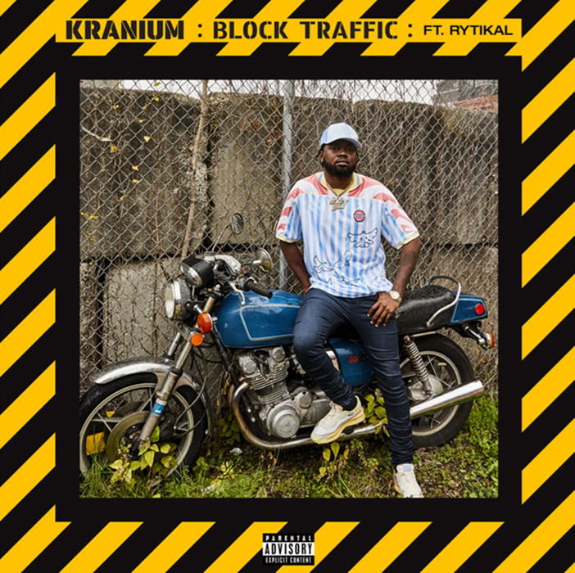

**CONNECT WITH KRANIUM**

[OFFICIAL](https://nam04.safelinks.protection.outlook.com/?url=http%3A%2F%2Fwww.officialkranium.com%2F&data=04%7C01%7CAlyssa.Reddish%40atlanticrecords.com%7C2cfbeeffb9634d9464e208d8b8a2eafc%7C8367939002ec4ba1ad3d69da3fdd637e%7C0%7C0%7C637462357180900289%7CUnknown%7CTWFpbGZsb3d8eyJWIjoiMC4wLjAwMDAiLCJQIjoiV2luMzIiLCJBTiI6Ik1haWwiLCJXVCI6Mn0%3D%7C1000&sdata=pcjamsQlWO3zOSPHdFEQF9C5JULfTPGw4FTLW4Zjv4A%3D&reserved=0) | [TWITTER](https://nam04.safelinks.protection.outlook.com/?url=https%3A%2F%2Ftwitter.com%2Ftherealkranium&data=04%7C01%7CAlyssa.Reddish%40atlanticrecords.com%7C2cfbeeffb9634d9464e208d8b8a2eafc%7C8367939002ec4ba1ad3d69da3fdd637e%7C0%7C0%7C637462357180900289%7CUnknown%7CTWFpbGZsb3d8eyJWIjoiMC4wLjAwMDAiLCJQIjoiV2luMzIiLCJBTiI6Ik1haWwiLCJXVCI6Mn0%3D%7C1000&sdata=bZ20D%2BOAONm7QT4G0LUyriA7iiepKUyib5QWIQr4oGY%3D&reserved=0) | [INSTAGRAM](https://nam04.safelinks.protection.outlook.com/?url=https%3A%2F%2Fwww.instagram.com%2Fkranium%2F&data=04%7C01%7CAlyssa.Reddish%40atlanticrecords.com%7C2cfbeeffb9634d9464e208d8b8a2eafc%7C8367939002ec4ba1ad3d69da3fdd637e%7C0%7C0%7C637462357180910282%7CUnknown%7CTWFpbGZsb3d8eyJWIjoiMC4wLjAwMDAiLCJQIjoiV2luMzIiLCJBTiI6Ik1haWwiLCJXVCI6Mn0%3D%7C1000&sdata=Aek3OQ7tnPL2StowEta%2B%2FMgbj3EczqGKJS63JnfdfvE%3D&reserved=0) | [FACEBOOK](https://nam04.safelinks.protection.outlook.com/?url=https%3A%2F%2Fwww.facebook.com%2FOfficialKranium&data=04%7C01%7CAlyssa.Reddish%40atlanticrecords.com%7C2cfbeeffb9634d9464e208d8b8a2eafc%7C8367939002ec4ba1ad3d69da3fdd637e%7C0%7C0%7C637462357180910282%7CUnknown%7CTWFpbGZsb3d8eyJWIjoiMC4wLjAwMDAiLCJQIjoiV2luMzIiLCJBTiI6Ik1haWwiLCJXVCI6Mn0%3D%7C1000&sdata=xaJ49FKYqKh89zTH2%2F%2Fm16E5w%2ByJCwozfXC2D%2BGpnSU%3D&reserved=0)

**FOR PRESS INQUIRIES**

**SYDNEY MARGETSON**

[SYDNEY.MARGETSON@ATLANTICRECORDS.COM](mailto:SYDNEY.MARGETSON@ATLANTICRECORDS.COM)

# # #