FOR IMMEDIATE RELEASE
AUGUST 27, 2021

KRANIUM KEEPS THE SUMMER HEAT BURNING WITH
“LIFE OF THE PARTY (FEAT. YOUNG T AND BUGSEY)”

GLOBAL DANCEHALL SUPERSTAR TEAMS WITH CREATORS BEHIND THE VIRAL HIT “DON’T RUSH” FOR INCENDIARY NEW SUMMER SINGLE

OFFICIAL DANCE VIDEO PREMIERES TODAY

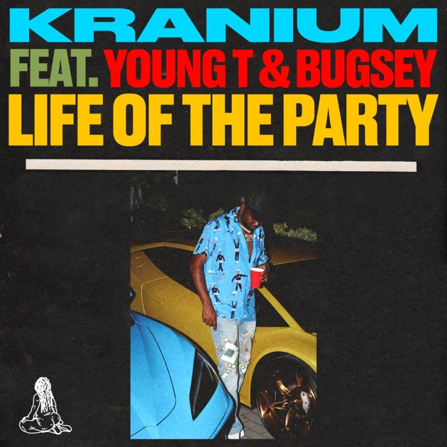

LISTEN TO “LIFE OF THE PARTY (FEAT. YOUNG T AND BUGSEY)” HERE
WATCH OFFICIAL DANCE VIDEO HERE

Global dancehall superstar Kranium is not letting the summer end with today’s premiere of a blazing hot new single. “Life Of The Party (Feat. Young T and Bugsey)” is available now at all DSPs and streaming services HERE; an official dance video is streaming now via YouTube. Shot in Kranium’s old Queens, NY neighborhood and with a crew of buzzing new dancers, the visual transports viewers to classic backyard party. Watch it HERE.

“Life Of The Party (Feat. Young T and Bugsey)” – which features the British hip-hop duo best known for the viral smash, “Don’t Rush” – sees Kranium once again showcasing his unique ability to blend melodies and bridge genres. With this particular single, you experience the melodic Dancehall vibe fans know and love, with hints of Hip Hop. It’s this approach and stimulating vocal talents that set him apart from his peers. The track’s irresistible verse and hook are further featured in an all-new acoustic medley of Kranium’s biggest hits, streaming now at his official YouTube channel HERE.

With his consistent delivery and success in offering a simmering sonic cocktail of Dancehall, R&B, Hip-Hop, Afrobeat, and soul, Kranium continues to make his mark on today’s Dancehall music scene. The Jamaica-born, NYC-based artist recently reached a major league milestone as his RIAA Gold certified breakthrough hit single, “Nobody Has To Know (Feat. Ty Dolla $ign),” hit 100M views via YouTube alone HERE. Known far and wide as “the Melody Gad,” Kranium’s catalog includes a handful of international hits, “We Can (Feat. Tory Lanez)” (recently certified gold in Canada), “Can’t Believe (Feat. Ty Dolla $ign & WizKid),” and last year’s global anthem, “Gal Policy,” earning him cumulative worldwide streams now exceeding 650M. Fans can catch him performing some of these songs and more this weekend as he kicks off his SOLD OUT “Toxic UK Tour”. More details here and listen to his 2020 “Toxic” EP here.

CONNECT WITH KRANIUM
OFFICIAL | TWITTER | INSTAGRAM | FACEBOOK | YOUTUBE

FOR ALL INQUIRIES
SYDNEY MARGETSON
SYDNEY.MARGETSON@ATLANTICRECORDS.COM

# # #

