KRANIUM RELEASES “TOXIC” REMIX FEATURING
BUZZING NEW FEMALE RAPPER FROM NEW ZEALAND JESSB

TOXIC REMIX AVAILABLE NOW EVERYWHERE HERE

OFFICIAL DANCE VIDEO FOR SONG ALSO RELEASED TODAY – WATCH HERE

TOXIC EP AVAILABLE NOW HERE

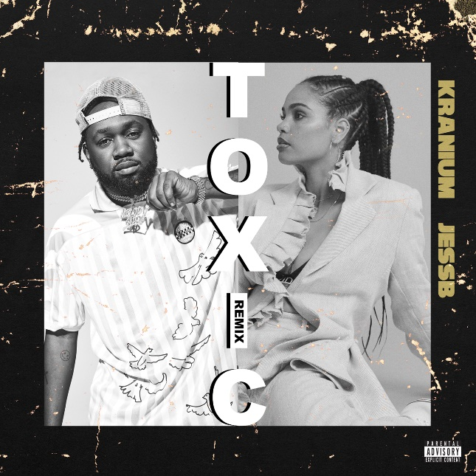
download hi-res cover art

Today, Atlantic Records’ own dancehall star Kranium has released a remix to “Toxic” featuring buzzing new female rapper out of New Zealand, JessB. The remix is accompanied by an official dance video – watch HERE. Released earlier this year, the original song came as the title track of his latest EP, Toxic. The 5-track project hit #1 on the Apple Music Reggae chart and debuted at #27 on the Billboard Reggae Chart. Listen to “Toxic” Remix now via all digital retailers and streaming platforms HERE.

“Toxic is a classy, strong and musically intelligent body of work from Kranium and the team. It feels like the experimental eclecticism of Midnight Sparks has been followed through on – with the EP now settling the artist into his own, distinctive and pleasing style. But the attention to detail is such that even with this ‘home coming’, all the tracks are intricately different”
- REGGAEVILLE

ABOUT KRANIUM

Global entertainer Kranium is taking dancehall music and his unique sound worldwide by delivering a simmering sonic cocktail of Reggae, R&B, Hip-Hop, and Soul. His music has streamed over half-a-billion times to date, and his talent is praised by the likes of Hypebeast, The Fader, Dancehall Mag, and Complex – with claims that “If there's anything Kranium seems to get right each time, it's the formula for making another hit." As a successful performing artist, Kranium has managed to bring the dancehall culture to stages where some artists have never been – territories ranging from the Caribbean to the Middle East to the South Pacific
.
In a very short time, Kranium has established himself as one of the hottest international dancehall artists with hits like “Nobody Has to Know,” “Lifestyle,” and “History.” He started to record in New York around 2008, earning the name Kranium for his ability to record songs “straight off the head” with no pen or paper, catapulting his career from New York’s underground dancehall scene to performing on BET to then signing to Atlantic Records. “Nobody Has To Know”’s widespread success has helped Kranium make history as the first New York-based dancehall artist to score a major international hit since Shaggy. Far from a one-hit-wonder, Kranium followed up his initial success with songs like “Can’t Believe” Feat Ty Dolla $ign & Wiz Kid and, “We Can” Feat Tory Lanez which went on to accumulate over 9 million audio streams on Spotify alone while peaking at #12 on the Reggae Charts.

In 2019, Kranium unveiled his debut album, Midnight Sparks to the world. The album saw Kranium continuing to craft a simmering sonic cocktail of reggae, R&B, hip-hop, and soul, including superstar features from the likes of AJ Tracey, Mahalia, Burna Boy, and longtime collaborator Ty Dolla $ign. The album showcases fiery singles as “So Me Move,” “Just The Style (Feat. Alkaline),” and “In Charge.” Kranium’s noteworthy debut was followed in 2020 with the release of “Gal Policy,” a summer anthem that’s still taking over the dancefloors today. The lyric video has over 25 million views to date and helped to set the tone for this latest EP release.

This year, Kranium has unleashed Toxic, his most personal project yet, which featured “Gal Policy”, “Through The Window”, and the street chune “Block Traffic” ft. Rytikal.

- - -

“With just two years on the music scene to her name (JessB), the New Zealand rapper already has the makings of a modern Missy Elliott, effortlessly switching between dance floor fillers and heavier subject matters like heartbreak and self-love from her recent EP New Views.”
- i-D MAGAZINE

ABOUT JESSB

After commanding the New Zealand hip-hop scene to take notice in 2017 following the delivery of a compelling performance as the first female MC to perform on David Dallas’ Red Bull 64 Bars, JessB continues a thrilling trajectory of releases in 2020 that have extended attention globally and proved the rapper is here to stay.

Now, with the release of her 3 Nights in Amsterdam mixtape, JessB masters new sounds with hype-inducing confidence propelling her rising status even higher. She’s got streams in the millions, has spins on commercial and alternative radio, and in the past year alone, has scored a spot in triple j’s Hottest 100 countdown for her feature on Baker Boy’s NIMA award-winning single and video “Meditjin”, and featured on triple j’s Like A Version for G Flip’s rendition of “Lady Marmalade”. Additionally, JessB took home the 2019 MTV European Music Award for Best New Zealand Act, before seeing her debut triple j Bars of Steel performance go live on Apple Music.

Since releasing two acclaimed EPs between 2018 and 2019, JessB has been expanding her world and cultivating her sound across stages in London, Amsterdam, LA, New York, and Australia, with performances at Venice Biennale, Red Bull Music Festival, Splendour in the Grass, Laneway Festival and Fire Fight Australia. Following strong support from Spotify’s global A1 Hip-Hop playlist, JessB performed at the flagship Spotify A1 Live event and has since also made her livestream debut on London’s NTS Radio 24-hour on-air festival.

When she hasn’t been getting stamps on her passport, JessB has continued to infiltrate the New Zealand music industry from within - she’s toured with role-model Ladi6 and supported SIX60 and Fat Freddy’s drop, as well as international acts YG and Lil Simz and Stormzy.

When she wasn’t spending her days and nights writing and recording at Red Bull Music Studios, JessB has been flexing her creative chops as part of the new generation of local artists, featuring on “Flying” as part of NZ rap collective BLKCITY. She also ran a week-long workshop at Roundhead Studio with some of her favorite artists and producers and co-curates the popular Filth club night with regular collaborator Half.Queen.

CONNECT WITH KRANIUM
OFFICIAL | TWITTER | INSTAGRAM | FACEBOOK

CONNECT WITH JESSB
INSTAGRAM | FACEBOOK

FOR PRESS INQUIRIES

SYDNEY MARGETSON
SYDNEY.MARGETSON@ATLANTICRECORDS.COM

# # #

