FOR IMMEDIATE RELEASE
FEBRUARY 1, 2022

GLOBAL DANCEHALL SUPERSTAR KRANIUM ANNOUNCES
BIGGEST NORTH AMERICAN HEADLINE TOUR TO DATE

WI DEH YAH TOUR BEGINS APRIL 28TH IN PHILADELPHIA, PA

TICKETS FOR ALL DATES ON SALE NOW

SUPREMELY CONFIDENT NEW SINGLE, “WI DEH YAH,” AVAILABLE NOW HERE

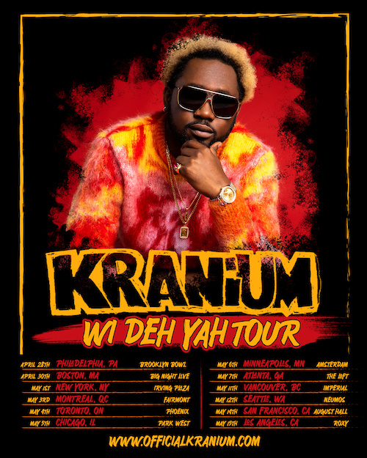

Global Dancehall superstar Kranium is set for his biggest North American headline tour to date. The Wi Deh Yah Tour kicks off April 28th at Philadelphia, PA’s Brooklyn Bowl and then travels through mid-May. Tickets for all announced dates are on sale now. For complete details, please visit www.officialkranium.com/tour.

KRANIUM
WI DEH YAH TOUR
NORTH AMERICA 2022

APRIL
28 – Philadelphia, PA – Brooklyn Bowl
30 – Boston, MA – Big Night Live

MAY
1 – New York, NY – Irving Plaza
3 – Montreal, QC – Fairmont
4 – Toronto, ON – Phoenix
5 – Chicago, IL – Park West
6 – Minneapolis, MN – Amsterdam
7 – Atlanta, GA – The Loft
11 – Vancouver, BC – Imperial
12 – Seattle, WA – Neumos
14 – San Francisco, CA – August Hall
15 – Los Angeles, CA – Roxy

# # #

With multiple plaque achievements within the U.S., Canada, and U.K. markets, Kranium is fast proving to be one of R&B/Dancehall’s greatest superstars, driving Dancehall music and culture into the future on his own characteristic terms. The Wi Deh Yah Tour celebrates the recent arrival of Kranium’s enthusiastically confident new single, “Wi Deh Yah,” available now at all DSPs and streaming services; an official lyric visualizer is streaming now via YouTube.

Recorded in Miami, FL with GRAMMY® Award-nominated production duo Bordeaux & Non Native (H.E.R., Pop Smoke, Lil Tjay & 6lack), “Wi Deh Yah” – Jamaican patois for “We’re here! We’ve arrived! We outside!” – sets the tone for an edgy and upbeat new approach from Kranium, showcasing the Jamaica-born, NYC-based artist’s clever lyricism, melodic gifts, and perfectly balanced vocals which blends his signature smoothness with a bit of Dancehall street flare. Infectious and unstoppably energetic, the track – which includes a sample of Alex Mali’s 2019 “Start It Up” – heralds an array of new music from Kranium, with additional projects due throughout 2022.

LISTEN TO “WI DEH YAH” HERE
WATCH OFFICIAL LYRIC VISUALIZER HERE

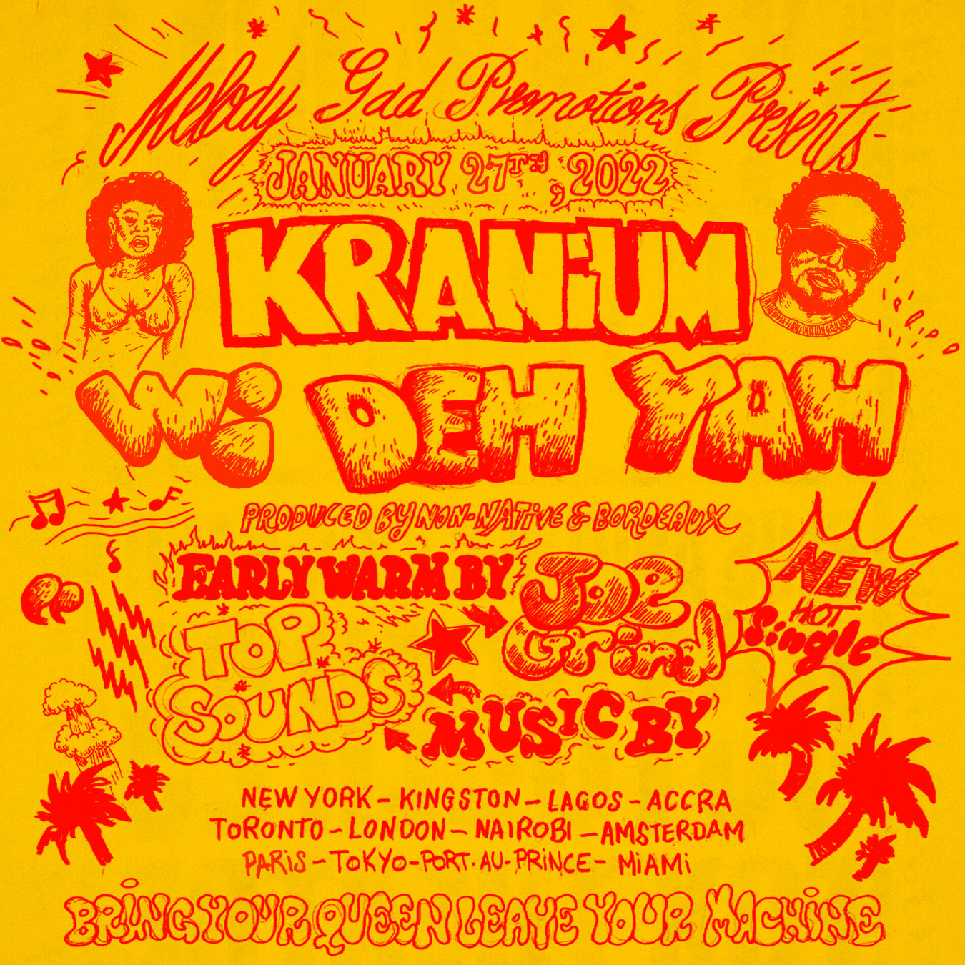
(DOWNLOAD HI-RES ARTWORK)

CONNECT WITH KRANIUM
OFFICIAL | TWITTER | INSTAGRAM | FACEBOOK | YOUTUBE

FOR ALL INQUIRIES
SYDNEY MARGETSON
SYDNEY.MARGETSON@ATLANTICRECORDS.COM

# # #

