FOR IMMEDIATE RELEASE
FEBRUARY 17, 2022

KRANIUM USHERS IN THE SUN WITH “WI DEH YAH”

SUPREMELY CONFIDENT NEW SINGLE IS NOW JOINED BY AN OFFICIAL MUSIC VIDEO

BIGGEST NORTH AMERICAN HEADLINE TOUR TO DATE
BEGINS APRIL 28TH IN PHILADELPHIA, PA

TICKETS FOR ALL DATES ON SALE NOW

STREAM/DOWNLOAD “WI DEH YAH” | WATCH OFFICIAL MUSIC VIDEO

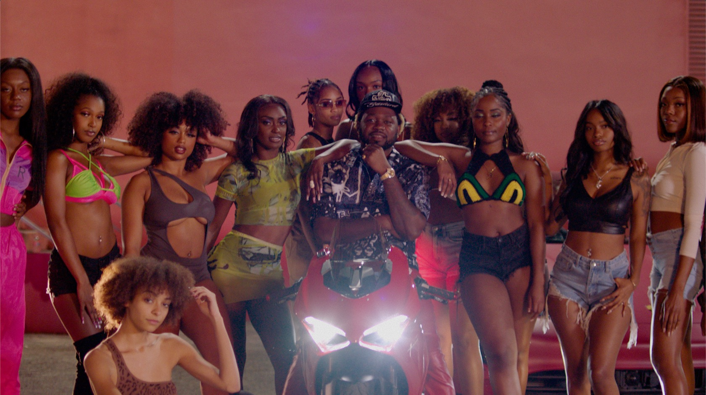

Global Dancehall superstar Kranium has unveiled the official music video for the first single from his latest project scheduled to drop later this year. “Wi Deh Yah,” co-stars popular Dancehall deejay Tanto Blacks and is streaming now via YouTube HERE.

“Wi Deh Yah” – Jamaican patois for “We’re here! We’ve arrived! We outside!” – is available now at all DSPs and streaming services HERE. Recorded in Miami, FL with GRAMMY® Award-nominated production duo Bordeaux & Non Native (H.E.R., Pop Smoke, Lil Tjay & 6lack), the enthusiastically confident track – which includes a sample of Alex Mali’s 2019 “Start It Up” – sets the tone for an edgy and upbeat new approach from Kranium, showcasing the Jamaica-born, NYC-based artist’s clever lyricism, melodic gifts, and perfectly balanced vocals which blends his signature smoothness with a bit of Dancehall street flare.

With multiple plaque achievements within the U.S., Canada, and U.K. markets, Kranium is fast proving to be one of R&B/Dancehall’s greatest superstars, driving Dancehall music and culture into the future on his own characteristic terms. Kranium will celebrate “Wi Deh Yah” – as well as new music to come later this year – with his biggest North American headline tour to date. The Wi Deh Yah Tour kicks off April 28th at Philadelphia, PA’s Brooklyn Bowl and then travels through mid-May. Tickets for all announced dates are on sale now. For complete details, please visit www.officialkranium.com/tour.

KRANIUM
WI DEH YAH TOUR
NORTH AMERICA 2022

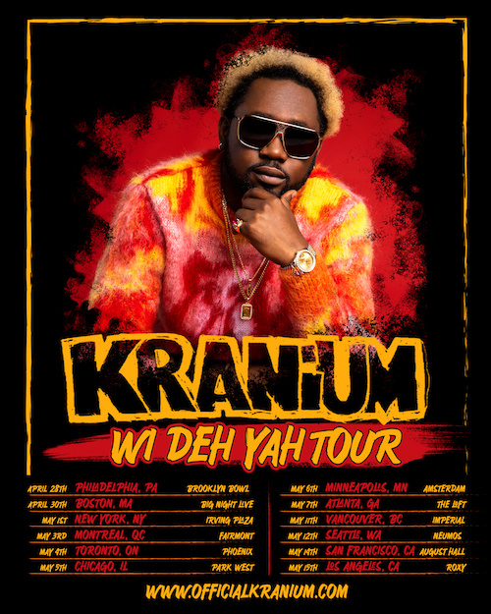

APRIL
28 – Philadelphia, PA – Brooklyn Bowl
30 – Boston, MA – Big Night Live

MAY
1 – New York, NY – Irving Plaza
3 – Montreal, QC – Fairmont
4 – Toronto, ON – Phoenix
5 – Chicago, IL – Park West
6 – Minneapolis, MN – Amsterdam
7 – Atlanta, GA – The Loft
11 – Vancouver, BC – Imperial
12 – Seattle, WA – Neumos
14 – San Francisco, CA – August Hall
15 – Los Angeles, CA – Roxy

# # #

CONNECT WITH KRANIUM
OFFICIAL | TWITTER | INSTAGRAM | FACEBOOK | YOUTUBE

FOR ALL INQUIRIES
SYDNEY MARGETSON
SYDNEY.MARGETSON@ATLANTICRECORDS.COM

# # #

