FOR IMMEDIATE RELEASE
JANUARY 27, 2022

KRANIUM SETS THE TONE FOR THE YEAR AHEAD WITH “WI DEH YAH”

GLOBAL DANCEHALL SUPERSTAR RETURNS WITH SUPREMELY CONFIDENT NEW SINGLE

WI DEH YAH TOUR BEGINS APRIL 28TH IN PHILADELPHIA, PA

OFFICIAL LYRIC VISUALIZER PREMIERES TODAY

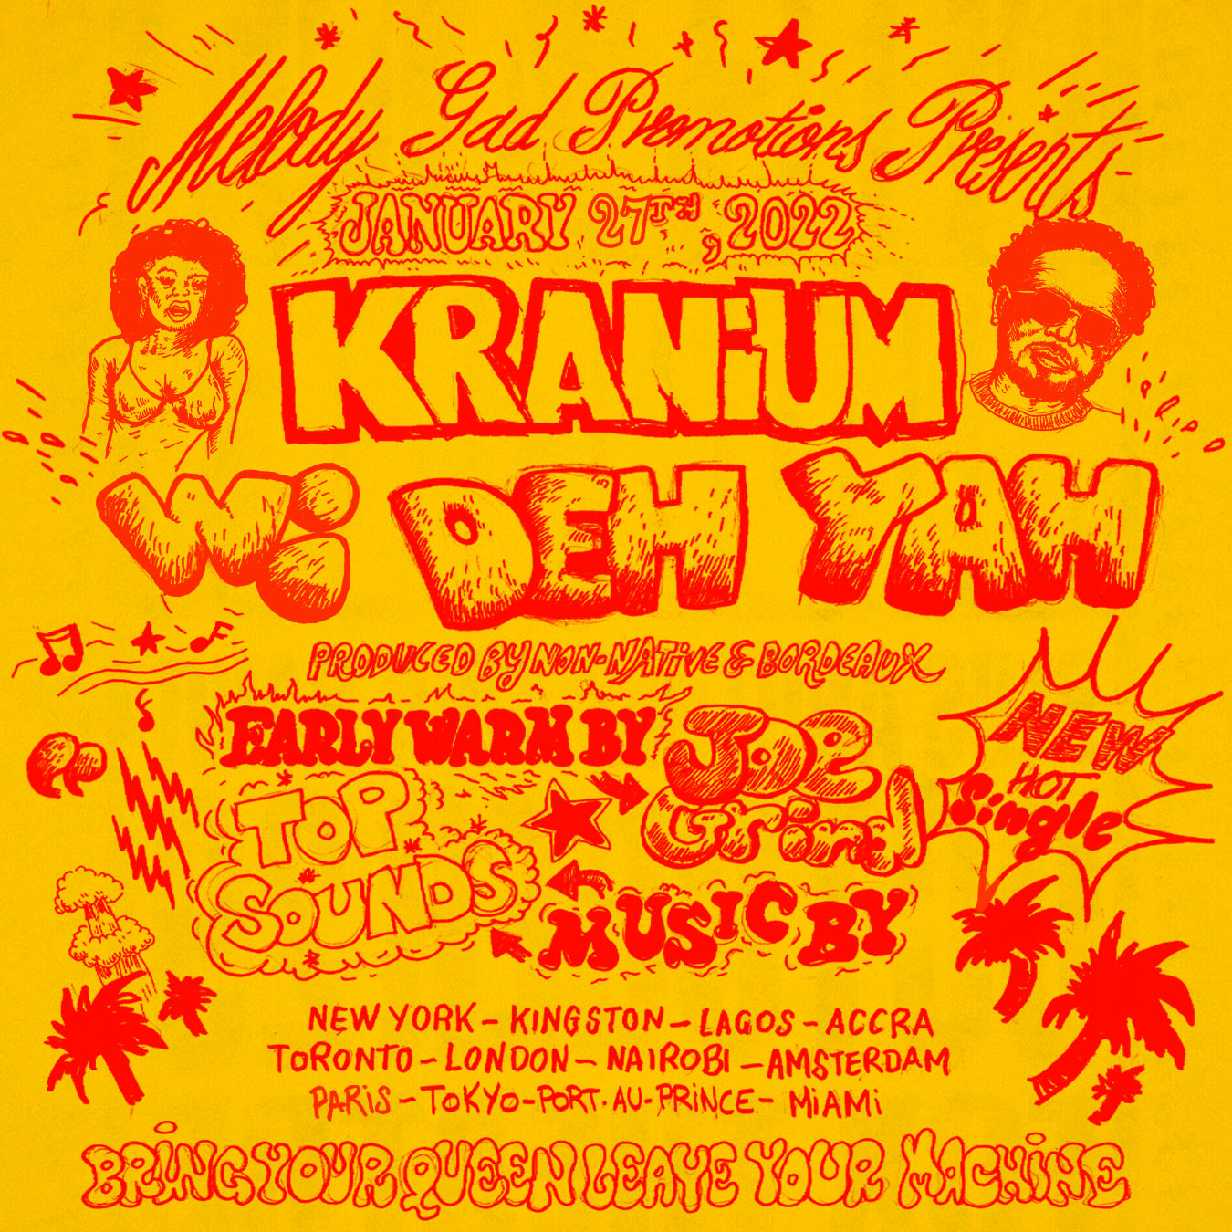
(DOWNLOAD HI-RES ARTWORK)

LISTEN TO “WI DEH YAH” HERE
WATCH OFFICIAL LYRIC VISUALIZER HERE

Global Dancehall superstar Kranium is kicking off the year with an enthusiastically confident new single. “Wi Deh Yah” is available now at all DSPs and streaming services; an official lyric visualizer premieres today via YouTube.

Recorded in Miami, FL with GRAMMY® Award-nominated production duo Bordeaux & Non Native (H.E.R., Pop Smoke, Lil Tjay & 6lack), “Wi Deh Yah” – Jamaican patois for “We’re here! We’ve arrived! We outside!” – sets the tone for an edgy and upbeat new approach from Kranium, showcasing the Jamaica-born, NYC-based artist’s clever lyricism, melodic gifts, and perfectly balanced vocals which blends his signature smoothness with a bit of Dancehall street flare. Infectious and unstoppably energetic, the track – which includes a sample of Alex Mali’s 2019 “Start It Up” – heralds an array of new music from Kranium, with additional projects due throughout 2022.

Kranium will mark the new single with his biggest North American headline tour to date. The Wi Deh Yah Tour kicks off April 28th at Philadelphia, PA’s Brooklyn Bowl and then travel through mid-May. Tickets for all announced dates go on sale Monday, January 31st at 9:00 am (ET). For complete details, please visit www.officialkranium.com/tour.

KRANIUM
WI DEH YAH TOUR
NORTH AMERICA 2022

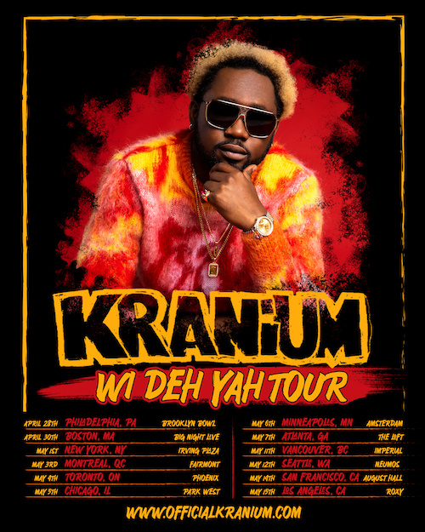

APRIL
28 – Philadelphia, PA – Brooklyn Bowl
30 – Boston, MA – Big Night Live

MAY
1 – New York, NY – Irving Plaza
3 – Montreal, QC – Fairmont
4 – Toronto, ON – Phoenix
5 – Chicago, IL – Park West
6 – Minneapolis, MN – Amsterdam
7 – Atlanta, GA – The Loft
11 – Vancouver, BC – Imperial
12 – Seattle, WA – Neumos
14 – San Francisco, CA – August Hall
15 – Los Angeles, CA – Roxy

# # #.

With multiple plaque achievements within U.S., Canada and U.K. markets Kranium is fast proving to be one of R&B/Dancehall’s greatest superstars, driving Dancehall music and culture into the future on his own characteristic terms.

CONNECT WITH KRANIUM
OFFICIAL | TWITTER | INSTAGRAM | FACEBOOK | YOUTUBE

FOR ALL INQUIRIES
SYDNEY MARGETSON
SYDNEY.MARGETSON@ATLANTICRECORDS.COM

# # #

