FOR IMMEDIATE RELEASE
OCTOBER 4, 2018

K’RON INTRODUCES NEW EP, WILD LOVA VOL. 1

K’RON JOINS ATLANTIC RECORDS AND LIVE NATION URBAN PRESENT
THE 2018 ACCESS GRANTED: HBCU COLLEGE TOUR

FEATURING ATLANTIC RECORDING ARTISTS AND RISING STARS
AYANIS, BRI STEVES & RECOHAVOC

WILD LOVA VOL. 1 AVAILABLE EVERYWHERE NOW

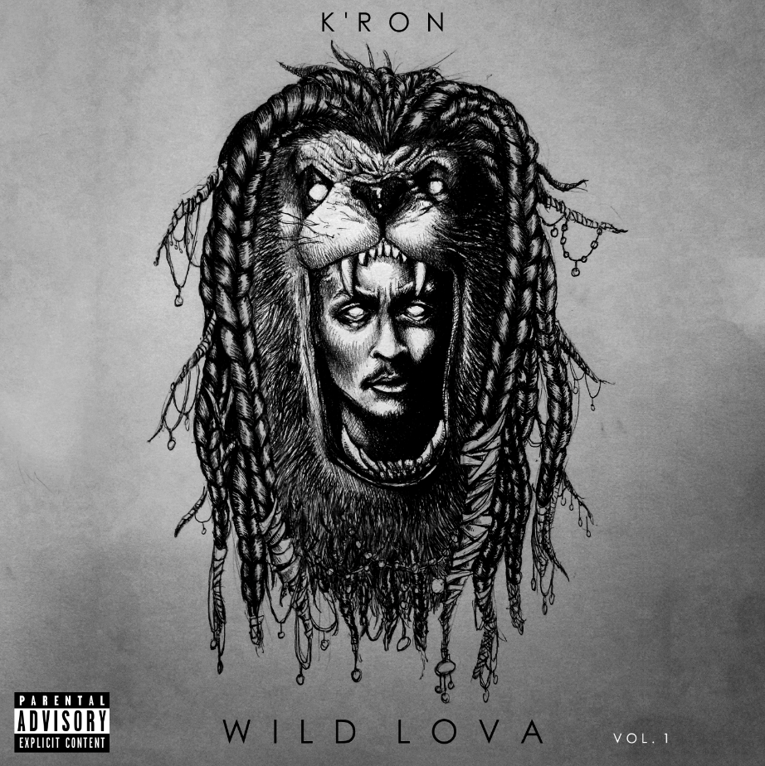

Atlantic Records’ newest contemporary R&B singer K’ron has announced the release of his newest EP. WILD LOVA VOL. 1 is available at all DSPs and streaming services here: https://kron.lnk.to/WildLovaVol1.

WILD LOVA VOL. 1 is highlighted by break out tracks “No BFs (Feat. Ty Dolla $ign)” and “BLS” – the former being joined by its companion video, streaming now on K’ron’s official YouTube channel. Upon its release the song garnered attention from some of the industry’s biggest platforms, as well as Jackson State University’s legendary Sonic Boom band who created their own rendition: https://youtu.be/nuhlRnI_wX4.

Keeping the momentum flowing, K’ron will be celebrating the release of this project on the road for Atlantic Records Access Granted: HBCU Tour in conjunction with Live Nation Urban. He will be joined by labelmates Ayanis, Bri Steves and RecoHavoc.

The tour is set to visit select Historically Black Colleges and Universities throughout the east and southeast during the 2018 homecoming season. It will begin today at Morgan State in Baltimore, MD and continue throughout the month, wrapping at Grambling State in Grambling, LA on November 2nd. The current itinerary can be found below with additional dates to be announced.

The 23-year-old DMV native has steadily built a name for himself as a singer, songwriter, producer and engineer. Originally born in Washington, D.C. and raised in Maryland K’ron first cut his teeth in music fulfilling a key role as the drummer in his church’s band, going on to earn the mentorship of Keith Killgo, the leader, vocalist and drummer of legendary jazz-funk and R&B band The Blackbyrds. Surrounded by a vibrant range of musical influences, K’ron released his breakthrough single “Round of Applause” in 2014, with the single reaching viral heights and since garnering over ten million streams across platforms. With his passion for music solidified and a redefined purpose to be a full-time recording artist, K’ron has lent his talents as a singer, producer and songwriter to other artists, such as Ty Dolla $ign and Omarion, all while establishing his own lane as a solo act. Self-describing his sound and persona as a “wild lova,” K’ron navigates between classic and contemporary R&B, winning over fans of both hip-hop and soul with his refreshingly raw and modernized approach.

_ _ _

WILD LOVA VOL. 1
(Atlantic Records)
Release Date: October 3, 2018

Track listing

1. Wild Lova (Da Intro)
2. BLS
3. Racing
4. Rocket
5. No BFs feat. Ty Dolla $ign
6. No BFs Outro
7. iLOVE

ATLANTIC RECORDS AND LIVE NATION URBAN PRESENT
ACCESS GRANTED: HBCU TOUR

10/4 Access Granted: HBCU Tour @ Morgan State (Baltimore, MD)
10/8 Access Granted: HBCU Tour @ Jackson State University (Jackson, MS)
10/9 Access Granted: HBCU Tour @ Stillman College (Tuscaloosa, AL)
10/11 Access Granted: HBCU Tour @ Bowie State (Bowie, MD)
10/12 Access Granted: HBCU Tour @ Lincoln University (Lincoln, PA)
10/16 Access Granted: HBCU Tour @ Norfolk State University (Norfolk, VA)
10/18 Access Granted: HBCU Tour @ South Carolina State University (Orangeburg, SC)
10/19 Access Granted: HBCU Tour @ Winston-Salem State University (Winston Salem, NC)
10/20 Access Granted: HBCU Tour @ St. Augustine’s (Raleigh, NC)
10/23 Access Granted: HBCU Tour @ Savannah State (Savannah, GA)
10/24 Access Granted: HBCU Tour @ Hampton University (Hampton, VA)
10/25 Access Granted: HBCU Tour @ Morehouse College (Atlanta, GA)
10/26 Access Granted: HBCU Tour @ Delaware State (Dover, DE)
10/26 Access Granted: HBCU Tour @ Howard University (Washington, DC)
10/29 Access Granted: HBCU Tour @ North Carolina Central (Durham, NC)
11/2 Access Granted: HBCU Tour @ Grambling State (Grambling, LA)

CONNECT WITH K’RON
WEBSITE
INSTAGRAM
TWITTER
FACEBOOK
YOUTUBE

FOR PRESS INQUIRIES, PLEASE CONTACT:
Ariana.White@atlanticrecords.com

