FOR IMMEDIATE RELEASE
NOVEMBER 13, 2020

Kelly Clarkson covers “All I Want For Christmas Is you”

Stunning version of Vince Vance & the Valiants’ classic available now,
alongside new original Christmas duet “Under The Mistletoe” with Brett Eldredge

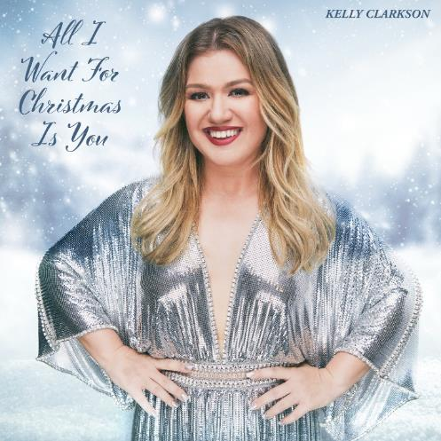
DOWNLOAD HIGH-RES ARTWORK

Stream “All I Want For Christmas Is You”: LINK
Stream “Under The Mistletoe” with Brett Eldredge: LINK
Stream the Atlantic Holiday playlist: LINK

GRAMMY-winning global superstar Kelly Clarkson has shared a stunning cover of the Vince Vance & the Valiants’ classic “All I Want For Christmas Is You” – available now via Atlantic Records. The release marks the second holiday offering from Clarkson this year, following her new original Christmas duet “Under The Mistletoe” with acclaimed country singer-songwriter Brett Eldredge.

“I have been singing Vince Vance & the Valiants’ song ‘All I Want For Christmas Is You’ since I was a little kid. I always loved that it's a ballad but the woman always sounded so rock n’ roll with her raspy tone on the big notes. It has an old school vibe and is a little pop, country, and rock n’ roll.” – KELLY CLARKSON

Last month, Clarkson hosted the Billboard Music Awards for a third consecutive year and resumed her role as three-time champion coach on NBC’s The Voice (to which she returned a sixth time for the show’s current 19th season). She also kicked off the second season of NBC’s The Kelly Clarkson Show following a blockbuster 2019 inaugural season that marked the highest rated daytime debut in seven years, in addition to earning three Daytime Emmy Awards (including “Outstanding Entertainment Talk Show Host”), a People’s Choice Award nomination for “Daytime Talk Show of 2020,” and a Critics’ Choice Television Award nomination for “Best Talk Show.”

ABOUT KELLY CLARKSON:
Kelly Clarkson is among the most popular artists of this era with total worldwide sales of more than 25 million albums and 40 million singles. The Texas-born singer-songwriter first came to fame in 2002 as the winner of the inaugural season of American Idol. Clarkson’s debut single, “A Moment Like This,” followed and quickly went to #1 on Billboard’s Hot 100, ultimately ranking as the year’s best-selling single in the U.S. Further, Clarkson is one of pop’s top singles artists, with 18 singles boasting multi-platinum, platinum and gold certifications around the world, including such global favorites as “Miss Independent” and “Because of You.” Clarkson has released eight studio albums (Thankful, Breakaway, My December, All I Ever Wanted, Stronger, Wrapped In Red, Piece By Piece, Meaning of Life), one greatest hits album, and two children’s books (New York Times Top 10 best seller River Rose and the Magical Lullaby and the follow up River Rose and the Magical Christmas). She is the recipient of an array of awards including three GRAMMY Awards, four American Music Awards, three MTV Video Music Awards, two Academy of Country Music Awards, two American Country Awards, one Country Music Association Award, and one Daytime Emmy Award. She is also the first artist to top each of Billboard’s pop, adult contemporary, country and dance charts.

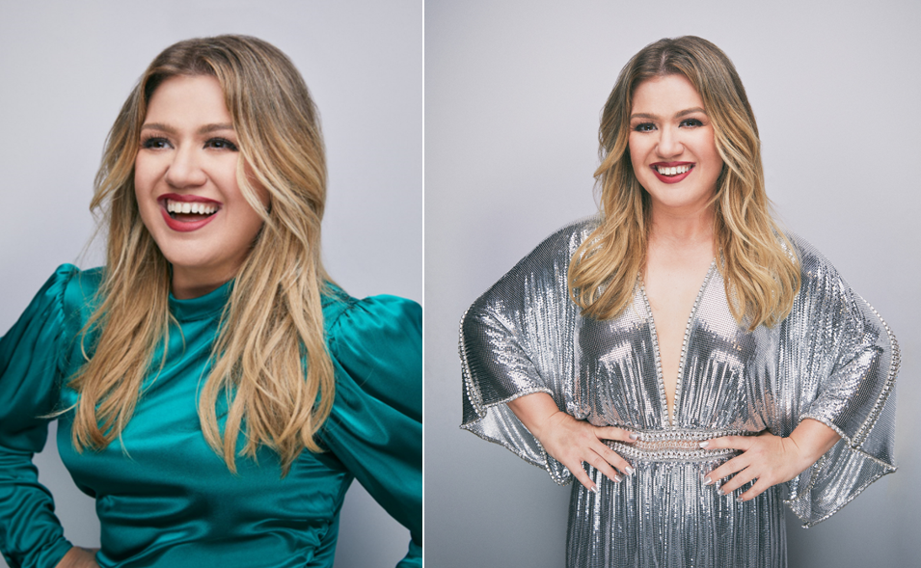
DOWNLOAD HIGH-RES IMAGES (credit: Weiss Eubanks)

For more information, please visit:
KellyClarkson.com | Facebook | Twitter | Instagram | YouTube | Press Assets

For press inquiries:
Sheila Richman | Sheila.Richman@atlanticrecords.com
Ted Sullivan | Ted.Sullivan@atlanticrecords.com

