**KELLY CLARKSON** **ANNOUNCES LAS VEGAS RESIDENCY**

**KELLY CLARKSON: INVINCIBLE**

**WATCH ANNOUNCEMENT:** <https://youtu.be/w203N-2mHjg>

**KICKS OFF APRIL 1, 2020 AT ZAPPOS THEATER *AT PLANET HOLLYWOOD RESORT & CASINO***

**PRE-SALES BEGIN NOVEMBER 4, PUBLIC ON-SALE NOVEMBER 8**

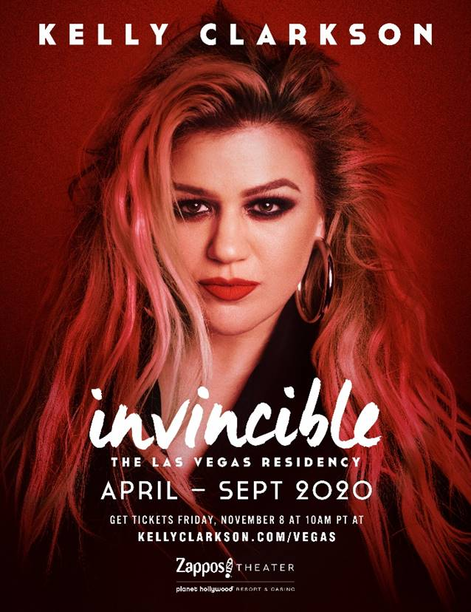

 For admat and photos, click [here](https://www.dropbox.com/sh/cqdvmxpgbkizcft/AADVrz_piGwJaStEYbyhQpVHa?dl=0)

**Las Vegas (Nov. 1, 2019)** – GRAMMY Award-winning global superstar Kelly Clarkson has announced that she will be headlining a brand-new Las Vegas residency, **Kelly Clarkson: Invincible**, opening on **Wednesday, April 1** at **Zappos Theater** at **Planet Hollywood Resort & Casino**.

To celebrate the announcement of her Las Vegas residency, Clarkson performs a very special Kellyoke medley. Tune in to today’s show to see the performance and stay tuned to “The Kelly Clarkson Show” broadcast and social media next week for additional pre-sale announcements. For “The Kelly Clarkson Show” show times, please check your [local listings](https://www.kellyclarksonshow.com/exclusives/where-to-watch).

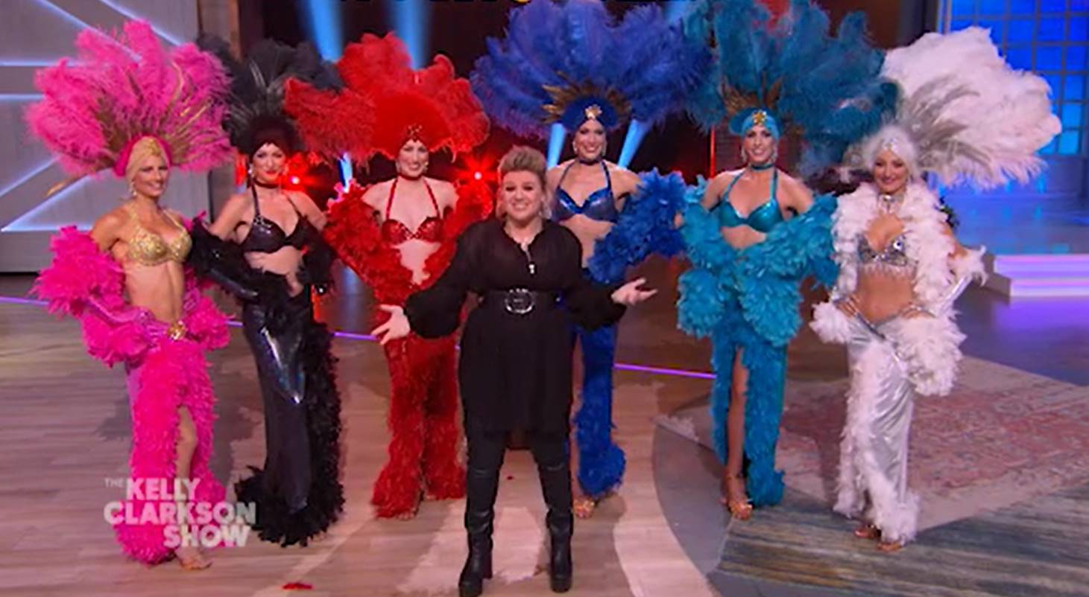

**WATCH ANNOUNCEMENT:** <https://youtu.be/w203N-2mHjg>

Designed exclusively for the Zappos Theater at Planet Hollywood Resort & Casino, Kelly and her longtime band will immerse fans in a one-of-a-kind up-close music experience that rocks through her nearly two-decade long catalog of award-winning smash hits. Clarkson will also offer VIP Experiences that bundle premium tickets with exclusive show perks like a stage-side bar. A limited number of meet and greets will also be available for purchase. Experience details are available at: [KellyClarkson.com/Vegas](http://www.kellyclarkson.com/vegas)

“I’ve always loved performing in Las Vegas and the high energy of the crowds there,” said Kelly Clarkson. “So many of my musical idols have had, and still have, incredible residencies on The Strip, and I’m so excited to create my own!”

Exclusive pre-sale ticket access will run from Monday, November 4 at 10 a.m. PT through Thursday, November 7 at 10 p.m. PT, with public on-sale access kicking off at 10 a.m. PT on Friday, November 8.

Citi is the official presale credit card of Kelly Clarkson: Invincible. As such, Citi cardmembers will have access to purchase presale tickets beginning Monday, November 4 at 10 a.m. PT until Thursday, November 7 at 10 p.m. PT through Citi EntertainmentSM. For complete presale details visit [www.citientertainment.com](http://www.citientertainment.com).

In addition, Caesars Rewards members, Caesars Entertainment’s loyalty program, and Live Nation and Ticketmaster customers will have access to a presale running **Thursday, Nov. 7 from 10 a.m. PT through 10 p.m. PT.** For additional ticket on-sale information please visit [KellyClarkson.com/Vegas](http://www.kellyclarkson.com/vegas).

The 16 performances going on sale are:

**Apr. 2020:** 1, 3, 4, 10, 11

**July 2020:** 29, 31

**Aug. 2020:** 1, 5, 7, 8

**Sept. 2020:** 18, 19, 23, 25, 26

General ticket prices begin at $59 plus applicable tax and fees. Tickets may be purchased online at [KellyClarkson.com/Vegas](http://www.kellyclarkson.com/vegas) or in-person at the Planet Hollywood box office. All shows begin at 8 p.m.

**KELLY CLARKSON**

Kelly Clarkson, who recently released her critically acclaimed Grammy nominated eighth studio album, “Meaning of Life,” is among the most popular artists of this era with total worldwide sales of more than 25 million albums and 36 million singles. The Texas-born singer-songwriter first came to fame in 2002 as the winner of the inaugural season of “American Idol.” Clarkson’s debut single, “A Moment Like This,” followed and quickly went to #1 on Billboard’s Hot 100, ultimately ranking as the year’s best-selling single in the U.S. Further, Clarkson is one of pop’s top singles artists, with 18 singles boasting multi-platinum, platinum and gold certifications around the world, including such global favorites as “Miss Independent” and “Because of You.” Clarkson has released eight studio albums (*Thankful*, *Breakaway*, *My December*, *All I Ever Wanted*, *Stronger*, *Wrapped In Red*, *Piece By Piece, Meaning of Life*), one greatest hits album, and two children’s books (New York Times Top 10 best seller *River Rose and the Magical Lullaby* and the follow up *River Rose and the Magical Christmas*). She is the recipient of an array of awards including three GRAMMY Awards, four American Music Awards, three MTV Video Music Awards, two Academy of Country Music Awards, two American Country Awards, and one Country Music Association Award. She is also the first artist to top each of Billboard’s pop, adult contemporary, country and dance charts. 2019 has already seen Clarkson host the Billboard Music Awards for a second consecutive year, voice the character of Moxy in STXFilms’ *UglyDolls* and reclaim her red chair for the 17th season of *The Voice* following back-to-back wins as coach last year on seasons 14 and 15. Clarkson also made the highest rated daytime debut in seven years with her very own talk show, “The Kelly Clarkson Show,” syndicated by NBCUniversal Television Distribution.

For more information, please visit:

[KellyClarkson.com/Vegas](http://www.KellyClarkson.com/Vegas) | [Facebook](https://www.facebook.com/kellyclarkson/)| [Twitter](https://twitter.com/kellyclarkson)| [Instagram](https://www.instagram.com/kellyclarkson/)| [YouTube](https://www.youtube.com/channel/UCoRUmyNL8KEYftmxRA2n3SQ) | [Press Assets](http://press.atlanticrecords.com/kelly-clarkson/)

**MESSINA TOURING GROUP**

Produced by Messina Touring Group.

**LIVE NATION LAS VEGAS**

Live Nation Entertainment (NYSE: LYV) is the world’s leading live entertainment company comprised of global market leaders: Ticketmaster, Live Nation & House of Blues Concerts, LN Media and Artist Nation Management. Live Nation Las Vegas produces residency shows from Mariah Carey, Journey and Sting at The Colosseum at Caesars Palace; Lady Gaga, Aerosmith and Bruno Mars at Park Theater at Park MGM; Billy Idol at Pearl Concert Theater at the Palms; FOREIGNER, The Doobie Brothers and Chicago at The Venetian Theatre at The Venetian Resort Las Vegas; and Kelly Clarkson, Shania Twain, Christina Aguilera, Gwen Stefani and Florida Georgia Line at Zappos Theater at Planet Hollywood Resort & Casino. Live Nation Las Vegas also brings other world-famous artists to many of the city’s other premier concert venues including T-Mobile Arena, Mandalay Bay Events Center, MGM Grand Garden Arena, House of Blues, Downtown Las Vegas Events Center, The Joint at Hard Rock Hotel & Casino Las Vegas, and more. For additional information, visit [www.livenation.com](http://r20.rs6.net/tn.jsp?f=001W1CLMFu6IGmNmoXBN2KtnZoQ-HWw3RIFFo_bbJq-jUoN8c5EOxaqS0r0Gs3_eb9ayHUYIPqydmYACv4othuluWWg_GiJuYDzY2FyvE_2Q6tU8aP5u_tGoPzY-1zspBSKR6fPofIN_y25hvpx4zh00OWqJ7OP-h-6N9vMD5OC_j3hrxu3OO04NOAzkqT0y3hIXFQn1NGGUly5EDIOuhsmvfM7NpAhkHojxrh9gdGgMOJyzji22Nn_nnIkACYa4VidlCHlNquxpo4HWeLj5IOKQf75FFrBLhEVR7KFBBYip3BPD1zROcd8xcbzeZbnSi4BgVfXrUZl7ne5pksmBZQCTxk9dAkHBM2D1HUunr_vobujl7qq37qc1QBAjhpInAJZrcg_EfRXE2LZtFN7SxNi9mhno_IYrOaX2JbVvcHmwcWzkPjpBonT77G0qNnFON-P1olN5H5MO9aQ5uGaYTj_RnYqmFIn1gfwrN65MOHVQTTuGBglDlIGF3shXfej0ZRpqMUU714UoMtB0vrtbFkVhQySlt4hbrgbT66gYtjmki4Ib_C3BYDQz-CwqaRXNw5XDIK76RXX2j7pBlrdzVjD0JVl0HUnPz3ORNwal1HopXWlyMr5yp0mNDgtBjVpy5DwlhH4eUlvEqEjL_IK6NwJXiGuHOHbYMShiDC9qOzZlB8jGsBfNnFz8wh1jAscrefFt7KqxMbAJxOuKiFfAlYbTs0jZeMhNmWaElFnI01BhTHcVMIhbfcUg-nbncIUQbeLBHCO-pxiQ3_gBL-apajEbhlgczJCXJhjS7u9vyFR0dmYC4IBGSkAsC_LIBedLlxybmhZ-SYCklvW0x1ey6rgdb1BN94VtbFz4um42UjPGlgqqTpCJ-AjPn4mSL-l9tgmXRQxjwe3YwT2lKh4UvShrcwR7UpgZCdK&c=QdBzJNv4ZNr_fiheGPfBD-LEd_8ZStieQBJIF_JGzfQ7PYh32B8MyA==&ch=EmVhLgIq7yZzUAHMBA2Kby--uxpLJAe9xdDu6KudzuXFddlkTduKHQ==). Find Live Nation Las Vegas on [Facebook](http://r20.rs6.net/tn.jsp?f=001W1CLMFu6IGmNmoXBN2KtnZoQ-HWw3RIFFo_bbJq-jUoN8c5EOxaqS0r0Gs3_eb9agZCeRbPG9zFgS1tSOBce9XhOYRT0nayKiJgUPMH-Az8eEE-feh4RqSp3e9TI3eLmsAYXz3Is8U52SxSfspVv9dGohKaDO-WfbwWyevyr7UQvV474M7pYJ6KhHNfu08v-ZNO_wTTHG-tMYs3RA3zjKRBSHuJkoAIutTZ3taJvMGEzLh7RwL_dOcBNUFPdE__lW7Uz8il54022dQ2lT6RJHdGI1r35r5hTbk0p8FN7ItA9H7LNWJw4Yp-VWGTE3NuUl0_Lad2pXm9bBDs_O7zKeIRBLWrO2omBoBU0CK7DKoxalg4oQDV_2M2JKkUWP3HJk5mXlLohZeDSylw9148zn_6FD-63oNNwiyVOch-dTRhs70ImsQXU3_0SubsAivTbXwto8VnbzJW6O8UnLKkUXud1CsOaOD0LOarzDejetq7ji6ywLL1AoYRzNsMLr5aCQUil4UuMc1Eaw-vCBJPwK69eUHSaz_yrE7lqgDQAKZ7K0bepVoo5xqgrqEUP2XdZTalYKcy-dTplpRtr475EjSPaLx6ZfwEv8BM1iCVLv7VQwu_F2UTnGXOcWnceJHl30S8dIjE-h8r6Fm7SpXaHqzUkEOgVSXMX5WQYnMtitSkm96sfLRKi5wI1swKXCBrkcMKSCIE-NUxC-Pkv5NarTpH9mMDOBZ0VMuEDFPWIj-TmyIfflrSoC1jYcTQUeDwJRvL8wfahg5qQSns5gDvyGsMSu_8vEzEtELdpGV_jt-IA6YnnxZHfF0IgZXt7UqE4j9kMwbEqBWkjeWZfI2E2pcB63AYVAV9D2KTswJ51PvDO0yV3w4FvrW2yjze5ygrm4DDsggy2MYy9lF7yn2Oww2_EGt-QQF9S&c=QdBzJNv4ZNr_fiheGPfBD-LEd_8ZStieQBJIF_JGzfQ7PYh32B8MyA==&ch=EmVhLgIq7yZzUAHMBA2Kby--uxpLJAe9xdDu6KudzuXFddlkTduKHQ==), [Instagram](http://r20.rs6.net/tn.jsp?f=001W1CLMFu6IGmNmoXBN2KtnZoQ-HWw3RIFFo_bbJq-jUoN8c5EOxaqS0r0Gs3_eb9aQ9q0-VPoyPIVFuNjsQfV0-p6ncsxI-dWOxf4bDhvwvmBC2XpQRFXe1CAncXGneIaO4lG73siooCHx7eEhinQH29w928utt3MvOGDN0agFrMHD3LRkZw8Qh8HZLJphxOIkkRf-tIZcpnVdm17VFHcHgW7U5nL5c1AAhGbriRlZMcjOykayuXJo9vZZcVIvX9lhJhpvafomGsiCD8P0WHfZrt1jTEmdsCUwrZlgZs3H8_Hb0h9g0tA8nUGkO04l_C2W5q5c5NJiH_w3JUKCmHcwrA6D48G_AcbmLfSbpiZaDadqL3e9JG0MMcDTX_tVfOeHL_CAfWLlMoRsAMy9KD9td0IA4hDM7aoE-IG5lCcmLe_CpQ29U_M1RqbLRDziswvPFK5SigkChsUxr9zVkMKokxIUFi-Yi79mgn2DXqSY7i5rtbV5LCIcxPoHFTSEwHgb03UDyXPujnZn5ddU3639gPVwH-Pzak9howfPGmptLZzQV1bmZVgqKyU0TnPU53S7xb-inPem-PguVKvPmbM39FTR7wVlogIT4c3H7Mwy6Gon5L0WOavGGUYHdEsV_7RoN8GPV6zlT_SvfCNvCQqSuI04RFB5WsDdkmefMh-G_dXATnLYYfVe1rvdmHiX7gzGMe_-e94yxsr_sG4vepCJqxrsxnTHkVfTmYK9ByiVEQOBF3UJ1mY4Lvj_8fJ4ccSYEZafWqmXLTq2CiIWN_GwGh8Gqq579A3mOMRYz-oBDOgU90E4IN0r-kQlbat7Upm_5qh5Eit9xAPHg3GbOCdt4CFd0Ms81KKDPV4x0Vr1Gri70k36b-J0mAducVoJ9UDCrg5jdOr9qEO39CBX7LFUDTq6o_P4avB&c=QdBzJNv4ZNr_fiheGPfBD-LEd_8ZStieQBJIF_JGzfQ7PYh32B8MyA==&ch=EmVhLgIq7yZzUAHMBA2Kby--uxpLJAe9xdDu6KudzuXFddlkTduKHQ==) and follow us on [Twitter](http://r20.rs6.net/tn.jsp?f=001W1CLMFu6IGmNmoXBN2KtnZoQ-HWw3RIFFo_bbJq-jUoN8c5EOxaqS0r0Gs3_eb9avm7lFieM_89uKvj1awvT66UfJJa2PWpNlHGz0ytluIVDj3zXpf8GlodFibj49auYpgbhQe8TwUlOtubusdbl0txvxxpGvfFvp_UMF5OUip76oSZJv6mYfWwJnh-xzHu5TJeXkQwy7_BZRf3opQy3TAqvpPeRcEq-vKAfzYh6ZISHAdDqEmqEH_mBc3uU78VfvpNvVjMVUR6cJelT599j8nH8fJ8dNwvzk1bW5Il6i68L9LjiB10ahajHHCxUx980Yni9I_FTUCp3tJGv98muqJ7ruhL2ipD_Sfi0umnCOq0Nfk5AqaiFdg7o1UTQ0NpIzjDLu-5TkG9pVw4AOxkvcCLZlsdPzJ9f34oX9rokJXQ31hQNzmbnjECEQ8eATFBnB8yEsPxIrE98COaYEHmMQ9K8zOr9ba1vNq6gP4mJ0K-zo1vQqaR0qqdjgJFMEEJ8STZGhZB1JrzqSBmiLVKbylTWBcOJwq_LIbEYmgp8vWkMSP1igDaLxeG5oo9k22UcJDnEVafZqritLQ-W2D1UHLk0Q4nOx_TUYEDufwbulCR1VJaU9EaXr8Il1jqhSAnjoY4hGNlcUSB9u4vTz_0rUNmWUizt-E-ZV_kwBB5kwknuuw1oIXVQDRZQHX_KvT37K1IotxlcDqI5OadoFuZwusCr0rCmadzjaPY5L_7KsmSOYeHBkyaMTBCUzPwdrARYY5eEYTEV0C4RmYl4D5bR6kFBPXhRtcDCbHRVHZ_8ck6Y791rPq44m2KQ53sEehtlZdUF8SJ-1bUoNwzDqhIgMojCvGtWL9i7DAvofp-JtaufBNqeU2NpP7IilxyjAkQkHjUyeo8jV-nPaN4Ta9k4wg==&c=QdBzJNv4ZNr_fiheGPfBD-LEd_8ZStieQBJIF_JGzfQ7PYh32B8MyA==&ch=EmVhLgIq7yZzUAHMBA2Kby--uxpLJAe9xdDu6KudzuXFddlkTduKHQ==).

**PLANET HOLLYWOOD RESORT & CASINO**

Planet Hollywood Resort & Casino is the centerpiece of the famed Las Vegas Strip, with 2,500 beautifully redesigned guest rooms and [suites](https://www.caesars.com/las-vegas/suites/) showcasing some of the best views in town, along with endless options of unparalleled shopping, distinguished dining, popular entertainment and a bustling nightlife. A bright, bold addition to the resort’s portfolio, the new Ultra Hip Rooms feature contemporary elegance and luxury bedding. Known as the place to play for its roster of A-list celebrity guests, Planet Hollywood’s 231 newly restyled suites feature stunning views of the glittering skyline and daring décor elements such as suspended sofas, lounge-style living spaces and oversized modern artwork. The resort encompasses more than 100,000 square-feet of gaming, several lounges, impressive restaurants including Gordon Ramsay Burger, KOI, Strip House, and the award-winning Spice Market Buffet, an intimate wedding chapel and the Planet Hollywood Spa by Mandara. The resort also features The Scene Pool Deck with the Strip’s first and only stand-alone wave machine, the FlowRider. Home to the first pop music residency in Las Vegas, Zappos Theater showcases resident headliners Christina Aguilera, Gwen Stefani, Kelly Clarkson and Shania Twain. Magician Criss Angel performs an over-the-top visual spectacular of “Criss Angel MINDFREAK®” in the newly-renovated Criss Angel Theater. The property is encircled by Miracle Mile Shops with more than 170 specialty stores and restaurants. Planet Hollywood Resort & Casino is operated by a subsidiary of Caesars Entertainment Corporation (NASDAQ: CZR). For more information, please visit [planethollywoodresort.com](http://www.planethollywoodresort.com) or the Caesars Entertainment Las Vegas [media room](http://caesars.mediaroom.com/).  Find Planet Hollywood Resort & Casino on [Facebook](http://www.facebook.com/phVegas) and follow on [Twitter](http://www.Twitter.com/phvegas) and [Instagram](https://www.instagram.com/phvegas/).

# # #

**MEDIA CONTACTS:**

For Kelly Clarkson:

Sheila Richman | [Sheila.Richman@atlanticrecords.com](mailto:Sheila.Richman@atlanticrecords.com)

Ted Sullivan | [Ted.Sullivan@atlanticrecords.com](mailto:Ted.Sullivan@atlanticrecords.com)

For Caesars Entertainment:

Robert Jarrett *|* [RJarrett@caesars.com](mailto:RJarrett@caesars.com)

For Live Nation Las Vegas:

Kelly Frey *|* [Kelly@thepublicitylab.com](mailto:Kelly@thepublicitylab.com)

