FOR IMMEDIATE RELEASE
SEPTEMBER 23, 2021

Kelly Clarkson declares “Christmas Isn’t Canceled (Just You)”

Ninth studio album When Christmas Comes Around… arriving October 15th
featuring original songs, classic covers,
collaborations with Ariana Grande, Chris Stapleton & more

New single “Christmas Isn’t Canceled (Just You)” available now

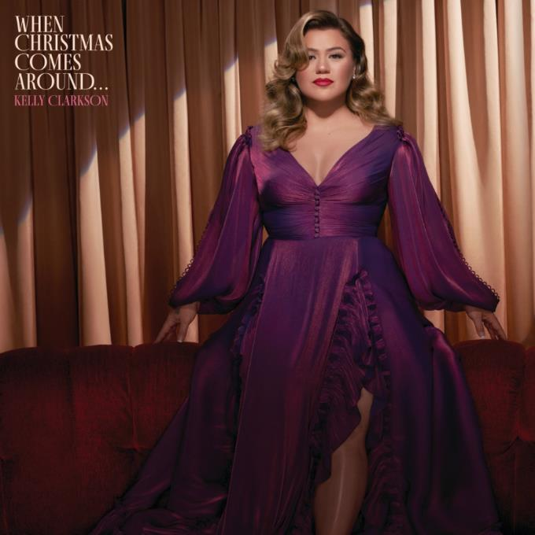

Buy/Stream “Christmas Isn’t Canceled (Just You)”: https://Atlantic.lnk.to/ChristmasIsntCanceledJustYouPR
Pre-order When Christmas Comes Around…: https://Atlantic.lnk.to/WhenChristmasComesAround-POPR

GRAMMY-winning global superstar Kelly Clarkson has announced When Christmas Comes Around…, her ninth studio album arriving October 15th via Atlantic Records. Preceded today by the fabulously bold lead single “Christmas Isn’t Canceled (Just You),” the album explores a wide range of holiday emotions and experiences anchored by Clarkson’s incomparable vocal prowess.

“My purpose for choosing this lyric for being the title of this project was to bring forth a sense of reality to the fact that we are probably all in very different places emotionally ‘when Christmas comes around.’ Some of us consumed with a new love, some of us reminded of loss, some filled with optimism for the coming new year, others elated for some much deserved time away from the chaos our work lives can sometimes bring us. Wherever you are, and whatever you may be experiencing, I wanted everyone to be able to connect to a message on this album. Each year you may even have a new favorite depending on where you are in your life, but while change can be unpredictable there is no better time of year, in my opinion, to breathe hope into one’s life and let possibility wander.”
– KELLY CLARKSON

The 15-track collection features a mix of new original songs and Christmas classics, alongside show-stopping collaborations with Ariana Grande (“Santa, Can’t You Hear Me”), Chris Stapleton (“Glow”) & Brett Eldredge (2020’s hit single “Under The Mistletoe”). When Christmas Comes Around… marks the latest album from Clarkson since 2017’s Meaning of Life and her second holiday offering following 2013’s Wrapped In Red. Meanwhile, this past month alone has seen Clarkson kick off the third season of the six-time Daytime Emmy Award-winning The Kelly Clarkson Show and return as three-time champion coach on the 21st season of The Voice.

When Christmas Comes Around…
(out October 15th via Atlantic Records)
1. Merry Christmas Baby
2. It’s Beginning To Look A lot Like Christmas
3. Christmas Isn’t Canceled (Just You)
4. Merry Christmas (To The One I Used To Know)
5. Rockin’ Around The Christmas Tree
6. Glow (feat. Chris Stapleton)
7. Santa Baby
8. Santa, Can’t You Hear Me (feat. Ariana Grande)
9. Last Christmas
10. Jingle Bell Rock
11. Blessed
12. Christmas Come Early
+ previously released bonus tracks:
13. Under The Mistletoe (feat. Brett Eldredge)
14. All I Want For Christmas Is You
15. Christmas Eve

ABOUT KELLY CLARKSON:
Kelly Clarkson is among the most popular artists of this era with total worldwide sales of more than 25 million albums and 40 million singles. The Texas-born singer-songwriter first came to fame in 2002 as the winner of the inaugural season of American Idol. Clarkson’s debut single, “A Moment Like This,” followed and quickly went to #1 on Billboard’s Hot 100, ultimately ranking as the year’s best-selling single in the U.S. Further, Clarkson is one of pop’s top singles artists, with 19 singles boasting multi-platinum, platinum and gold certifications around the world, including such global favorites as “Miss Independent” and “Because of You.” Clarkson has released eight studio albums (Thankful, Breakaway, My December, All I Ever Wanted, Stronger, Wrapped In Red, Piece By Piece, Meaning of Life), one greatest hits album, and two children’s books (New York Times Top 10 best seller River Rose and the Magical Lullaby and the follow up River Rose and the Magical Christmas). She is the recipient of an array of awards including three GRAMMY Awards, four American Music Awards, three MTV Video Music Awards, two Academy of Country Music Awards, two American Country Awards, one Country Music Association Award, and two Daytime Emmy Awards. She is also the first artist to top each of Billboard’s pop, adult contemporary, country and dance charts.

DOWNLOAD HIGH-RES ARTWORK

For more information, please visit:
KellyClarkson.com | Facebook | Twitter | Instagram | YouTube | Press Assets

For press inquiries:
Sheila Richman | Sheila.Richman@atlanticrecords.com
Ted Sullivan | Ted.Sullivan@atlanticrecords.com

