FOR IMMEDIATE RELEASE
OCTOBER 15, 2021

Kelly Clarkson celebrates When Christmas Comes Around…

Ninth studio album available now featuring original songs, classic covers,
collaborations with Ariana Grande, Chris Stapleton & more

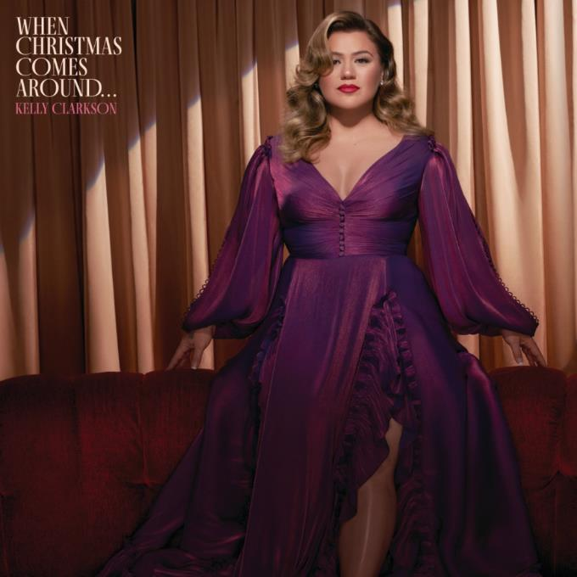
DOWNLOAD HIGH-RES IMAGES + ARTWORK

STREAM “Santa, Can’t You Hear Me” fEAt. Ariana Grande: LINK
Stream When Christmas Comes Around…: LINK

GRAMMY-winning global superstar Kelly Clarkson has released When Christmas Comes Around…, her ninth studio album via Atlantic Records. The 15-track collection sees Clarkson reunite with long time collaborators Jason Halbert, Jesse Shatkin and more for a mix of new original songs and Christmas classics.

“’When Christmas Comes Around…’ captures how different the holidays can be for all of us during the varying stages of our lives, and I hope everyone can find something on the record they relate to. Hopefully the happier songs, but if not, hey… you’re not alone!” – KELLY CLARKSON

From the show-stopping duet “Santa, Can’t You Hear Me” featuring Ariana Grande to the hauntingly beautiful ballad “Merry Christmas (To The One I Used To Know),” When Christmas Comes Around… explores a wide range of holiday emotions and experiences anchored by Clarkson’s incomparable vocal prowess. The album also features cheerful standout “Glow” featuring Chris Stapleton and the fabulously bold lead single “Christmas Isn’t Canceled (Just You),” the latter of which was deemed “a sassy bop” by Entertainment Weekly and “infused with empowerment” by USA Today. A festive album visualizer will also be unveiled this afternoon via Clarkson’s official YouTube channel, bringing the stunning album even more to life.

When Christmas Comes Around… marks the latest album from Clarkson since 2017’s Meaning of Life and her second holiday offering following 2013’s Wrapped In Red. Meanwhile, the past month alone has seen Clarkson kick off the third season of the six-time Daytime Emmy Award-winning The Kelly Clarkson Show and return as three-time champion coach on the 21st season of The Voice.

When Christmas Comes Around…
(available now via Atlantic Records)
1. Merry Christmas Baby
2. It’s Beginning To Look A lot Like Christmas
3. Christmas Isn’t Canceled (Just You)
4. Merry Christmas (To The One I Used To Know)
5. Rockin’ Around The Christmas Tree
6. Glow (feat. Chris Stapleton)
7. Santa Baby
8. Santa, Can’t You Hear Me (feat. Ariana Grande)
9. Last Christmas
10. Jingle Bell Rock
11. Blessed
12. Christmas Come Early
+ previously released bonus tracks:
13. Under The Mistletoe (feat. Brett Eldredge)
14. All I Want For Christmas Is You
15. Christmas Eve

ABOUT KELLY CLARKSON:
Kelly Clarkson is among the most popular artists of this era with total worldwide sales of more than 25 million albums and 40 million singles. The Texas-born singer-songwriter first came to fame in 2002 as the winner of the inaugural season of American Idol. Clarkson’s debut single, “A Moment Like This,” followed and quickly went to #1 on Billboard’s Hot 100, ultimately ranking as the year’s best-selling single in the U.S. Further, Clarkson is one of pop’s top singles artists, with 19 singles boasting multi-platinum, platinum and gold certifications around the world, including such global favorites as “Miss Independent” and “Because of You.” Clarkson has released eight studio albums (Thankful, Breakaway, My December, All I Ever Wanted, Stronger, Wrapped In Red, Piece By Piece, Meaning of Life), one greatest hits album, and two children’s books (New York Times Top 10 best seller River Rose and the Magical Lullaby and the follow up River Rose and the Magical Christmas). She is the recipient of an array of awards including three GRAMMY Awards, four American Music Awards, three MTV Video Music Awards, two Academy of Country Music Awards, two American Country Awards, one Country Music Association Award, and two Daytime Emmy Awards. She is also the first artist to top each of Billboard’s pop, adult contemporary, country and dance charts.

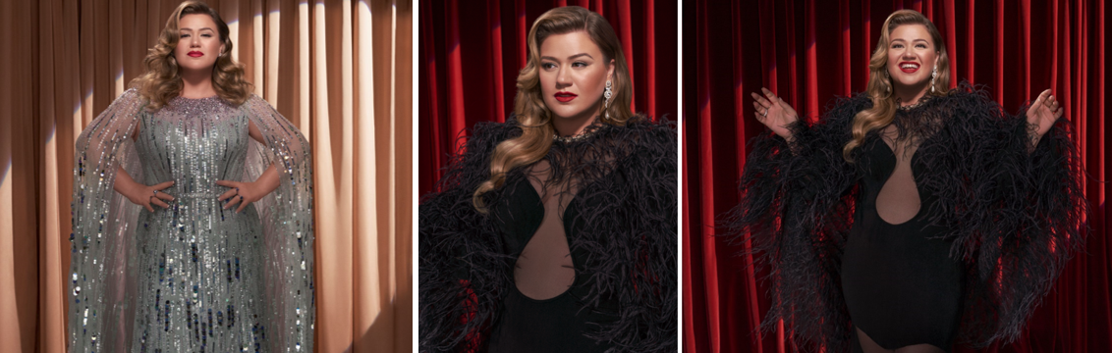
DOWNLOAD HIGH-RES IMAGES + ARTWORK

For more information, please visit:
KellyClarkson.com | Facebook | Twitter | Instagram | YouTube | Press Assets

For press inquiries:
Sheila Richman | Sheila.Richman@atlanticrecords.com
Ted Sullivan | Ted.Sullivan@atlanticrecords.com

