MULTI-PLATINUM RAPPER KEVIN GATES REMIXES DON TOLIVER’S “DIVA”
LISTEN HERE: https://kevingates.lnk.to/Diva
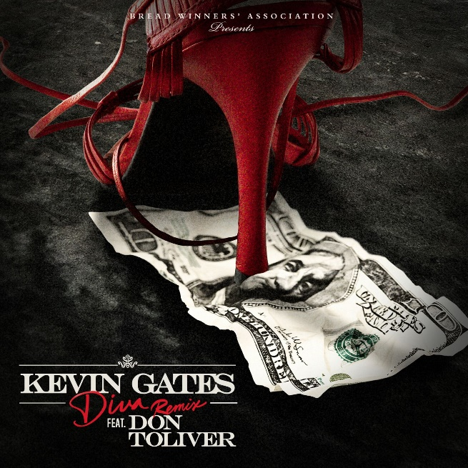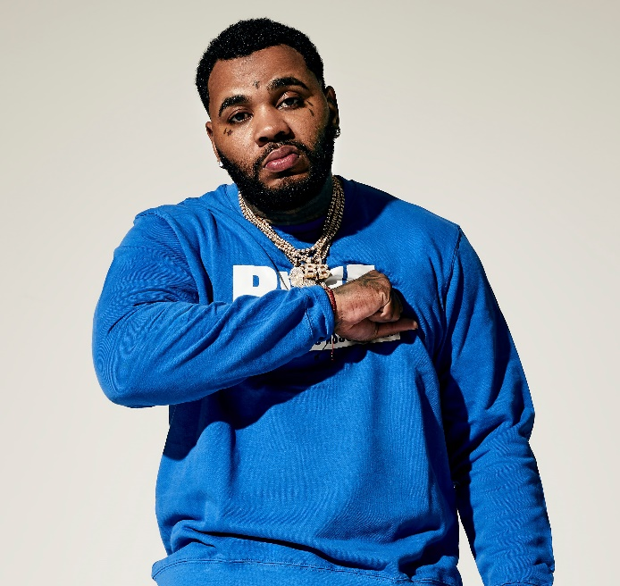

“Gates drops off two new verses while layering his deep vocal range underneath Toliver's infectious hook.” – Hot New Hip Hop

Yesterday, multi-platinum rapper Kevin Gates unveiled his remix of Don Toliver’s “Diva,” and today the new track is available at all DSPs, listen HERE. Gates put his own spin on the up-and-comer’s infections track and critics and fans alike are already loving it. Hot New Hip Hop applauds, “Gates has mastered the art of balancing his romantic and softer side and his more rough, gangster side throughout his music. Don Toliver's original track was already great but it's hard to deny that Kevin Gates didn't deliver on the remix.”

Gates recently announced his return to live music with the highly-anticipated “LUCA BRASI 3 TOUR,” supporting his forthcoming release, the third installment of Gates’ breakout mixtape Luca Brasi. While Gates has not yet unveiled the release date for Luca Brasi 3, dates for the tour are confirmed to kick off October 2nd in Austin, TX and continue through November 3rd in Wichita, KS (see full itinerary below). For more information, visit www.kvngates.com and watch tour trailer here.

The Bread Winners Association MC returned to music earlier this summer with CHAINED TO THE CITY, Gates first release after 15 months of incarceration. On the first week of release, two of the three tracks from “Chained To The City” made remarkable debuts on the Billboard Hot 100 chart. With “Change Lanes” and “Let It Sing” debuting at No. 68 and No. 82, respectively, Gates redeclared he is a major force to be reckoned with. Gates launched “Chained To The City” with a video by Chicago native Cole Bennett for “Change Lanes,” which garnered over 1 million views in the first day and has now climbed to over 33 million views since its release. Watch “Change Lanes” HERE.

Most recently, Gates unveiled a new video for “Vouch,” where he took to the streets of Watts, Los Angeles, proving Gates is welcomed and shown love in any neighborhood. Directed by Julien Soulier, the video features Kevin in his most natural element, connecting with a community of characters including Compton native Demar Derozan, pro NBA player for the San Antonio Spurs. Watch “Vouch” HERE.

ABOUT KEVIN GATES
Gates made history with this debut album ISLAH, which was released in January 2016 and cemented Kevin as one of the best-selling hip-hop artists of 2016, second only to Drake. The critically acclaimed debut album was certified platinum by the RIAA for sales in excess of 1 million – 2016’s only debut album to receive platinum certification within one year. One of the rare major hip-hop releases to contain no featured artists, ISLAH made an incredible chart debut, entering Billboard’s “Top Rap Albums” chart at #1 while also coming in at #2 on the Billboard 200. “ISLAH” received critical acclaim cementing its place as a milestone hip-hop release, named among 2016’s top 50 releases by both Billboard and Complex. “‘ISLAH’ is a sustained and triumphant outpouring,” declared Pitchfork in a “Best New Music” 8.5-out-of-10 rave review, “and Gates gives every good, bad, and ugly thing he has. It’s by far the best single release of his career.” The album earned Gates a nomination for Best Rap Album at the 2017 Billboard Music Awards.

While incarcerated by the Illinois Board of Corrections, Gates surprised fans around the world with the September 2017 release of BY ANY MEANS 2, which debuted at No. 4 on the Billboard 200. Gates launched the BY ANY MEANS 2 mixtape with an emotional visual for his acclaimed single “What If” and a deeply personal handwritten message posted on his official Instagram – Gates’ first public statement since his October 2016 imprisonment. Following “What If” came two more emotional and personal visuals for both “Imagine That,” and “Had To.”

MORE ON KEVIN GATES
PRESS PHOTO // ARTWORK // INSTAGRAM
WEBSITE // TWITTER // YOUTUBE // OFFICIAL BWA // ATLANTIC RECORDS

KEVIN GATES
LUCA BRASI 3 TOUR 2018
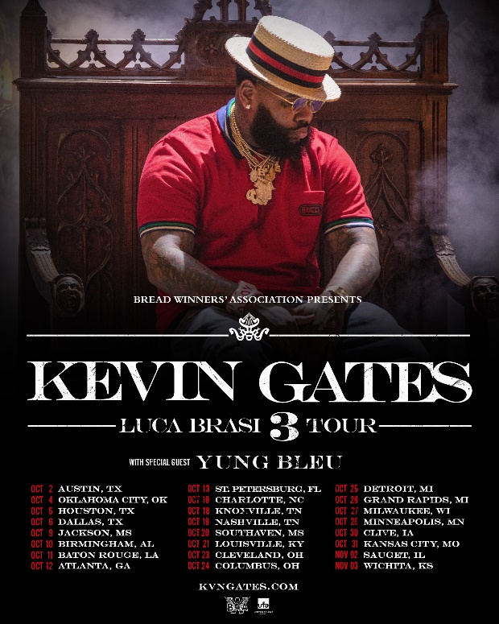

DATE CITY VENUE
2-Oct Austin, TX ACL The Moody Theater
4-Oct Oklahoma City, OK The Criterion
5-Oct Houston, TX Revention Music Center
6-Oct Dallas, TX The Bomb Factory
9-Oct Jackson, MS Thalia Mara Hall
10-Oct Birmingham, AL BJCC Concert Hall
11-Oct Baton Rouge, LA Raising Cain's River Center
12-Oct Atlanta, GA Tabernacle
13-Oct St. Petersburg, FL Jannus Live
16-Oct Charlotte, NC Ovens Auditorium
18-Oct Knoxville, TN Knoxville Civic Coliseum
19-Oct Nashville, TN Nashville Municipal Auditorium
20-Oct Southaven, MS Landers Center
21-Oct Louisville, KY The Bourbon Hall
23-Oct Cleveland, OH Agora Ballroom
24-Oct Columbus, OH Express Live!
25-Oct Detroit, MI Royal Oak Music Theatre
26-Oct Grand Rapids, MI 20 Monroe Live
27-Oct Milwaukee, WI The Eagles Ballroom
28-Oct Minneapolis, MN Myth Live
30-Oct Clive, IA Seven Flags Event Center
31-Oct Kansas City, MO Uptown Theater
2-Nov Sauget, IL Pop's
3-Nov Wichita, KS The Cotillion Ballroom

