FOR IMMEDIATE RELEASE
FEBRUARY 5, 2020

KEVIN GATES DEDICATES NEW SINGLE TO HIS WIFE DREKA
+ ANNOUNCES I’M HIM PART 2 TOUR

ON HIS OWN BIRTHDAY, KEVIN GATES REAFFIRMS HIS LOVE FOR
HIS WIFE, MANAGER AND BUSINESS PARTNER
WITH NEW TRACK “DREKA”
LISTEN HERE

CHART-TOPPING RAPPER TO EXTEND I’M HIM TOUR WITH SLEW OF
NORTH AMERICAN DATES INCLUDING MASSIVE FESTIVAL PERFORMANCES
AT NEON DESERT AND BONNAROO
+ LONGEST RUNNING EUROPEAN TOUR KICKS OFF THIS SPRING

NORTH AMERICAN DATES BEGIN MAY 19TH AT DENVER’S ICONIC RED ROCKS AMPHITHEATRE
TICKETS ON SALE FRIDAY FEBRUARY 7TH AT 10AM LOCAL TIME
FOR TICKETS VISIT OFFICIAL WEBSITE

LISTEN TO GATES’ #1 R&B/HIP-HOP ALBUM I’M HIM HERE

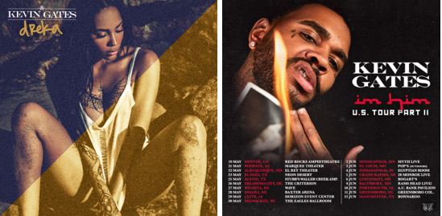
DOWNLOAD HI-RES ARTWORK | DOWNLOAD HI-RES ADMAT

Today, on his birthday, multi-Platinum recording artist Kevin Gates unveiled one of his most personal and special tracks yet. Gates wears his heart on his sleeve on the romantic track “Dreka,” named for his wife, manager, business partner and mother of his two children – affectionately known as #bossmaynedrek. Listen to “Dreka” HERE. Watch the visualizer for “Dreka” HERE.

Yesterday, the prolific rapper announced his North American tour dates for “I’M HIM Part 2 Tour.” The tour kicks off at Denver, CO’s iconic venue, Red Rocks Amphitheatre, on May 19th. Gates is slated to perform at El Paso, TX’s Neon Desert on May 23rd and wraps his tour with an incredible performance at Manchester, TN’s Bonnaroo Music & Arts Festival on June 13th. Artist presale began 2/4 at 12PM local time and will continue through 2/6 10PM local time; Songkick presale will begin 2/5 at 10 AM local time and run through 2/6 at 10Pm local and venue presales will run 2/6 from 10AM to 10PM local time. Tickets for the “I’m Him Part 2 Tour” go on sale to the general public Friday, 2/7 at 10AM local time. See full itinerary below. For complete details, please visit www.kvngates.com/tour. Please note, tickets for Neon Desert will be on sale soon.

Gates recently announced his longest-ever European headline tour. The “I’M HIM European Tour” begins March 26th in Dublin, Ireland and includes visits to far-reaching locales including Norway, Finland, Sweden, Denmark, Germany, Poland, Switzerland, France, Belgium, the Netherlands, and Spain. Tickets are currently available for purchase at www.kvngates.com/tour.

Kevin and Dreka Gates recently teamed up to create the short film for Kevin’s track “Fatal Attraction” of his chart-topping album I’M HIM -- watch the visual HERE. The unstoppable power couple went on Complex’s Everyday Struggle for a rare and exclusive joint interview to speak about the Louisiana heritage and the voodoo culture that inspired the film, which was shot in New Orleans. The incredibly adorable and informative, must-see interview is streaming now HERE.

“Dreka” follows Gates’ critically acclaimed I’M HIM which arrived last year. The album debuted at #1 on the Billboard R&B/Hip-Hop Album Sales chart and at #4 on the Billboard 200 chart, giving Gates his fourth top 10 album. Pitchfork raved about the impressive showing from Gates by stating “seventeen songs with no guest features should be a recipe for exhaustion, yet there's hardly a trace of fat on I’M HIM.”

The Kevin & Dreka Gates Foundation – founded by the dynamic duo– partnered with The Crystal Campaign, a global movement of healing with the mission to make mental health as common and important of a conversation as physical health. Gates, who has always shared his struggle with mental health through his raw and emotional lyrics, has announced a “Walls Talking” inspired merch line that will raise funds for the Kevin & Dreka Gates Foundation which seeks to raise awareness and advocate for policy changes that support the mental health of formerly incarcerated people. Shop the full line HERE.

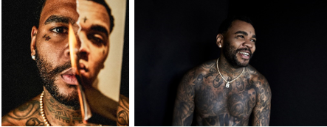
[Download – Credit: Jimmy Fontaine]

MORE ON KEVIN GATES
PRESS PHOTOS // ARTWORK // INSTAGRAM
WEBSITE // TWITTER // YOUTUBE // OFFICIAL BWA // ATLANTIC RECORDS

I’M HIM EUROPEAN TOUR ITINERARY
MARCH
26 Dublin Green Room
28 Oslo Rockefeller
29 Helsinki The Circus
31 Stockholm Debaser Strand

APRIL
2 Arhaus Voxhall
3 Copenhagen Pumpehuset
4 Hamburg Waagenbau
7 Berlin BiNuu
8 Warsaw Praga Centrum
10 Weisbaden Weisbaden
11 Basel Club Vice
14 Zurich Exil
16 Paris Bellevilloise
17 Cologne CBE
18 Brussels Bloody Louis
21 Amsterdam Melkweg
22 Barcelona Shoko

I’M HIM PART 2 NORTH AMERICAN TOUR ITINERARY
MAY
19 Denver, CO Red Rocks Amphitheatre
21 Phoenix, AZ Marquee Theatre
22 Albuquerque, NM El Rey Theater
23 El Paso, TX Neon Desert**
25 Austin, TX Stubb's Waller Creek Amphitheater
26 Oklahoma City, OK The Criterion
27 Wichita, KS WAVE
28 Omaha, NE Baxter Arena
29 Clive, IA Horizon Event Center
30 Milwaukee, WI The Eagles Ballroom

JUNE
2 Minneapolis, MN Myth Live
3 St. Louis, MO Pop's (Outdoors)
4 Indianapolis, IN Egyptian Room at Old National Centre
5 Grand Rapids, MI 20 Monroe Live
6 Cincinnati, OH Bogart's
9 Baltimore, MD Rams Head Live!
10 Portsmouth, VA Atlantic Union Bank Pavilion
11 Greensboro, NC Greensboro Coliseum
13 Manchester, TN Bonnaroo**

**Festival performance

