FOR IMMEDIATE RELEASE
JANUARY 23, 2020

KEVIN GATES FALLS UNDER A VOODOO SPELL
IN HIS VIDEO MOVIE FOR “FATAL ATTRACTION” FROM I’M HIM

THE 1920s INSPIRED NEW ORLEANS FILM BY KEVIN AND DREKA GATES IS NOW STREAMING; WATCH HERE

CHECK OUT THE INSPIRATIONAL COUPLE’S MUST-SEE INTERVIEW ABOUT THE NEW VISUAL
ON COMPLEX’S EVERYDAY STRUGGLE; WATCH HERE

CHART-TOPPING RAPPER TO PERFORM AT BONNAROO THIS SUMMER;
ADDITIONAL LIVE DATES TO BE ANNOUNCED SOON

LISTEN TO GATES’ #1 R&B/HIP-HOP ALBUM I’M HIM HERE

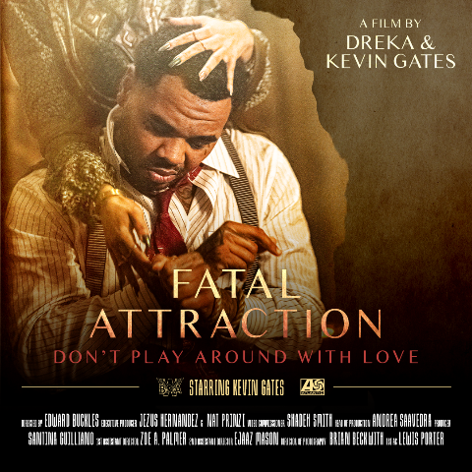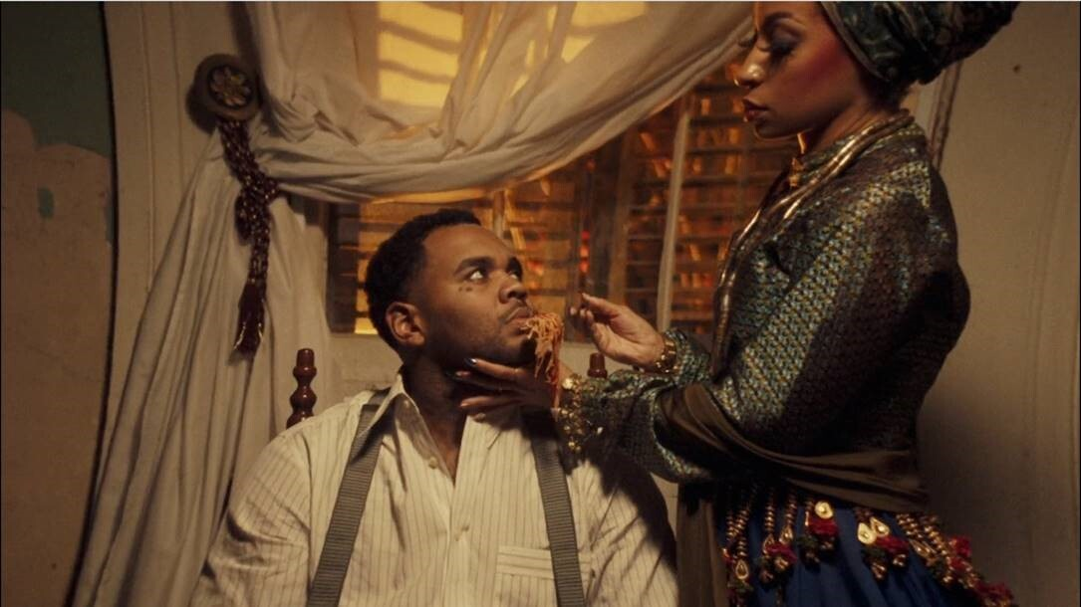
DOWNLOAD HI-RES IMAGES + ASSETS HERE

Multi-Platinum recording artist and Baton Rouge native Kevin Gates unveiled his most captivating visual yet for the standout fan-favorite track “Fatal Attraction” from his chart-topping album I’M HIM. Inspired by Louisiana Voodoo culture, the spellbinding video features Gates as an affluent mob boss who frequents brothels and falls under the spell of the madame of the house. Under the full moon, the madame is shown putting the “woo” in Kevin’s spaghetti. As Kevin eats the meal, the madame takes control over him spiritually and physically -- watch the visual HERE.

“She was tryna hit him with the woo, tryna catch him. She was tryna put it in his food, tryna trap him. Maybe underneath the full moon, night of passion. Thinking he'll fall deeply in love from attraction”

Today, Kevin and Dreka Gates went on Complex’s Everyday Struggle for a rare and exclusive joint interview to speak about their Louisiana heritage and the voodoo culture that inspired the film, which was shot in New Orleans. The incredibly informative, must-see interview is streaming now HERE.

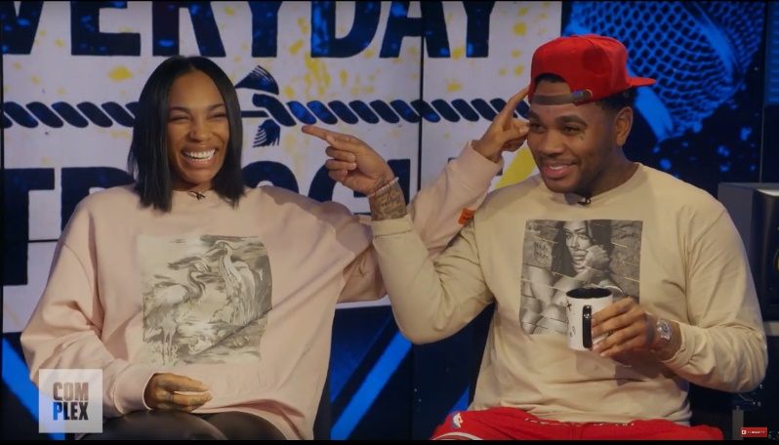

The Gates couple has taken an unparalleled approach to releasing a music video and have built an unforgettable campaign around the story, including an authentic “Missing” newspaper story, a movie poster and a trailer fit for the big screen. Download all assets HERE.

The entirely vintage wardrobe in the video was styled after the late 1920’s, early 1930’s. With the larger part of the looks drawing heavy inspiration from the black gangster film Hoodlum starring Laurence Fishburne, Francis Ford Coppola’s Cotton Club and The Harlem Renaissance. While Louisiana Creole Voodoo practitioner, Marie Laveau, provided the inspiration for THE QUEEN. To maintain authenticity, the costume designer utilized actual vintage period pieces, with the one exception of Kevin’s black and white wing tip Stacey Adams shoes; which were incorporated to elevate his overall look and provide a boss vibe.

“Fatal Attraction” is an standout track from Gates’ critically acclaimed I’M HIM which arrived earlier this year. The album debuted at #1 on the Billboard R&B/Hip-Hop Album Sales chart and at #4 on the Billboard 200 chart, giving Gates his fourth top 10 album. Pitchfork raved about the impressive showing from Gates by stating “seventeen songs with no guest features should be a recipe for exhaustion, yet there's hardly a trace of fat on I’M HIM.”

Kevin Gates will be performing at the 2020 Bonnaroo Music & Arts Festival in Manchester, TN, while new headline dates will be announced soon. Recently, the Kevin & Dreka Gates Foundation – founded by multi-Platinum recording artist Kevin Gates and his wife/manager Dreka – partnered with The Crystal Campaign, a global movement of healing with the mission to make mental health as common and important of a conversation as physical health. Gates, who has always shared his struggle with mental health through his raw and emotional lyrics, has announced a “Walls Talking” inspired merch line that will raise funds for the Kevin & Dreka Gates Foundation which seeks to raise awareness and advocate for policy changes that support the mental health of formerly incarcerated people. Shop the full line HERE.

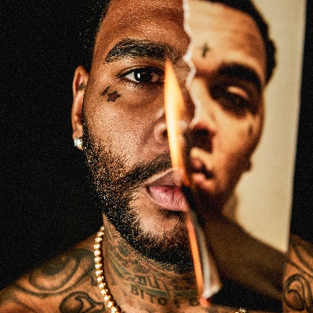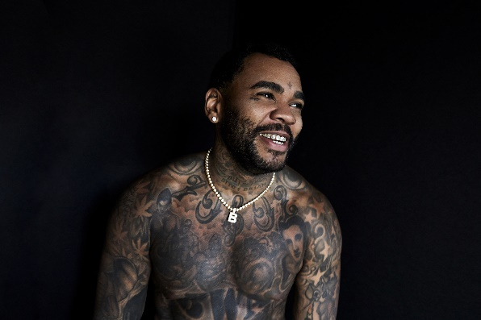
[Download – Credit: Jimmy Fontaine]

MORE ON KEVIN GATES
PRESS PHOTOS // ARTWORK // INSTAGRAM
WEBSITE // TWITTER // YOUTUBE // OFFICIAL BWA // ATLANTIC RECORDS

