KEVIN GATES PARTNERS WITH HOLLYWOOD ESCAPE HOUSE TO LAUNCH
THE “HOUSE ON CAROLINA” ESCAPE ROOM

THE MULTI-PLATINUM RAPPER OPENS GROUNDBREAKING ESCAPE ROOM REPLICATING HIS BATON ROUGE TRAP HOUSE

THE HOUSE ON CAROLINA IS NOW OPEN TO THE PUBLIC INDEFINITELY;
VIP CELEBRATION WITH KEVIN + DREKA GATES ON THURSDAY, NOVEMBER 8TH

“This attraction is pure genius” – AllHipHop
“Escape the Room with Kevin Gates” – VICE Noisey
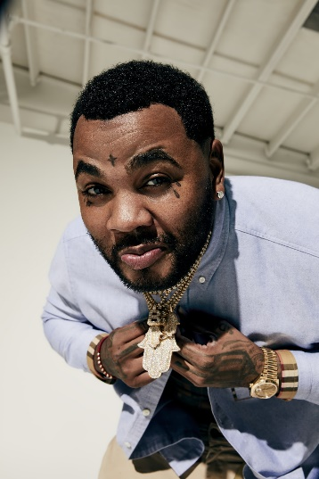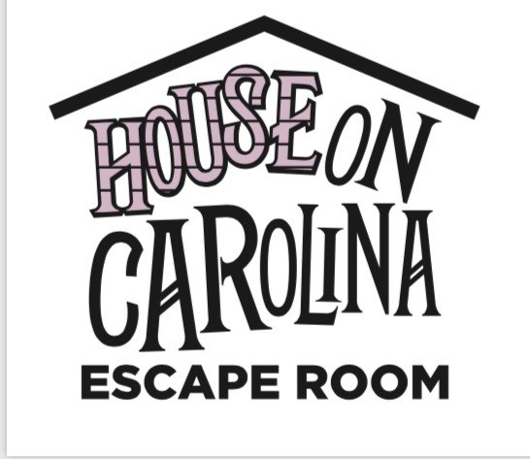
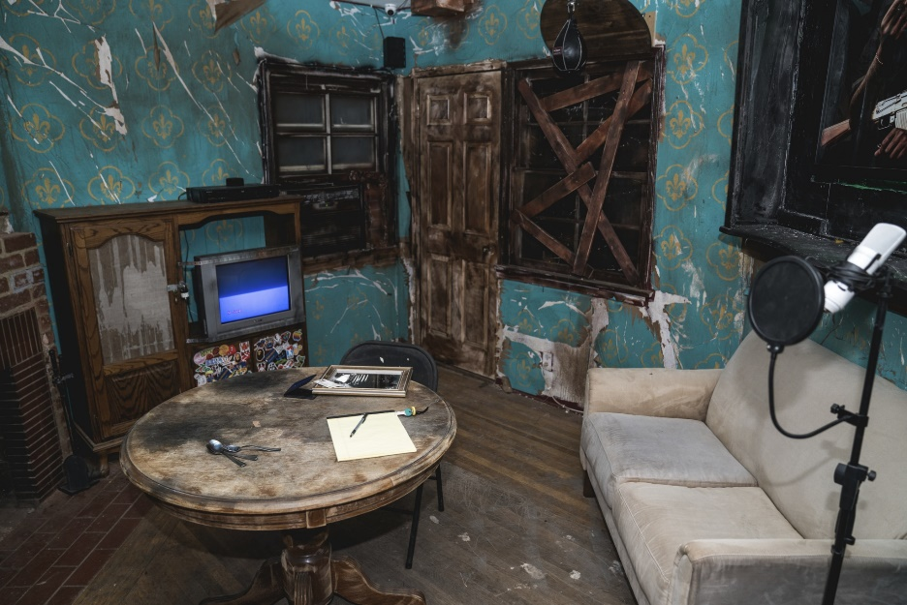
Watch Kevin try to escape here!
Follow @HouseOnCarolina on Instagram
Download photos from Kevin + Dreka’s experience here.

Multi-Platinum artist Kevin Gates has expanded his role as a business man, teaming up with the Hollywood Escape House to launch an exclusive escape room themed and tailor-made to fit Kevin’s story. The “House On Carolina” escape room experience is now open to the public and can be booked at www.houseoncarolina.com. Gates has intertwined stories about his house on Carolina street into his lyrics since he started making music. The Bread Winners’ Association MC and his wife/manager Dreka trapped out of the pink house in their early twenties in Baton Rouge, LA. It was in those crucial few years of Kevin’s life where he began writing lyrics and rapping, releasing his earliest mixtapes back in 2007 (Pick of Da Litter) and 2008 (All or Nuthin’) while living in that same house.

During last week’s launch, Kevin and Dreka did the room themselves for the first time with BWA crew members and set the record escape time. Check out photos and video from their experience.

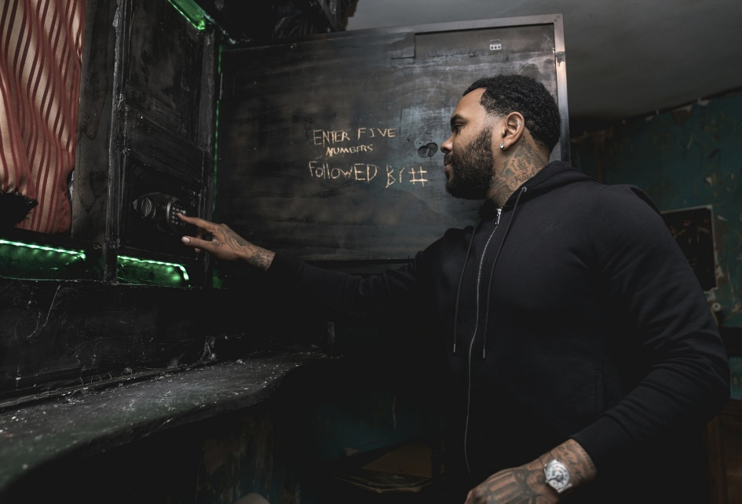

During Kevin’s recent incarceration, Dreka and the Bread Winners’ Association team started doing escape rooms for fun on a weekly basis. Dreka’s passion for escape rooms has led her to transform the team’s latest hobby into a creative business opportunity for the label and organization, alongside her husband and business partner. Over the past several months since Kevin’s release, he and Dreka and the BWA team have been working with Hollywood Escape House to develop the escape room and bring their “House On Carolina” vision to life.

Gates is fresh off the release of Luca Brasi 3, the first mixtape since his release from prison earlier this year, and the third installment of his breakthrough mixtape The Luca Brasi Story. Luca Brasi 3 made an astounding debut at No. 4 on the Billboard 200, with sales equivalents exceeding 78,000. Gates is currently on the sold-out Luca Brasi 3 Tour, hitting cities throughout the US, ending November 3rd in Wichita, KS.

KEVIN GATES: THE HOUSE ON CAROLINA ESCAPE ROOM
Address: 5010 Vineland Ave North Hollywood, CA 91606
Book here: www.houseoncarolina.com

