FOR IMMEDIATE RELEASE
SEPTEMBER 27, 2019

KEVIN GATES DECLARES “I’M HIM”

HIGHLY-ANTICIPATED NEW ALBUM ARRIVES TODAY
ALONGSIDE VIDEO FOR OPENING TRACK “RBS INTRO”

LISTEN TO I’M HIM HERE
WATCH VIDEO FOR “RBS” HERE
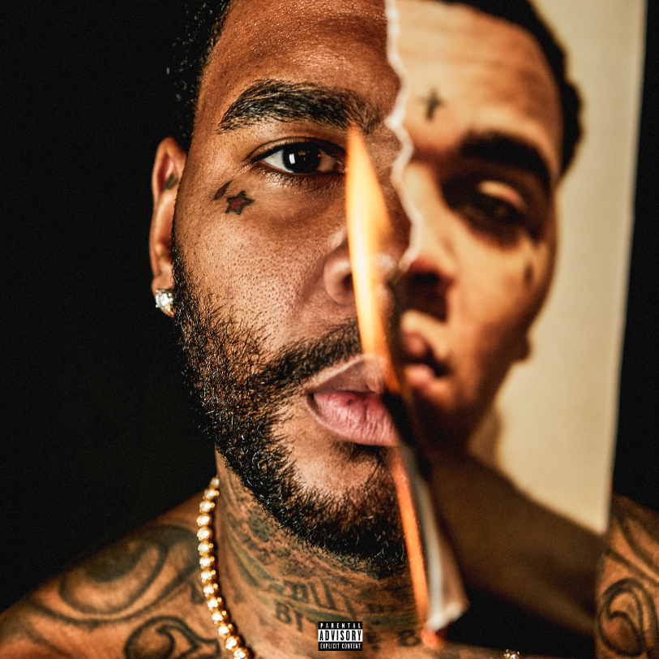
*Download Album Art*

Today, Bread Winners Association recording artist Kevin Gates releases his highly-anticipated new album I’M HIM. The 17-track follow-up to his platinum-certified debut ISLAH, is available now at all DSPs and streaming services HERE. Alongside the new album, Gates has also unveiled a brand-new music video filmed in Amsterdam for the I’M HIM’s opening track, “RBS Intro” – watch it HERE.

“All of those negative connotations the world puts out...I’m him. All of those positive connotations the world puts out...I’m him as well. This is the new Kevin verses the old Kevin. It’s a celebration. It’s a rebirth. It’s redemption. I’m overcoming who I used to be in order to be greater.”
– Kevin Gates

In typical Gates fashion, the fearless emcee tackled his sophomore album head-on with no features. In addition to summer anthems “Push It” and “Facts,” I’M HIM also includes stand-out tracks “Ice Box,” “By My Lonely,” “Let It Go,” and “Pretend,” as well as the emotional tearjerker “Betta For You,” written for his daughter. Watch Gates’ spoken definition talking through the meaning of I’M HIM HERE.

Gates – who is currently nominated for two BET Hip Hop Awards – is launching this new album while in the best shape of his life mentally, physically, emotionally and spiritually. Kevin recently gave Men’s Health a glimpse into his healthy lifestyle and fitness routine – watch his episode of “Gym & Fridge” HERE. The enigmatic rapper also recently sat down to answer a series of intimate questions with Amazon’s Alexa in a game of “Fact or Fiction.” Watch the entertaining conversation HERE.

On the heels of an epic, sold-out hometown underplay show in Baton Rouge, Gates will soon embark on a massive North American headline tour to celebrate I’M HIM; watch the I’M HIM Tour trailer HERE. Long hailed as an electrifying live performer, Gates will kick off the trek October 12th in Chicago and continues through the November 30th in Seattle. Full itinerary below; for tickets and additional information, please visit www.kvngates.com.

I’M HIM marks Gates’ first official album release in more than three years, following 2016’s now-classic debut, ISLAH. Gates has been releasing a constant stream of music since his debut album. Despite his legal challenges and incarceration circumstances over the past three years, the Baton Rouge-raised emcee hasn’t stopped delivering heavy-hitting music to his fans, including BY ANY MEANS 2, CHAINED TO THE CITY, LUCA BRASI 3, and his latest ONLY THE GENERALS GON UNDERSTAND, available now at all DSPs and streaming services HERE. The six-track project – which includes such acclaimed singles as “Big Gangsta” and “#Yukatán” – has fast proven another smash for Gates, now with over 80 million streams.

ISLAH affirmed Kevin Gates as one of hip-hop’s greatest new stars, second only to Drake as the best-selling hip-hop artist of 2016. One of the rare major hip hop releases to contain no featured artists, the album made an incredible chart debut upon its January 2016 arrival, entering Billboard’s “Top Rap Albums” chart at #1 while also coming in at #2 on the SoundScan/Billboard 200 with sales in excess of 110,000 – Gates’ biggest sales week to date. ISLAH of course includes a pair of smashes in the 3x platinum certified “Really Really” and the 4x platinum, top 20 blockbuster, “2 Phones,” the latter of which ascended to #17 on Billboard’s overall “Hot 100” – Gates’ highest charting mainstream single to date. What’s more, Gates’ distinctive accompanying visuals saw him ranked by the New York Times as the #5 most-watched artist on YouTube in the US between January 2016 and April 2017. Indeed, “Really Really” has drawn more than 228 million views thus far, while “2 Phones” has earned a remarkable 275 million views and counting via YouTube alone.

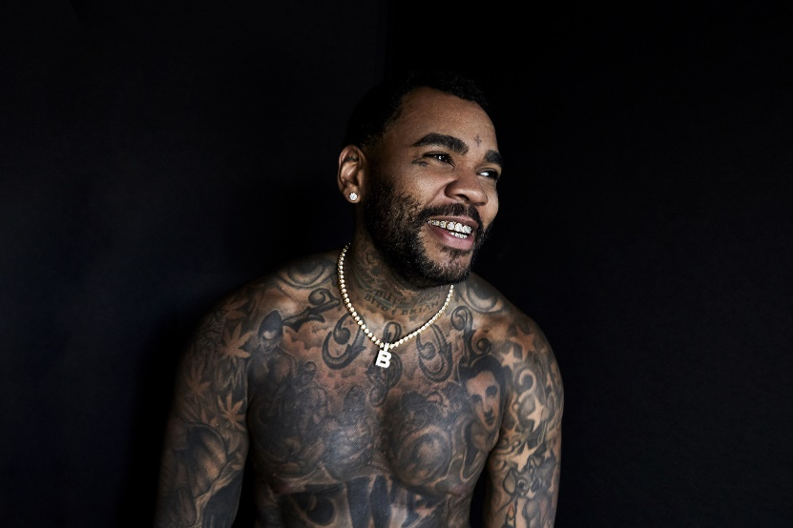
[Download – Credit: Jimmy Fontaine]

MORE ON KEVIN GATES
PRESS PHOTOS // ARTWORK // INSTAGRAM
WEBSITE // TWITTER // YOUTUBE // OFFICIAL BWA // ATLANTIC RECORDS
KEVIN GATES - I’M HIM
TRACKLISTING

- RBS Intro
- Icebox
- By My Lonely
- Bags
- Facts
- Fatal Attraction
- Say It Twice
- Walls Talking
- Let It Go
- Face Down
- Push It
- Have You Ever
- Pretend
- What I Like
- Funny How
- Betta For You
- Fly Again

KEVIN GATES
I’M HIM TOUR 2019
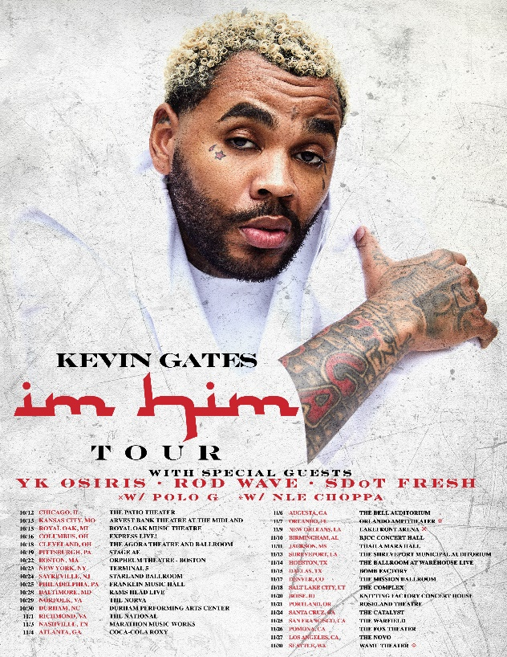

OCTOBER
12 – Chicago, IL – The Patio Theater
13 – Kansas City, MO – Arvest Bank Theatre at the Midland
15 – Royal Oak, MI – Royal Oak Music Theatre
16 – Columbus, OH – Express Live!
18 – Cleveland, OH – The Agora Theatre and Ballroom
19 – Pittsburgh, PA – Stage AE
20 – Philadelphia, PA – Franklin Music Hall
22 – Boston, MA – Orpheum Theatre
23 – New York, NY – Terminal 5
24 – Sayreville, NJ – Starland Ballroom
27 – Washington, DC – Echostage
29 – Norfolk, VA – The Norva
30 – Durham, NC – Durham Performing Arts Center

NOVEMBER
1 – Richmond, VA – The National
3 – Nashville, TN – Nashville Municipal Auditorium
4 – Atlanta, GA – Coca-Cola Roxy
6 – Augusta, GA – The Bell Auditorium
7 – Orlando, FL – Orlando Amphitheater
9 – New Orleans, LA – Lakefront Arena
10 – Birmingham, AL – BJCC Concert Hall
11 – Jackson, MS – Thalia Maria Hall
12 – Shreveport, LA – The Shreveport Municipal Auditorium
13 – Houston, TX – Revention Music Center
15 – Dallas, TX – Bomb Factory
17 – Denver, CO – The Mission Ballroom
18 – Salt Lake City, UT – The Complex
20 – Boise, ID – Knitting Factory Concert House
21 – Portland, OR – Roseland Theatre
24 – Santa Cruz, CA – The Catalyst
25 – San Francisco, CA – The Warfield
26 – Pomona, CA – The Fox Theater
27 – Los Angeles, CA – The Novo
30 – Seattle, WA – WaMu Theater

###

