FOR IMMEDIATE RELEASE

AUGUST 14, 2018

**MULTI-PLATINUM RAPPER KEVIN GATES ANNOUNCES RETURN TO TOURING WITH MASSIVE NATIONWIDE HEADLINE RUN**

**“LUCA BRASI 3 TOUR” KICKS OFF OCTOBER 2ND IN AUSTIN, TX**

**[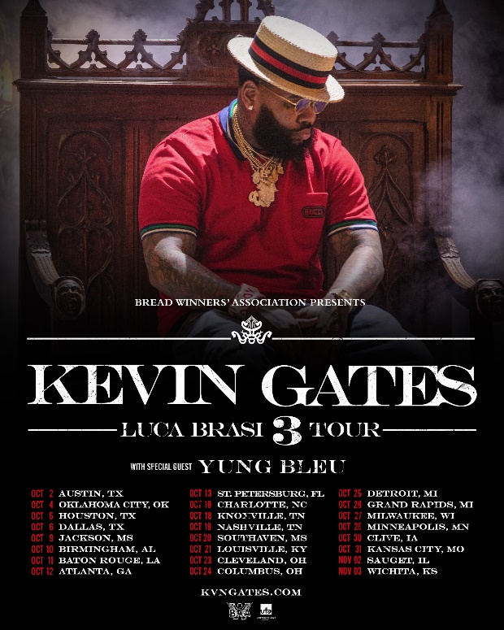](https://kevingates.lnk.to/LucaBrasi3TourTrailer)**

Today, multi-platinum rapper Kevin Gates announces his return to live music with the highly-anticipated “LUCA BRASI 3 TOUR.” Dates get underway October 2nd in Austin, TX and continue through November 3rd, concluding in Wichita, KS (see full itinerary below). Tickets will officially go onsale to the public this Friday, August 17th at 10am local time. For more information, visit [www.kvngates.com](http://www.kvngates.com). Watch tour trailer here: <https://kevingates.lnk.to/LucaBrasi3TourTrailer>.

Just last week the Baton Rouge MC released his latest video for “Vouch,” where he took to the streets of Watts, Los Angeles, proving Gates is welcomed and shown love in any neighborhood. Directed by Julien Soulier, the video features Kevin in his most natural element, connecting with a community of characters including Compton native Demar Derozan, pro NBA player for the San Antonio Spurs. Watch “Vouch” here: <https://kevingates.lnk.to/VouchVideoPR>

“Vouch” is from Gates’ latest 3-song release [*CHAINED TO THE CITY*](https://kevingates.lnk.to/ChainedToTheCity), which was released earlier this summer on the first night of Ramadan. Listen to “Chained To The City” [HERE](https://kevingates.lnk.to/ChainedToTheCity). In addition to “Vouch,” [*Chained To The City*](https://kevingates.lnk.to/ChainedToTheCity)  also features new tracks “[Change Lanes](https://youtu.be/Wbm-GzCnC-g)” and “[Let It Sing](https://kevingates.lnk.to/LetItSingVideo).”

Just a couple of weeks ago, Gates gave the world a first behind-the-scenes look into his life after 15 months of incarceration. The multi-Platinum MC performs his first live show, goes back into the studio, and spends time with family. Watch Kevin Gates – 2018 – Episode 1 here: <https://youtu.be/SrZagnHD0IU>.

On the first week of release, two of the three tracks from “[Chained To The City](https://kevingates.lnk.to/ChainedToTheCity)” made remarkable debuts on the Billboard Hot 100 chart. With “[Change Lanes](https://youtu.be/Wbm-GzCnC-g)” and “[Let It Sing](https://kevingates.lnk.to/LetItSingVideo)” debuting at No. 68 and No. 82, respectively, Gates has redeclared that he is a force to be reckoned with upon his return to music.

Gates launched “[Chained To The City](https://kevingates.lnk.to/ChainedToTheCity)” with a video by Chicago native Cole Bennett for “[Change Lanes](https://youtu.be/Wbm-GzCnC-g),” which garnered over 1 million views in the first day and has now climbed to over 26 million views since its release. Watch “Change Lanes” [**HERE**](https://youtu.be/Wbm-GzCnC-g).

[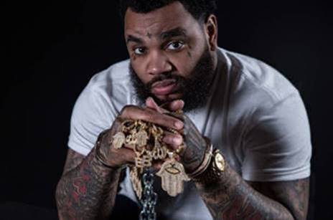](https://kevingates.lnk.to/ChainedToTheCity)

ABOUT KEVIN GATES

Gates made history with this debut album ISLAH, which was released in January 2016 and cemented Kevin as one of the best-selling hip-hop artists of 2016, second only to Drake. The critically acclaimed debut album was certified platinum by the RIAA for sales in excess of 1 million – 2016’s only debut album to receive platinum certification within one year. One of the rare major hip-hop releases to contain no featured artists, ISLAH made an incredible chart debut, entering Billboard’s “Top Rap Albums” chart at #1 while also coming in at #2 on the Billboard 200. “ISLAH” received critical acclaim cementing its place as a milestone hip-hop release, named among 2016’s top 50 releases by both Billboard and Complex. “‘ISLAH’ is a sustained and triumphant outpouring,” declared [Pitchfork](https://protect-us.mimecast.com/s/TKNdCM851MFVD5LVTwMiNy) in a “Best New Music” 8.5-out-of-10 rave review, “and Gates gives every good, bad, and ugly thing he has. It’s by far the best single release of his career.” The album earned Gates a nomination for Best Rap Album at the 2017 Billboard Music Awards.

While incarcerated by the Illinois Board of Corrections, Gates surprised fans around the world with the September 2017 release of *BY ANY MEANS 2*, which debuted at No. 4 on the Billboard 200. Gates launched the *BY ANY MEANS 2* mixtape with an emotional visual for his acclaimed single “[What If](https://protect-us.mimecast.com/s/R_00CNk50Nc5JNQ5h460ah)” and a deeply personal handwritten message posted on his official [Instagram](https://protect-us.mimecast.com/s/relbCOY58OcrlAgrukEZgz) – Gates’ first public statement since his October 2016 imprisonment. Following “[What If](https://protect-us.mimecast.com/s/fcPECPN5QPsA942AFjMhTY)” came two more emotional and personal visuals for both “[Imagine That](https://protect-us.mimecast.com/s/W3iaCQW57QH4g6K4srtVP_),” and “[Had To](https://protect-us.mimecast.com/s/VnjpCR651RhPorpPfofUgv).”

**MORE ON KEVIN GATES**

[PRESS PHOTO](https://warnermusicgroup.app.box.com/s/2xmyus0wfzmla0jb0nuok84ru21wl3qs/file/292922351454) // [ARTWORK](https://warnermusicgroup.app.box.com/s/tfc1uua0642k3oe76ik5okggcog6p810/file/292147285802) // [INSTAGRAM](https://www.instagram.com/iamkevingates/)

[WEBSITE](http://www.kvngates.com) // TWITTER // YOUTUBE // OFFICIAL BWA // ATLANTIC RECORDS

**KEVIN GATES**

**LUCA BRASI 3 TOUR**

**2018**

**DATE CITY VENUE**

2-Oct Austin, TX ACL The Moody Theater

4-Oct Oklahoma City, OK The Criterion

5-Oct Houston, TX Revention Music Center

6-Oct Dallas, TX The Bomb Factory

9-Oct Jackson, MS Thalia Mara Hall

10-Oct Birmingham, AL BJCC Concert Hall

11-Oct Baton Rouge, LA Raising Cain's River Center

12-Oct Atlanta, GA Tabernacle

13-Oct St. Petersburg, FL Jannus Live

16-Oct Charlotte, NC Ovens Auditorium

18-Oct Knoxville, TN Knoxville Civic Coliseum

19-Oct Nashville, TN Nashville Municipal Auditorium

20-Oct Southaven, MS Landers Center

21-Oct Louisville, KY The Bourbon Hall

23-Oct Cleveland, OH Agora Ballroom

24-Oct Columbus, OH Express Live!

25-Oct Detroit, MI Royal Oak Music Theatre

26-Oct Grand Rapids, MI 20 Monroe Live

27-Oct Milwaukee, WI The Eagles Ballroom

28-Oct Minneapolis, MN Myth Live

30-Oct Clive, IA Seven Flags Event Center

31-Oct Kansas City, MO Uptown Theater

2-Nov Sauget, IL Pop's

3-Nov Wichita, KS The Cotillion Ballroom