KEVIN GATES TEAMS UP WITH PROPELLER FOR NEW CAMPAIGN
BENEFITING CAUSES THAT ARE IMPORTANT TO HIM
INCLUDING MENTAL HEALTH, ENDING MASS INCARCERATION & CLIMATE JUSTICE

Fans Can Take Action and Win Prizes Including
An All-Expense Paid Flyaway Experience to See Kevin Live in Atlanta and
A Pair of Tickets and Virtual Meet & Greets for Every Stop on his Khaza Tour

Items from Kevin & Dreka Gates’ Closet Will Also Be Available for Auction
With All Proceeds Benefiting the Kevin & Dreka Gates Foundation

Learn more at: https://propeller.la/kevingates-landing

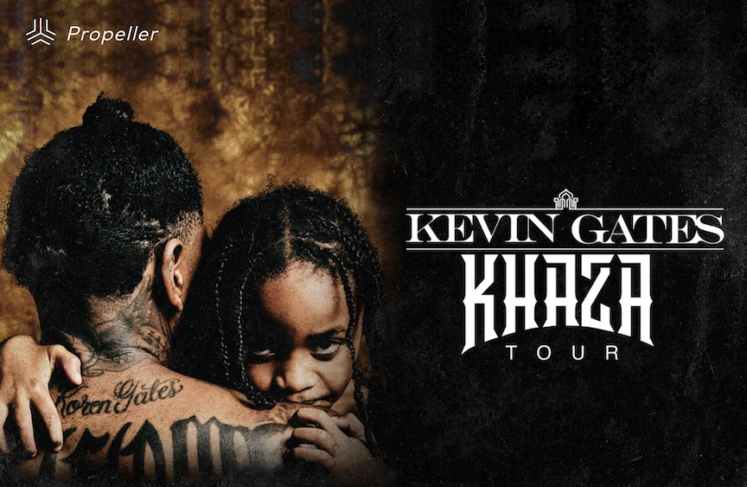
Download Kevin Gates x Propeller Flyer HERE

LOS ANGELES, CA (July 28, 2021) - Kevin Gates is known for speaking his mind and fulfills every promise. Today, the multi-platinum selling artist has announced a partnership with social impact-focused digital platform Propeller, in conjunction with his upcoming massive KHAZA TOUR. The campaign will benefit causes that mean the most to him from mental health to ending mass incarceration and climate justice. For simply taking action and supporting the organizations Kevin has chosen, fans can enter to win one-of-a-kind prizes including a pair of VIP tickets and a virtual meet and greet with Kevin (2 tix for each city), and a grand prize flyaway trip to meet Kevin on the final stop of his massive tour in Atlanta that includes airfare, hotel, tickets and more. Fans can then continue completing additional actions to earn more points and increase chances of winning.

Organizations benefitting from the campaign include the Anti-Recidivism Coalition (ARC) who are working to end mass incarceration in California; To Write Love on Her Arms who are dedicated to presenting hope and finding help for people struggling with depression, addiction, self-injury, and suicide; NRDC whose mission is to safeguard the Earth, its people, its plants and animals and the natural systems on which all life depends; and his own organization with his partner The Kevin & Dreka Gates Foundation which they founded to educate youth and bring awareness to depression, mental health, financial hardships and many other trying issues that young people are faced with today.

“Just knowing the work that these organizations do to make a change, made me want to get behind them and support them,” notes Kevin. “I know ARC does a lot of work with helping previously incarcerated individuals reintegrate back into society and help them get back to their family. That’s not always an easy thing to do. I remember when I was locked up, that was the hardest thing, being away from family, especially my son Khaza. He was at home around a bunch of amazing women but I knew he needed his dad. I named this upcoming KHAZA tour after him to show him I love him and I’m here. We did it for Islah, now it’s his turn.” Dreka Gates -- Kevin’s wife, manager and influential presence of social media -- who is an active part of the campaign adds, “Supporting these causes makes my heart sing. I happily support them because I know, beyond a shadow of a doubt, that they are intentional in their efforts to really make a difference.”

In addition to taking action with these organizations, Kevin and Dreka have donated items straight from their closets to raise funds for their organization. Fans can bid on items including Kevin’s Red Letterman Bomber Jacket, which he notes “My baby, my red bomber jacket. We had our time together, now I’m ready to donate it for such a good cause.” Additional items include pairs of his Nike AF1-TYPE Summit White Shoes, Custom Colored Rose Nike ID Air Force 1 Shoes, ‘Light Bone' Nike Air Force 1 MID '07 Shoes, and a pair of Spruce Frog' Nike Air Force 1 Utility Shoes. Dreka Gates has donated two pairs of kicks -- her Adidas Yeezy Boost 700 V2 Hospital Blue and her Adidas Yeezy Boost 350 V2 Clay, noting “I’m a huge fan of Yeezy and went a little crazy at one point, buying every pair of shoes that I could get my tiny hands on. I’m so happy they can now support the Kevin & Dreka Gates Foundation.”

Kevin Gates transformed into one of the most impactful and inimitable rappers in the game by simply being Kevin Gates. Nearly 15 years into an unbelievable career, he doesn’t chase trends. He doesn’t censor himself. He doesn’t hold back. It’s why the Baton Rouge, LA native has racked up 6 billion streams, 6 billion views, and dozens of multi-platinum, platinum and gold certifications. It’s why he’s logged four Top 5 entries on the Billboard Top 200 in addition to seven Top 5 entries on both the Top Rap Albums Chart and the Top R&B/Hip-Hop Albums Charts. It’s why he’s sold out successive headline tours, delivered show-stopping sets at Rolling Loud and JMBLYA, and ignited arenas with Cardi B. It’s why he’s received various high-profile award nominations. It’s why he’s reached rarified air, emerging as second best-selling hip-hop artist of 2016 only behind Drake. It’s why he’s also spawned countless think pieces. Among those, Pitchfork described 2019’s gold-certified I’m Him as “another showcase for the Baton Rouge rapper’s fully formed and gloriously weird personality” and praised, “The hooks are magnificent, his most boisterous and fine-tuned since Islah.” As always, he doesn’t compromise on 2021’s Only The Generals Part II [Breadwinners Association/Atlantic Records] and more music on the horizon. He’s only gotten better at being Kevin Gates.

KEVIN GATES - KHAZA TOUR DATES
Jul 31 Niceville, FL - NW FL College Amphitheater***
Aug 14 Columbia, SC - Colonial Life Arena***
Aug 28 Fort Wayne, IN - Piere’s Entertainment Center***
Sep 03 Mobile, AL - Mobile Civic Center
Sep 04 Manchester, TN - Bonnaroo***
Sep 05 Greensboro, NC - Greensboro Coliseum
Sep 08 Austin, TX - Stubb’s Waller Creek Amphitheater
Sep 09 Houston, TX - Bayou Music Center
Sep 10 Dallas, TX - South Side Music Hall
Sep 11 Oklahoma City, OK - The Criterion
Sep 14 El Paso, TX - El Paso County Coliseum
Sep 15 Albuquerque, NM - El Rey Theater
Sep 16 Tempe, AZ - Marquee Theatre
Sep 17 Los Angeles, CA - Belasco
Sep 18 Anaheim, CA - House of Blues
Sep 19 San Franciscio, CA - The Warfield
Sep 21 Portland, OR - Roseland Theatre
Sep 22 Seattle, WA - WaMu Theater
Sep 23 Boise, ID - Knitting Factory
Sep 24 Salt Lake City, UT - The Rockwell
Sep 25 Denver, CO - Mission Ballroom
Sep 27 Wichita, KS - WAVE
Sep 29 Kansas City, MO - Uptown Theatre
Sep 30 Omaha, NE - Baxter Arena
Oct 01 St. Louis, MO - Pop’s Outdoor
Oct 02 Clive, IA - Horizon Event Center
Oct 03 Minneapolis, MN - Myth
Oct 06 Chicago, IL - Radius
Oct 07 Milwaukee, WI - Eagles Ballroom
Oct 08 Cleveland, OH - Agora Theatre
Oct 09 Indianapolis, IN - Egyptian Room at Old National Centre
Oct 10 Grand Rapids, MI - 20 Monroe Live
Oct 13 Cincinnati, OH - Bogart’s
Oct 14 Cincinnati, OH - Bogart’s
Oct 15 Columbus, OH - Express Live
Oct 17 Boston, MA - House of Blues
Oct 18 New York, NY - Irving Plaza
Oct 19 New York, NY - Irving Plaza
Oct 20 Philadelphia, PA - Fillmore
Oct 21 Silver Spring, MD - Fillmore
Oct 22 Baltimore, MD - Ram’s Head Live
Oct 23 Rochester, NY - Main Street Armory
Oct 24 Pittsburgh, PA - Stage AE
Oct 27 Knoxville, TN - Knoxville Civic Coliseum
Oct 28 Southaven, MS - Landers Center
Oct 29 Biloxi, MS - MS Coast Coliseum
Oct 30 Baton Rouge, LA - Raising Cane’s River Center
Nov 02 Charleston, SC - North Charleston’s Performing Arts Center
Nov 03 Saint Petersburg, FL - Jannus Live
Nov 05 Atlanta, GA - Coca-Cola Roxy
***NOTE DATES WITHOUT DDG & GANG51E JUNE

About PROPELLER
Website | Instagram | Twitter
Propeller is a digital marketing platform that works at the crossroads of culture and social good. We enable our partners, both for- and non-profit, to connect with new audiences and build meaningful campaigns. As a for-profit public benefit corporation, we operate with the financial transparency of a non-profit and our success is based solely on the impact we create together.

About The Kevin & Dreka Gates Foundation
Website
The Kevin and Dreka Gates Foundation was founded by multi-Platinum recording artist Kevin Gates and his manager and lifelong partner Dreka. The purpose of the foundation is to educate youth and bring awareness to depression, mental health, financial hardships and many other trying issues that young people are faced with today. The overall mission of The Kevin and Dreka Gates Foundation is to educate and empower youth with the mindset that even if you are dealt a bad hand, you can still make good decisions early in life that lead to a successful and positive outcome.

For additional information on PROPELLER, contact Grandstand Media:
Kate Jackson, katej@grandstandhq.com
Shazila Mohammed, shazm@grandstandhq.com

For additional information on KEVIN GATES, contact Atlantic Records:
Sydney Margetson, sydney.margetson@atlanticrecords.com
Chandler Owen (tour), chandler.owen@atlanticrecords.com

